**CMPE 273: Enterprise Distributed Systems**

**Lab 3 Assignment: Web Services**



**Sravani Gunti**

**010090405**

[**sravani.gunti@sjsu.edu**](mailto:sravani.gunti@sjsu.edu)

Table of Contents

**Calculator Client/Server** 4

**Purpose of Web Service based Calculator Server** 4

**System Design** 4

**Web Service Results:** 6

**Exception Handling Details:** 8

**Results:** 9

**Addition:** 11

**Subtraction:** 12

**Multiplication:** 13

**Division:** 14

**Performance Results:** 17

**For 1000 calls:** 17

**Comparison of Restful Services to Web Services:** 21

**For 5000 calls:** 22

**Comparison with Restful Services:** 24

**100 concurrent users with 1000 calls each:** 25

**Comparison with Restful Services:** 29

**LinkedIn Client/Server** 30

**Purpose of Web Service based LinkedIn Server** 30

**System Design** 30

**Exception Handling:** 33

**Web Services Result for LinkedIn Server** 34

**Screen Shots for LinkedIn Application:** 43

**Performance Results for LinkedIn:** 59

**For 100 calls:** 59

**For 200 calls:** 61

**For 300 calls:** 64

**For 400 calls:** 66

**For 500 calls:** 69

**For 1000 calls:** 71

**For 5000 calls:** 74

**For 100 concurrent users each operation 1000 calls:** 76

**Comparison with Restful Services:** 79

**For 100 users:** 79

**For 200 users** 79

**For 300 users** 80

**For 400 users** 80

**For 500 users** 81

# **Calculator Client/Server**

Calculator server, alias Server 1 is the first web service based server and it is used to perform mathematical operations such as:

1. Addition
2. Subtraction
3. Multiplication
4. Division

## **Purpose of Web Service based Calculator Server**

A web service based calculator server is used as it can manage the code and can be remotely invoked using HTTP, that is HTTP requests are activated using it. It is also used to expose the functionality of existing code over the network. Other applications can use this functionality of the program as it is exposed to a network.

## **System Design**

The calculator client/server are designed using JSP servlets using web services. It mainly has three layers:

 

Servlets

Web Browser calc.jsp Calculation servlet Web Service Server



Result.jsp

Figure 1: Flow Diagram of Calculator Client/Server

1. Client Layer:

In this case web browser is the client.

1. Presentation Layer:

In this layer the user interface is generated dynamically. In this layer we have the below components.

Servlets:

It handles the application’s presentation logic. They also help us in managing sessions, in simple input validations and also servlets are the page-to-page navigation dispatchers. They help is in tie of business logic elements together.

JSPs:

Views by the client are defined in .jsp files using the URL: http://localhost:8080/CalculatorClient/View/calc.jsp

JSPs handle application display tasks, in this scenario **“calc.jsp”** and **“results.jsp”** work in conjunction with servlets to define the presentation screens and page navigation. EJB components and JDBC objects are called by these JSPs and they typically encapsulate business logic functionality. They carry out the required calculations and other repetitively requested tasks.

Static Content:

HTML pages are the static content and they appear uniformly across different browsers.

1. The Business Logic Layer:

Business rules are encapsulated in this layer and EJB components are deployed in this layer by using message driven beans, entity beans and session beans.

To check whether the business logic is valid or not we can create web services by following below steps:

Service -> Create Web Service ->Publish Web Service-> Select the WSDL ->Start Server->Finish

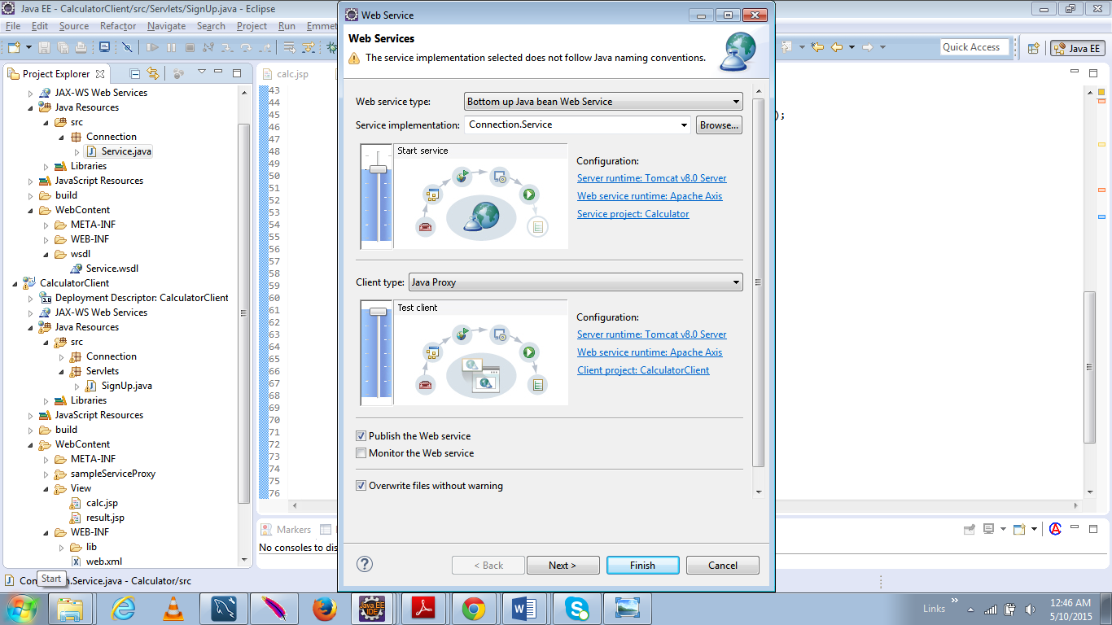

**Creating a Web Service**

## **Web Service Results:**

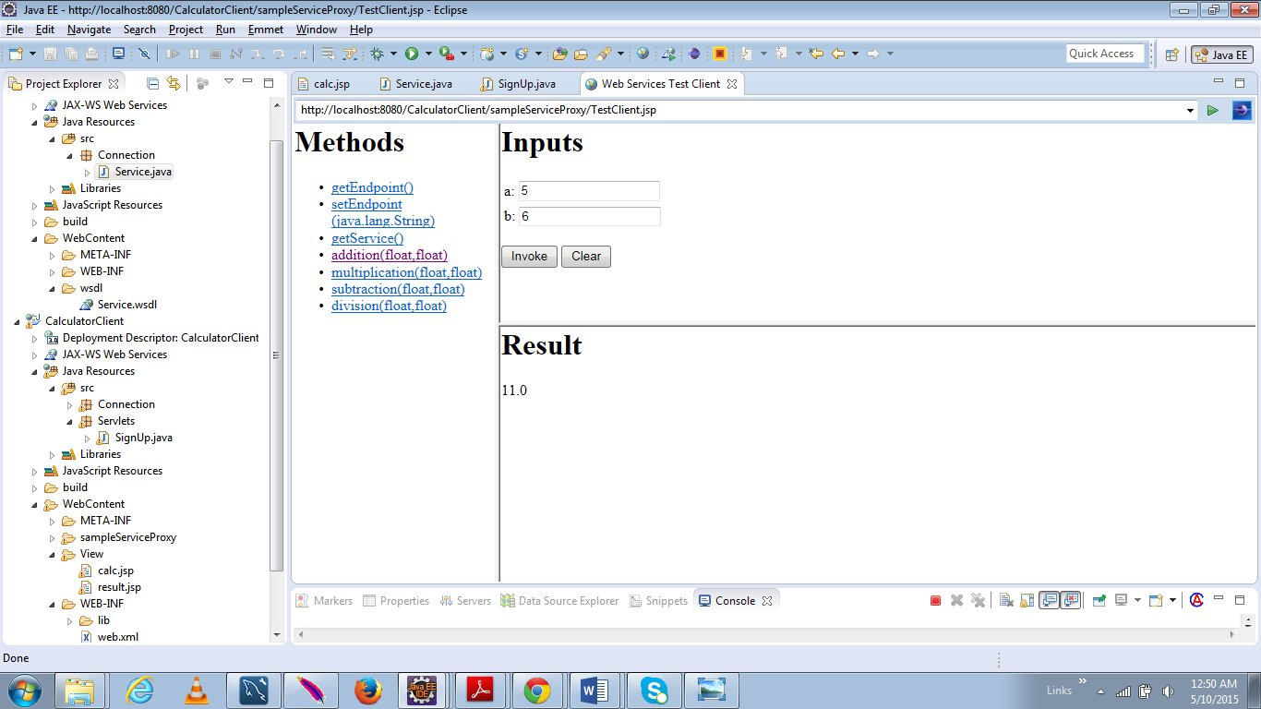

**Web Service for Addition**

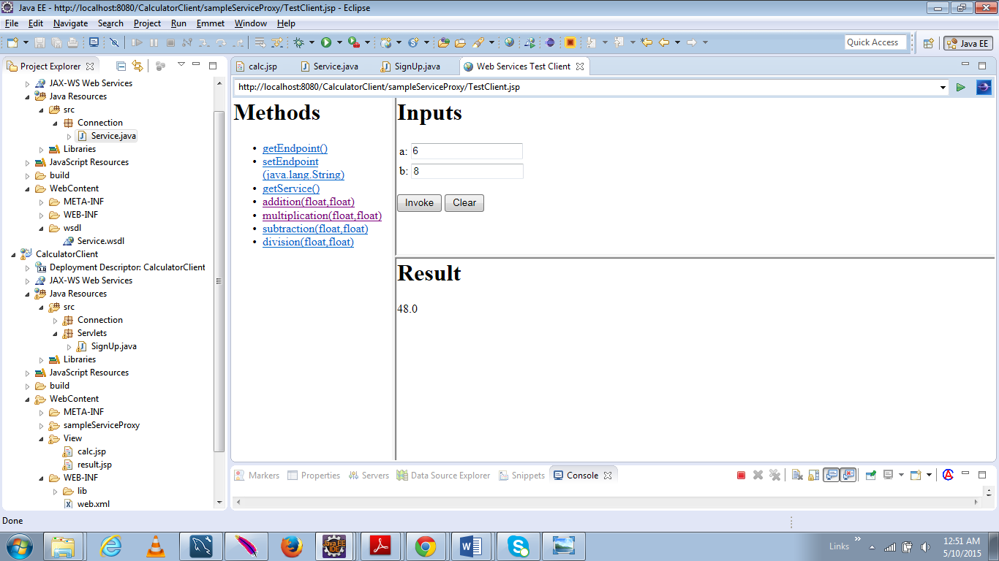

**Web Service for Multiplication**

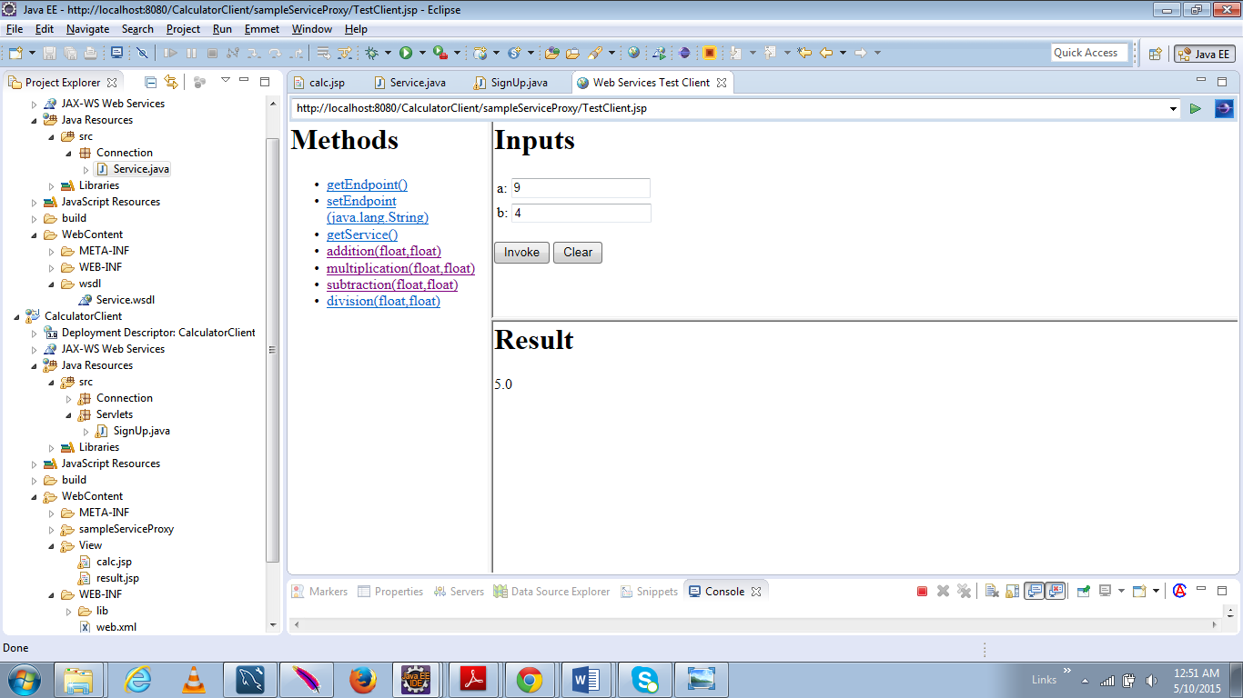

**Web Service for Subtraction**

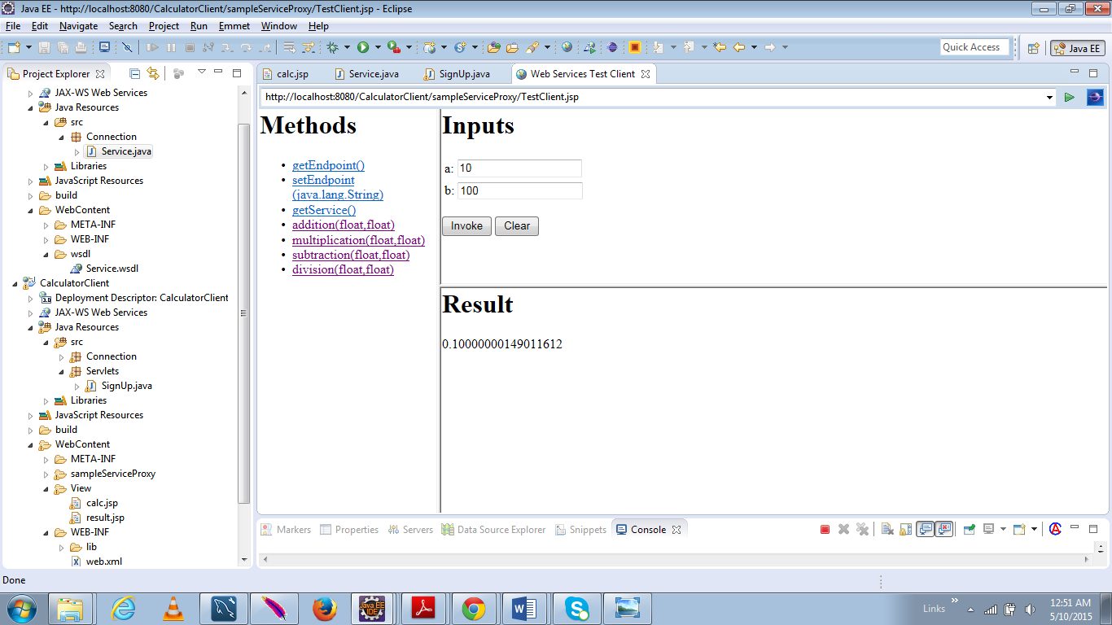

**Web Service for Division**

## **Exception Handling Details:**

Exceptions are handled based on the parameter values which are given as input and their corresponding operations. Example:

* Input parameters cannot be characters or spaces.
* The divide by zero exception is handled.

## **Results:**

Screen shots of calculator application:

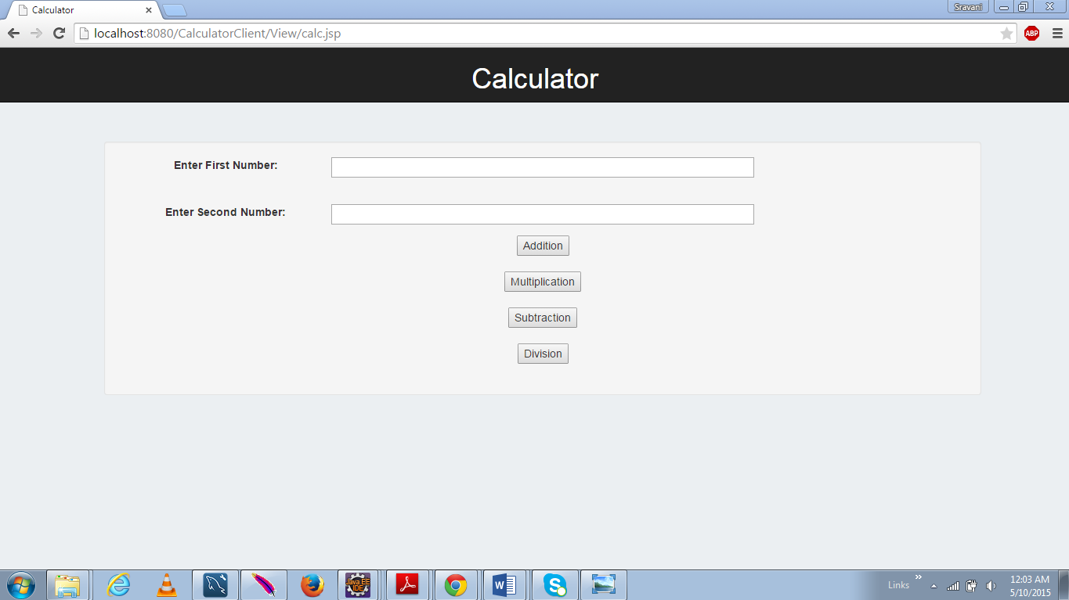

**Figure 1: Client View of Calculator**

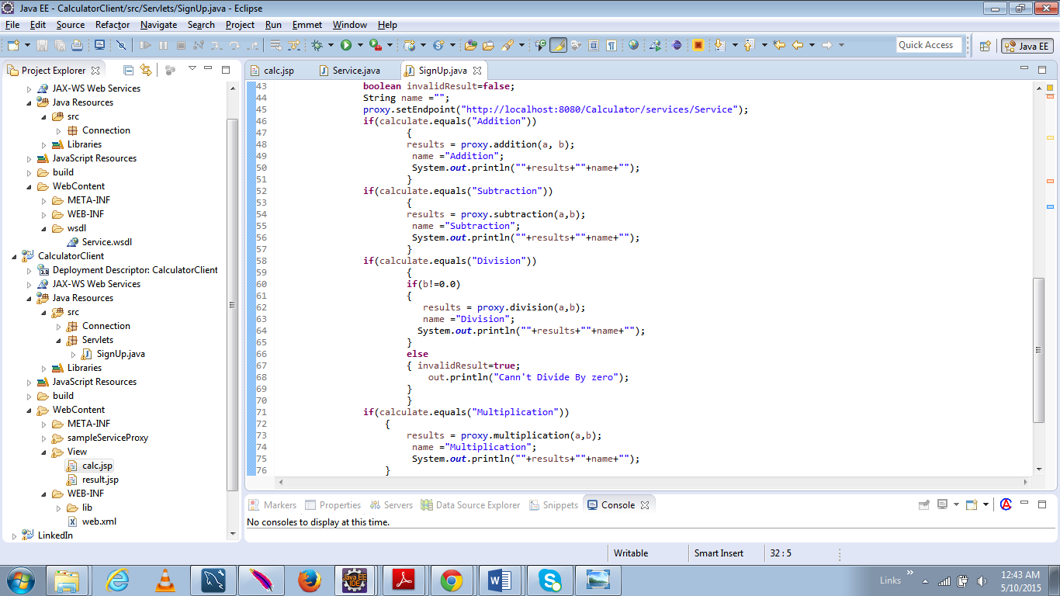

**Figure 2: Presentation Logic in Servlet; in this phase the validation is done for division functionality**

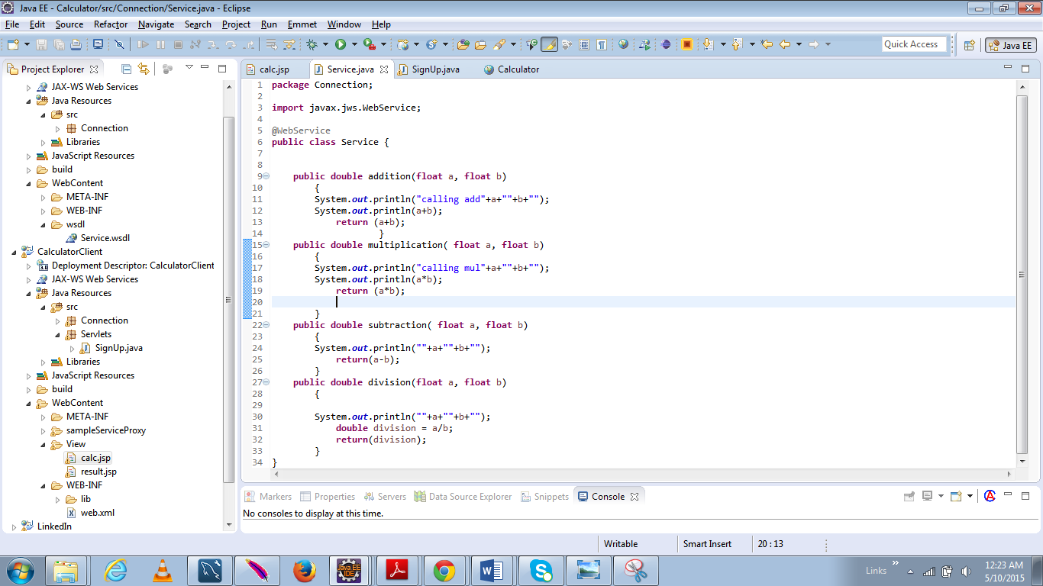

**Figure 3: Server Side View of Calculator**

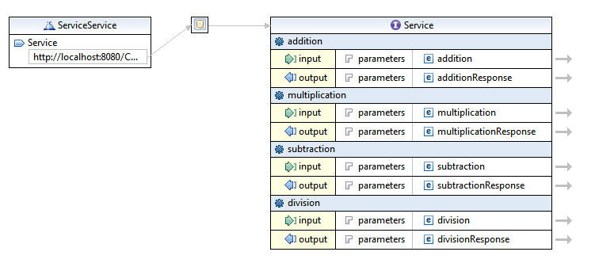

**WSDL file of Calculator Service**

### **Addition:**

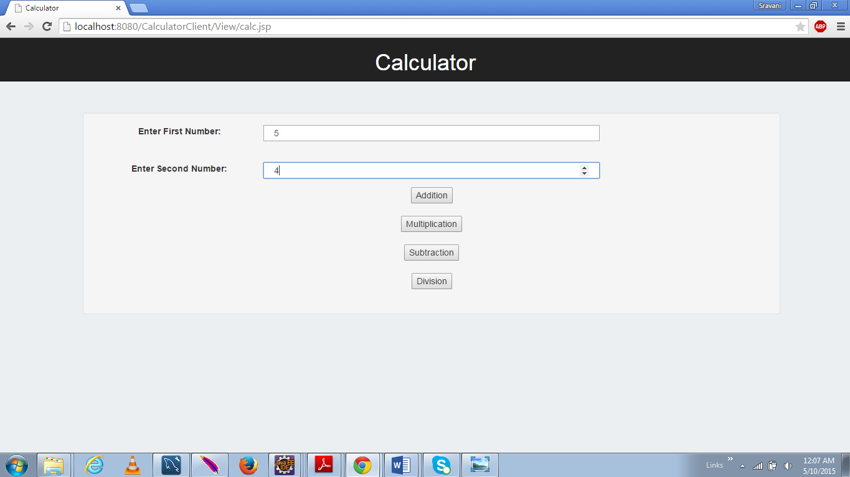

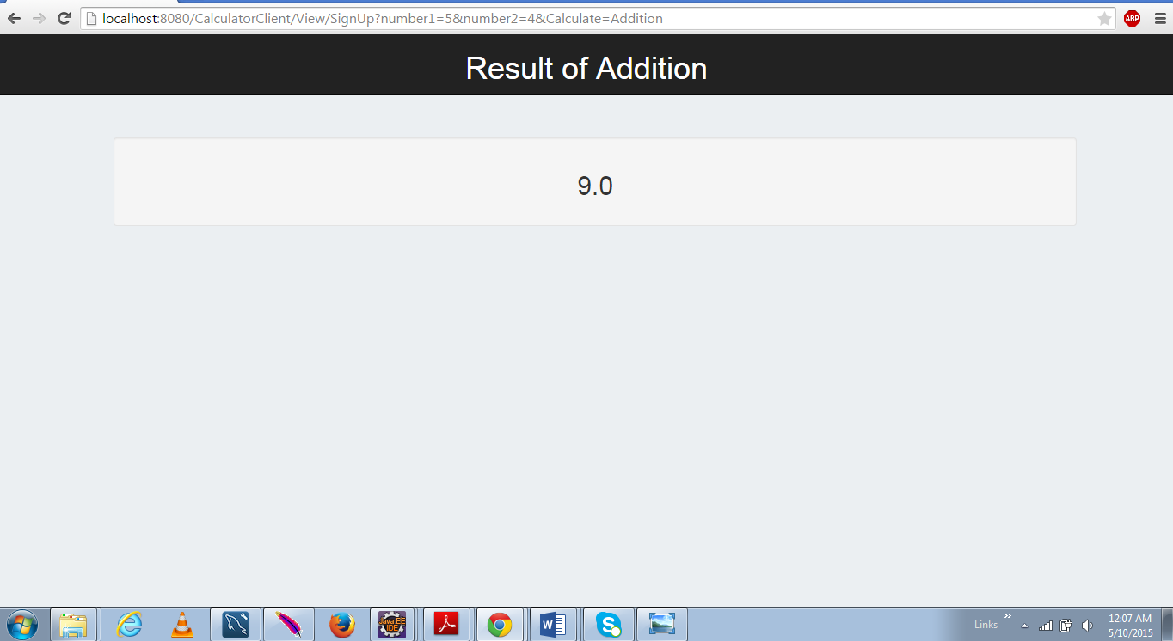

### **Subtraction:**

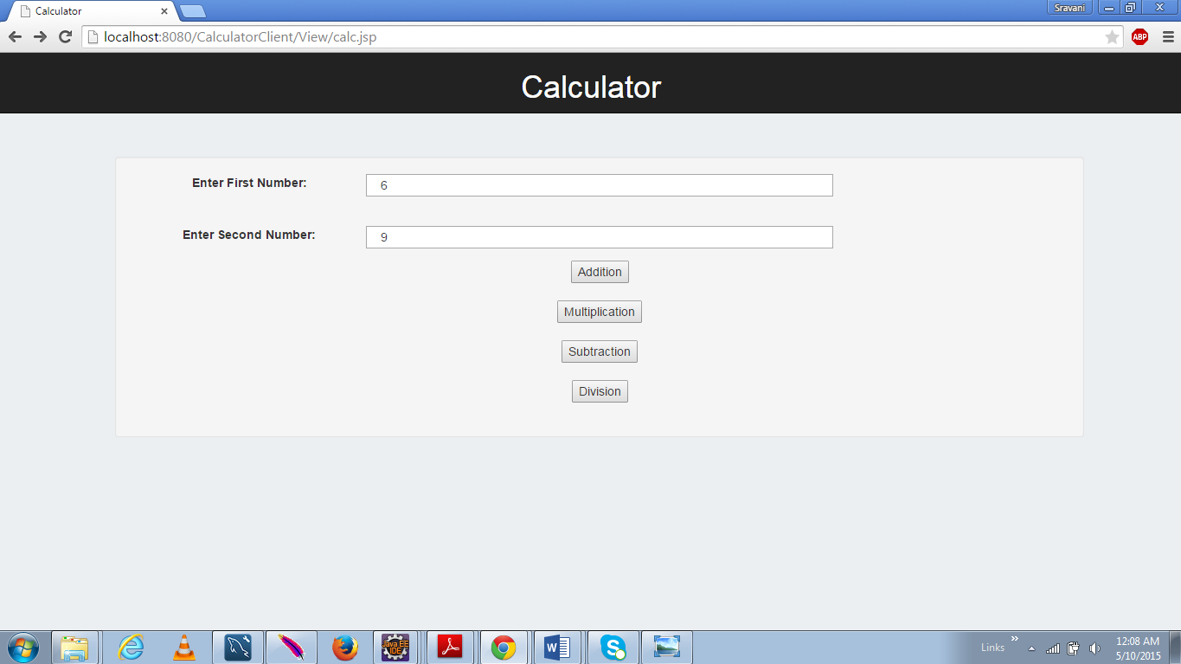

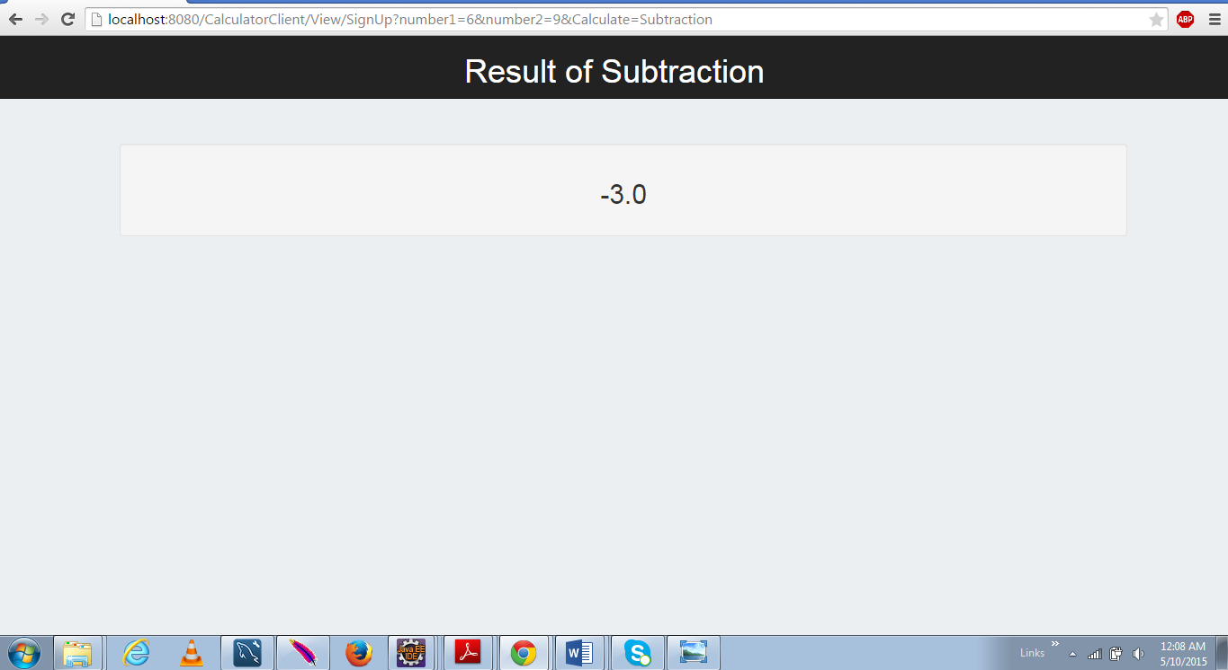

### **Multiplication:**

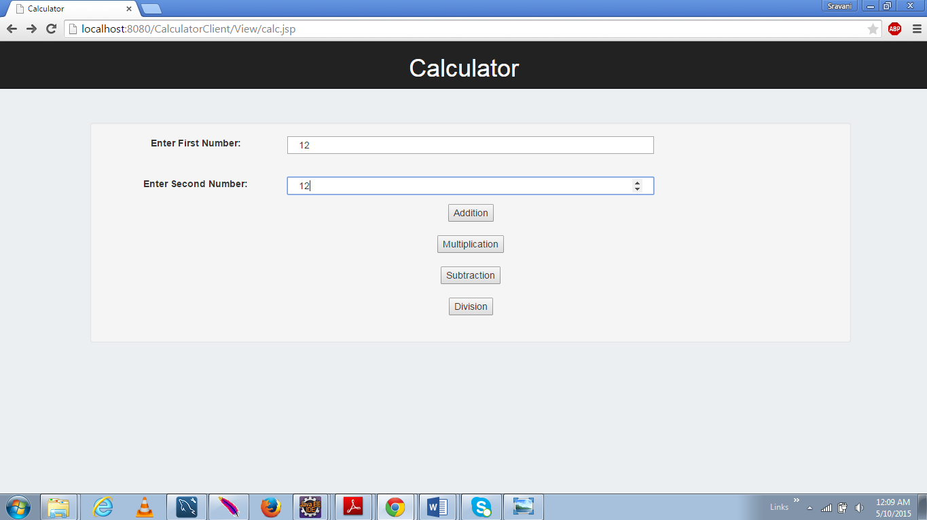

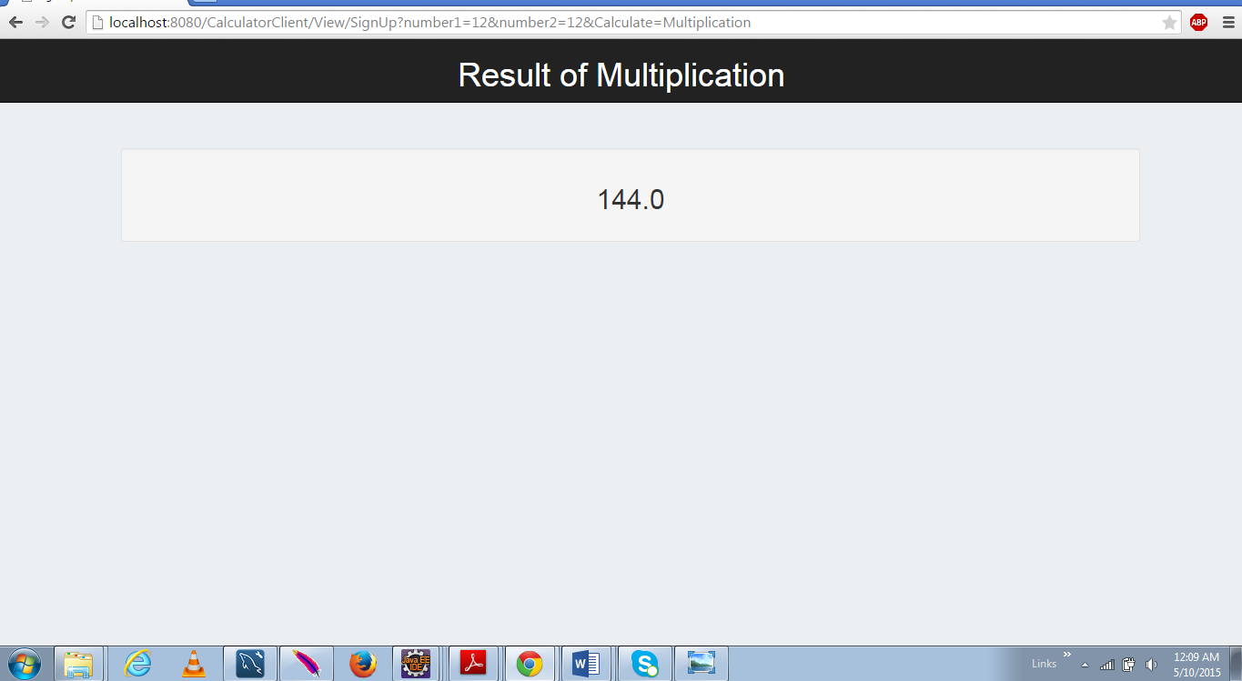

### **Division:**

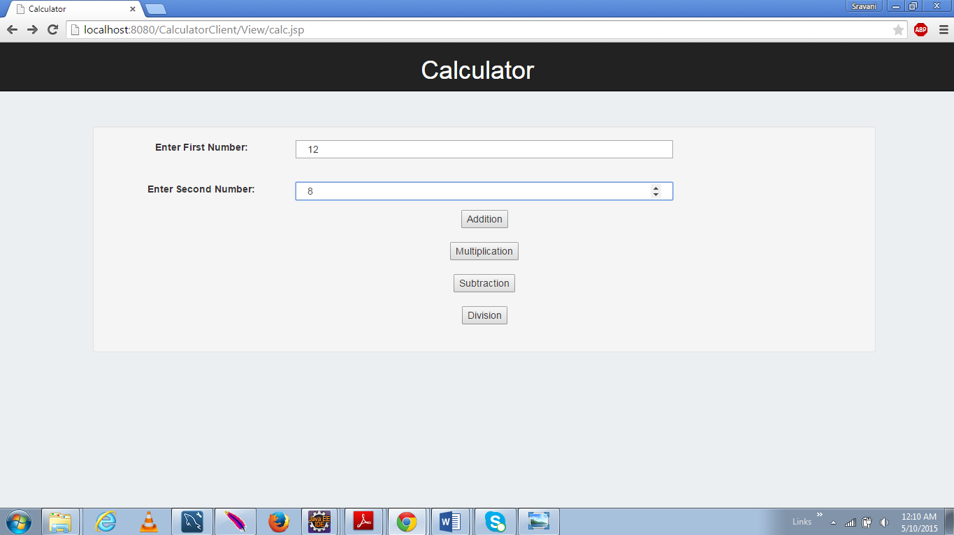

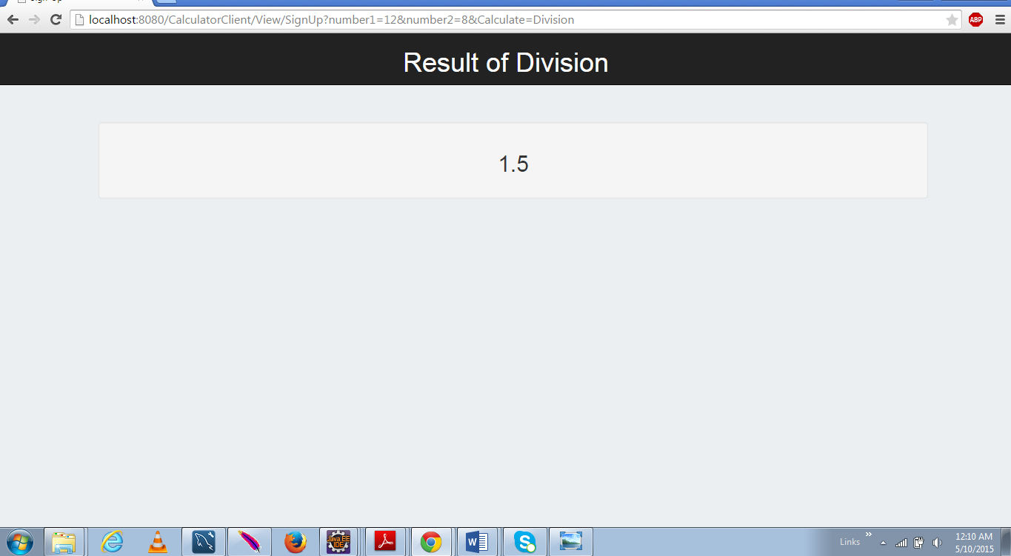

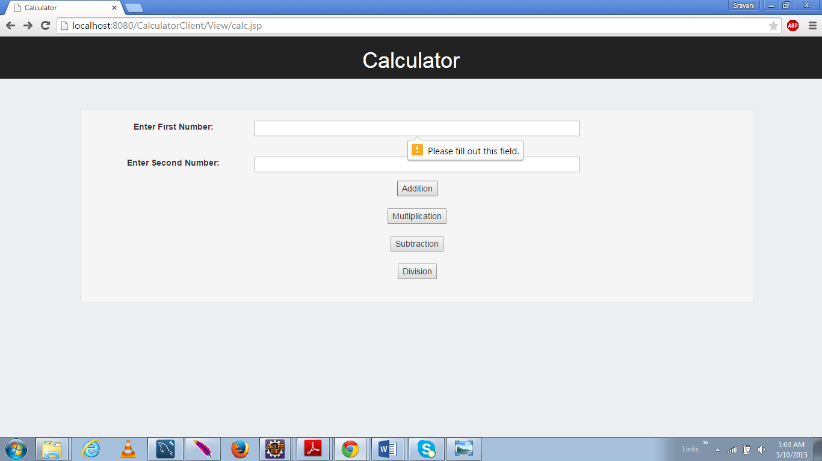

**Parameter 1 Empty Validation**

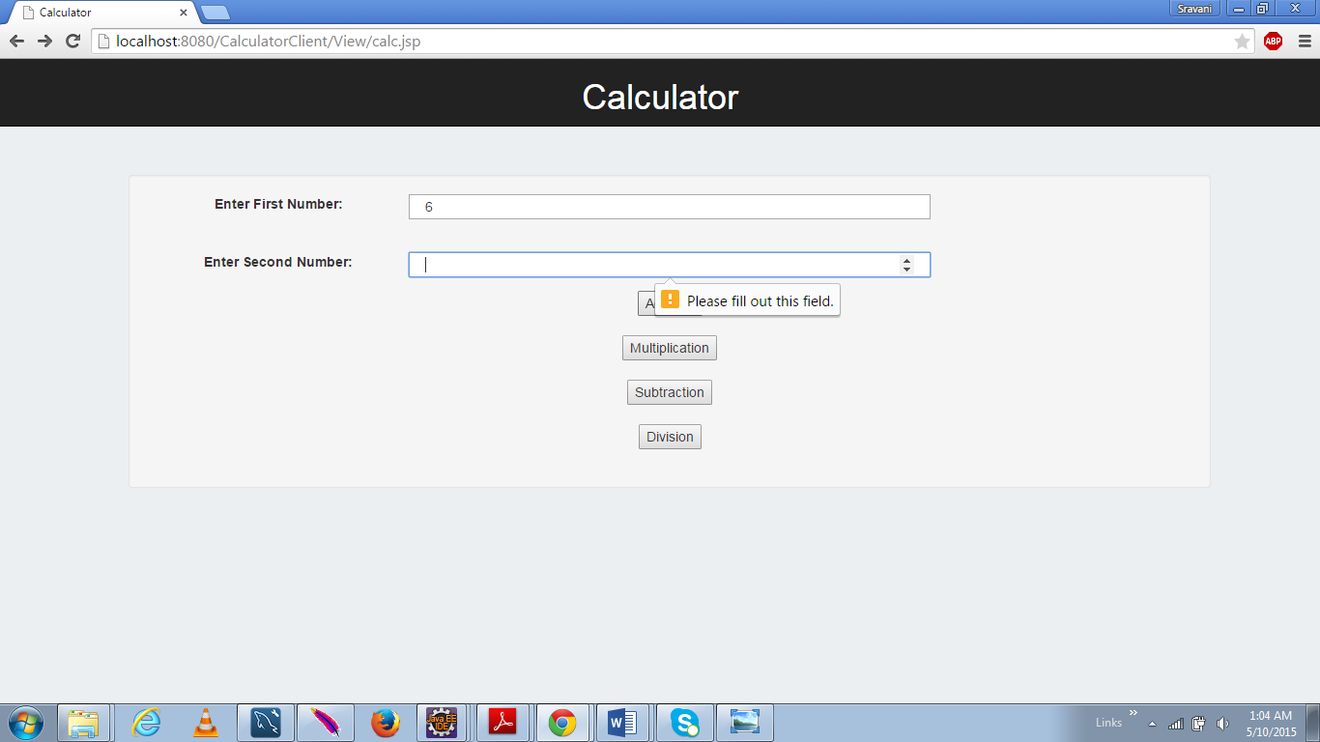

**Parameter 2 Empty Validation**

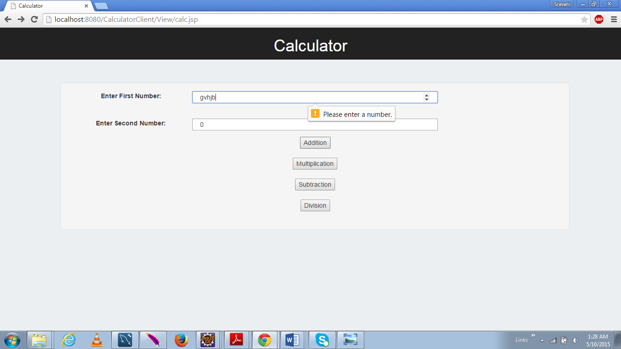

**Validate to accept only number**

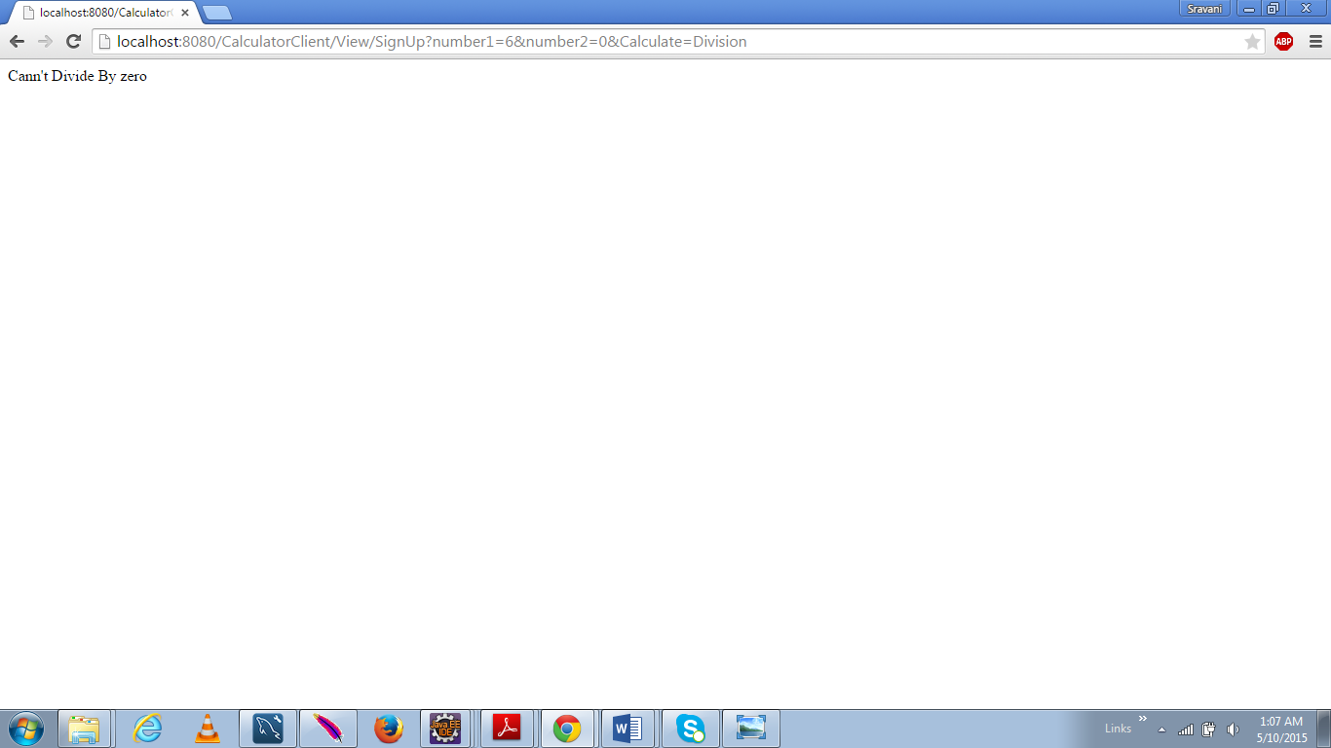

**Error Message when a number is divided by zero**

## **Performance Results:**

### **For 1000 calls:**

#### **Addition:**

SOAP request sent in the Jmeter test cases for addition

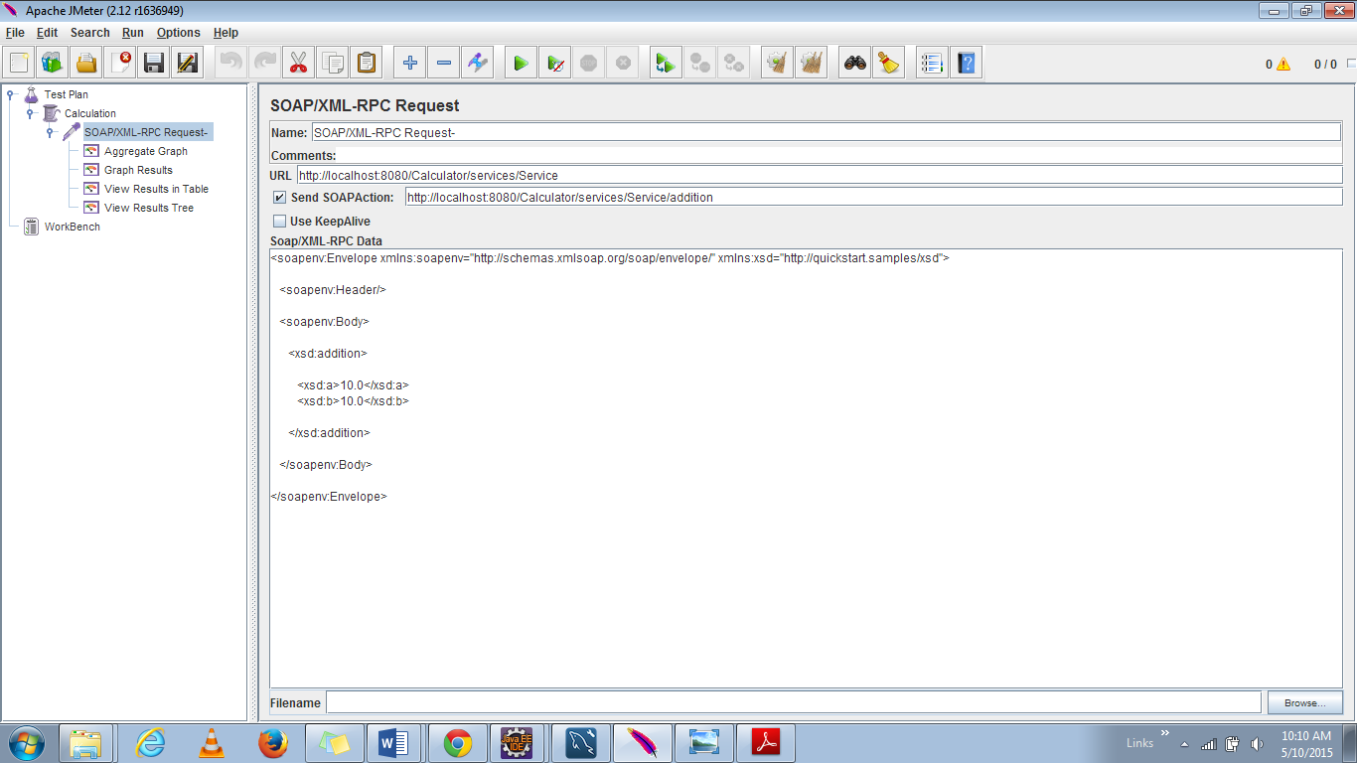

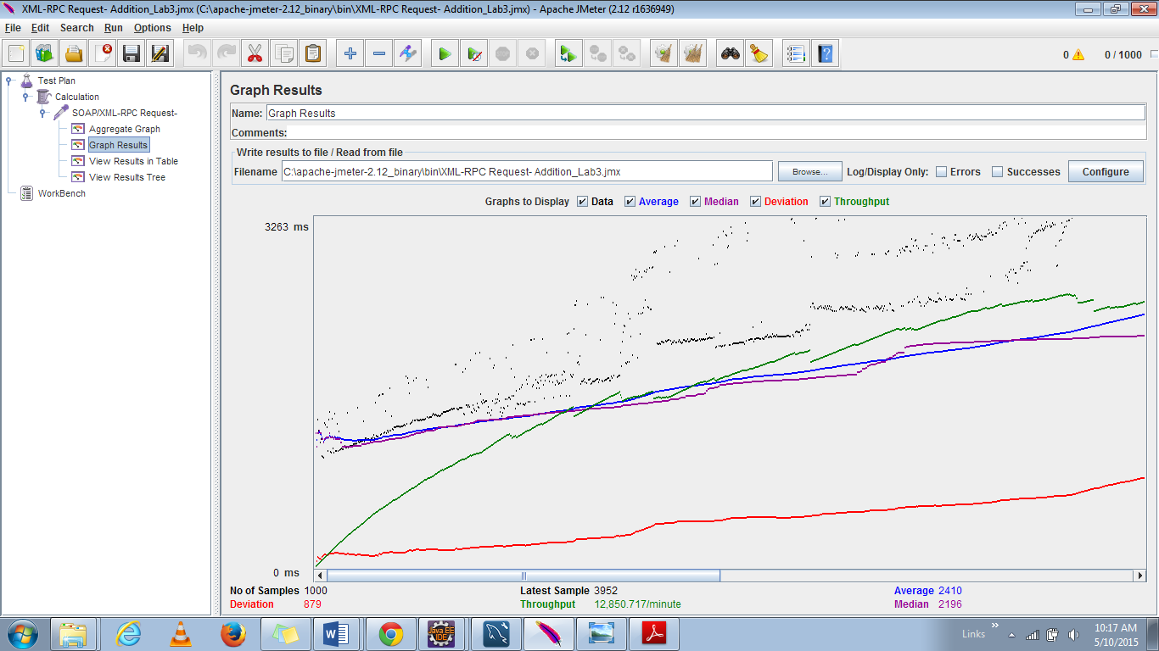

#### **Subtraction:**

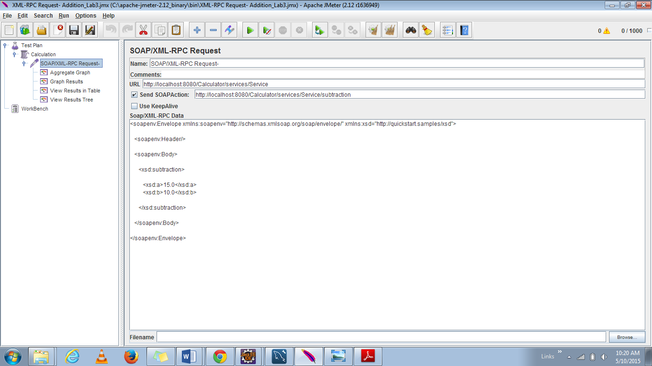

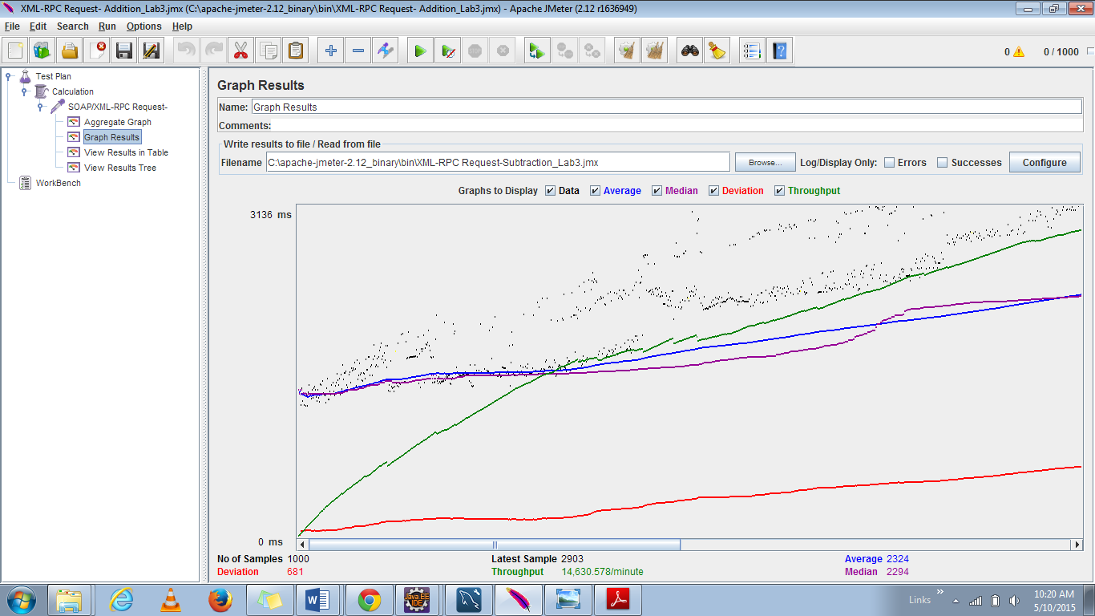

#### **Multiplication**

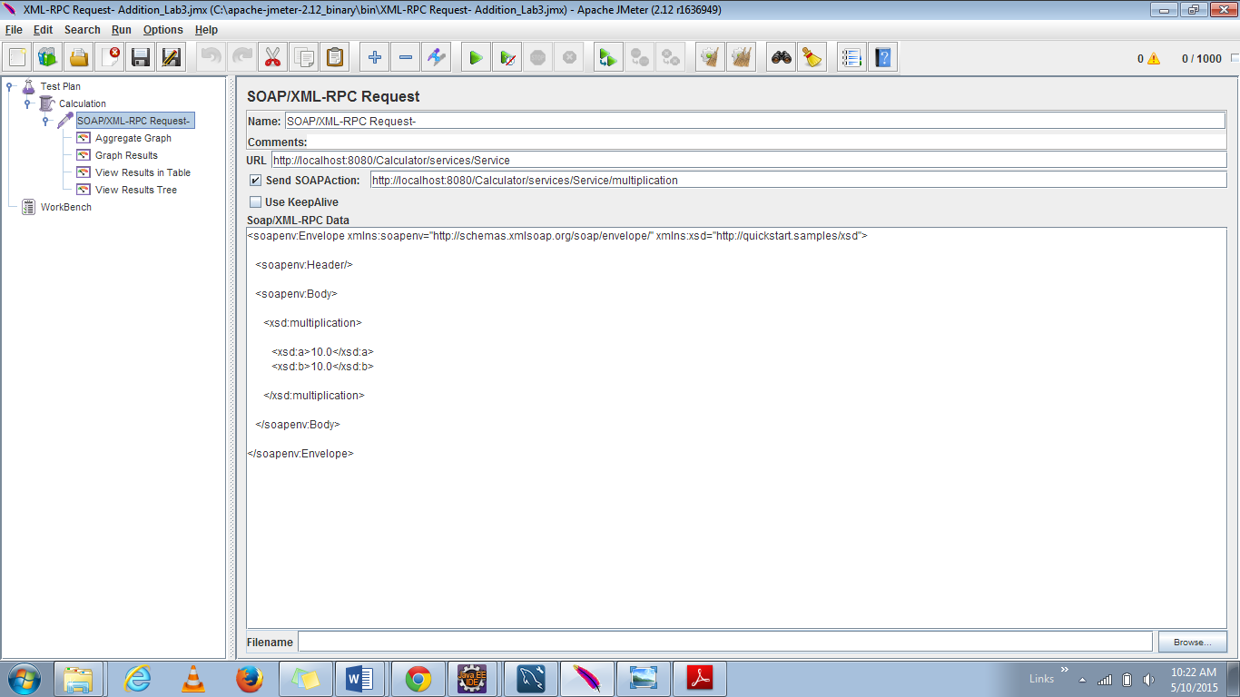

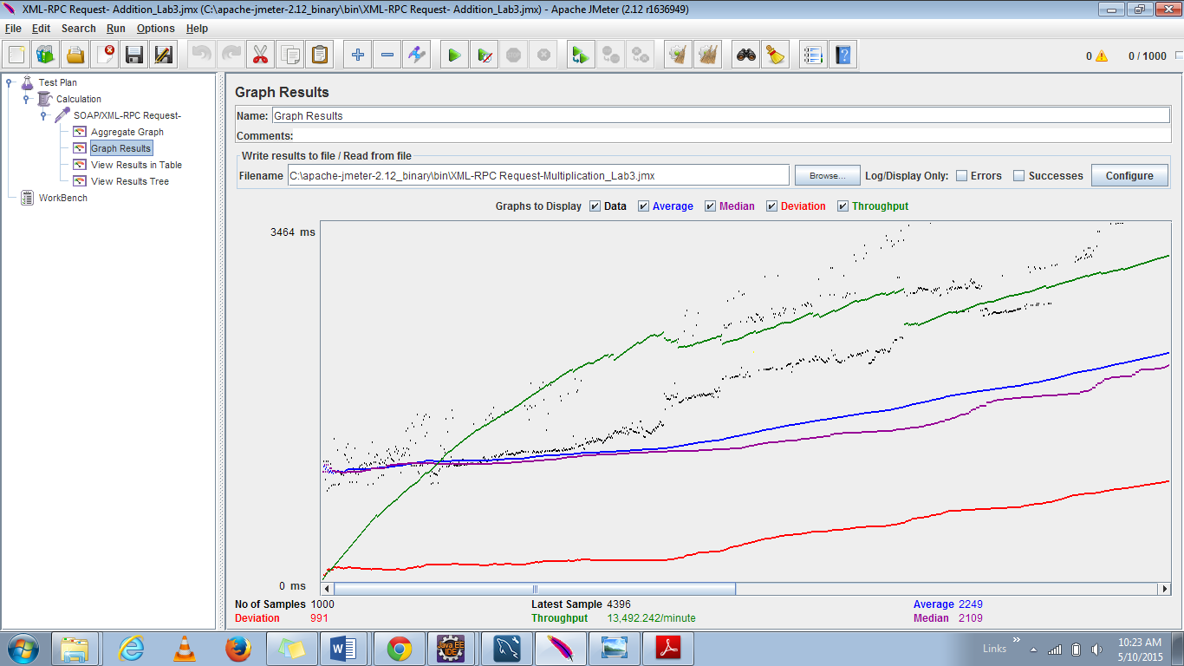

#### **Division:**

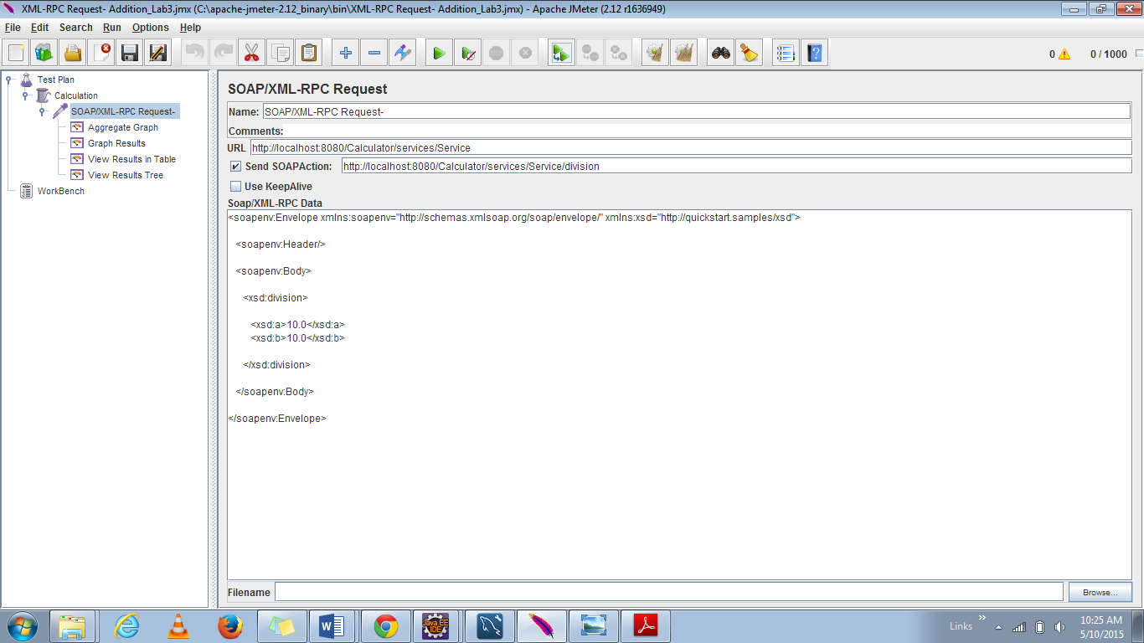

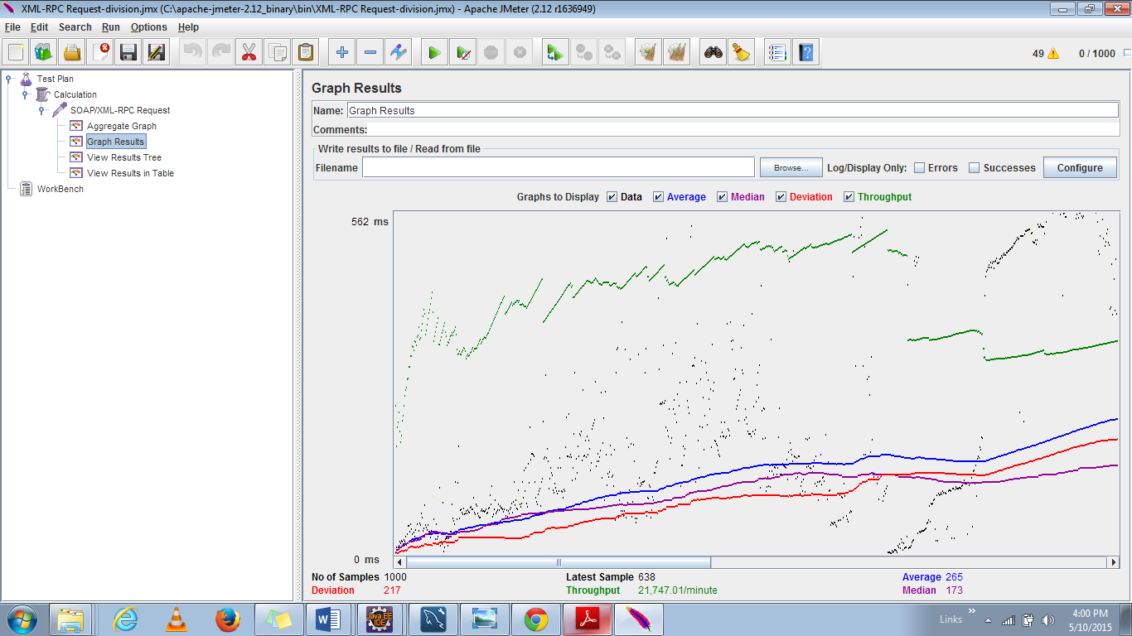

|  |  |  |  |  |
| --- | --- | --- | --- | --- |
| Calculation | Average(ms) | Median | Throughput (per minute) | Deviation |
| Addition | 2410 | 2195 | 12850.7 | 600 |
| Subtraction | 2324 | 2294 | 14630.5 | 681 |
| Multiplication | 2249 | 2109 | 13492.242 | 581 |
| Division | 285 | 173 | 21747.01 | 217 |

**Discussions:**

* Calculator server application for all the calculations; that is; addition, subtraction, multiplication and division there is a **slight deviation** as seen in the graph. The blue line indicates the average time taken for all the 1000 calls.

## **Comparison of Restful Services to Web Services:**

* Below is the aggregate graph retrieved for calculation using REST API’s
* 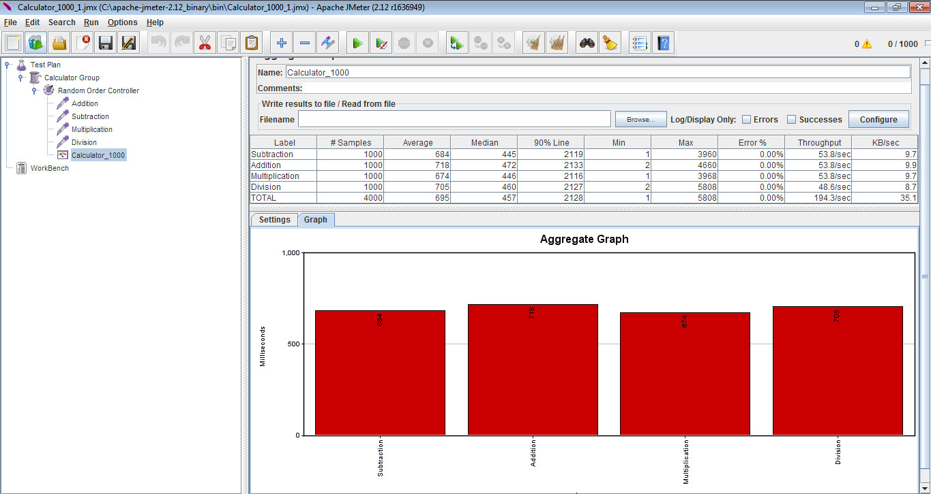
* From the graph it is clearly shown that the average time taken by REST services is very low compared to the Web Services.
* As Node js has a light weight and scalable server; rapid prototyping is done and thus the through put is also high.
* But when we need machine to machine interoperable interaction over a network we need Web Services.

### **For 5000 calls:**

#### **Addition:**

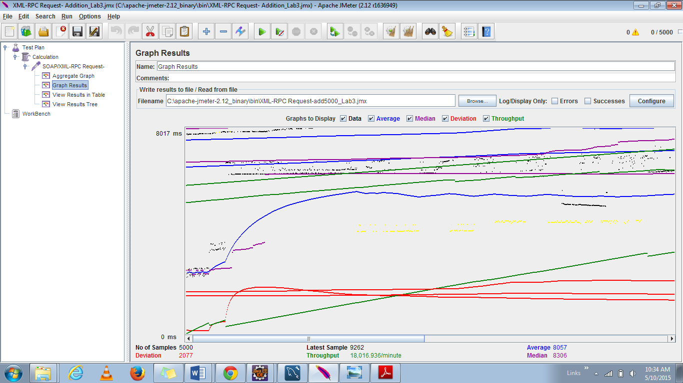

#### **Subtraction:**

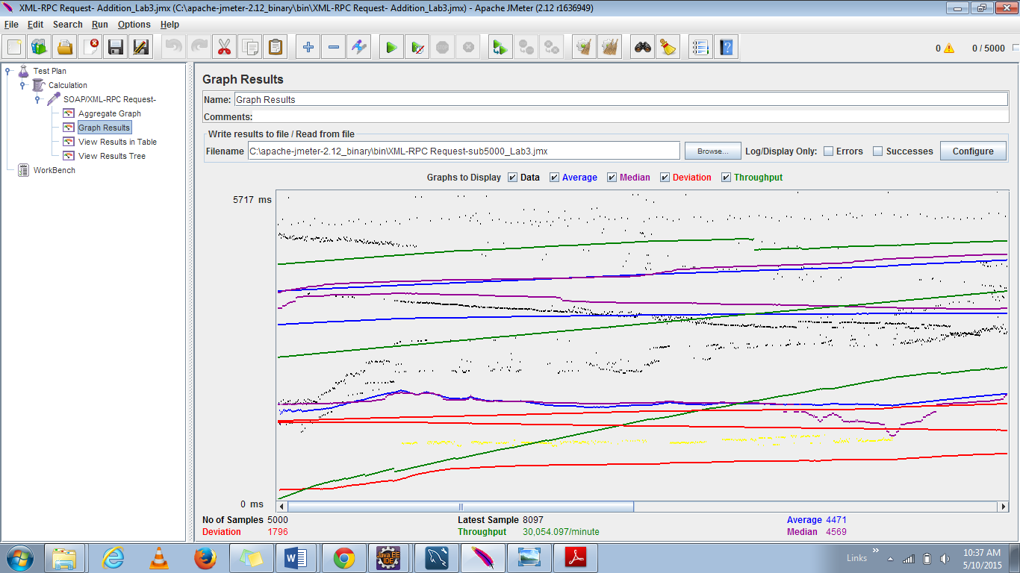

#### **Multiplication:**

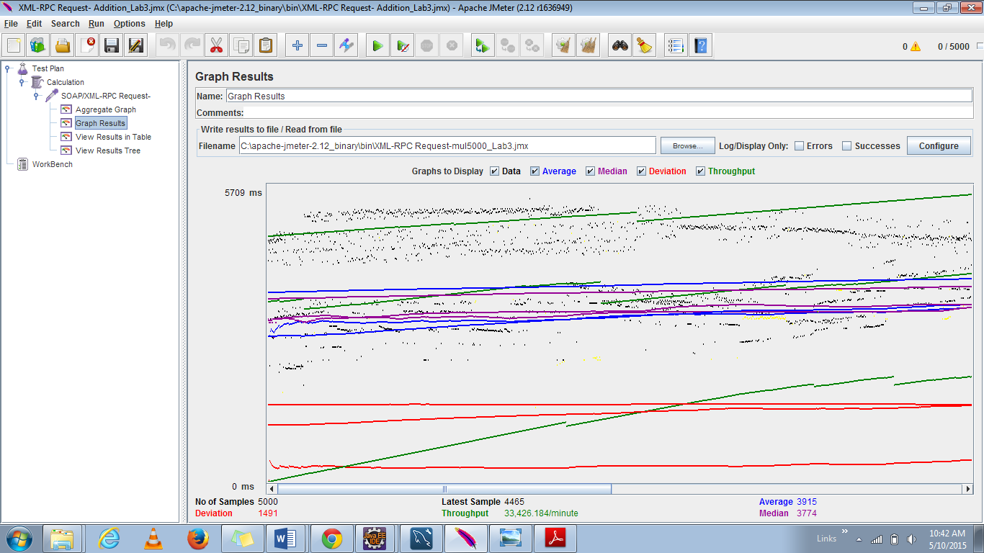

#### **Division:**

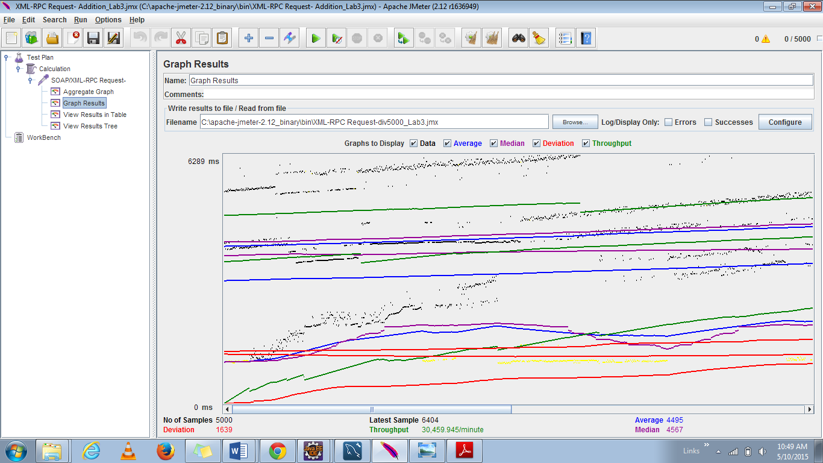

|  |  |  |  |  |
| --- | --- | --- | --- | --- |
| **Calculation** | **Average(ms)** | **Median** | **Throughput (per minute)** | **Deviation** |
| Addition | 4957 | 8306 | 18016 | 2000 |
| Subtraction | 4471 | 4560 | 30054.5 | 1795 |
| Multiplication | 3915 | 3374 | 33426.18 | 1491 |
| Division | 4495 | 4567 | 30459.91 | 1639 |

**Discussions:**

The performance of the calculator has a wide range of deviation initially and later it seems to be consistent. The blue color line shows the average time for performing the calculation.

## **Comparison with Restful Services:**

The graph shown below depicts the aggregate graph of Restful Services server for 5000 users.

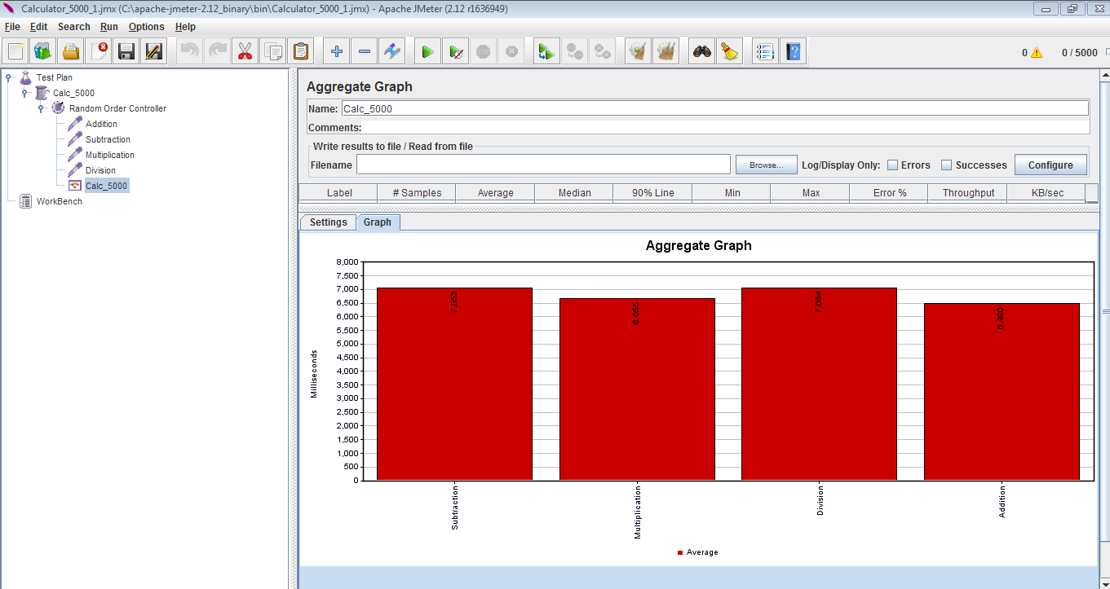

* It is clearly shown from the graph that the average time taken by Restful services is very low (half of) compared to the time taken by Web Services.
* As nodejs is a lightweight scalable server rapid prototyping is done and thus the through put is also high.
* But when we need machine to machine interoperable interaction over a network we need Web Services.
* As node js is asynchronous non-blocking execution whereas web services is blocking; there is a wait time and the average time for web services is high.
* Moreover Java web service has a overhead of SOAP; whereas Restful services do not have that overhead.

### **100 concurrent users with 1000 calls each:**

#### **Division:**

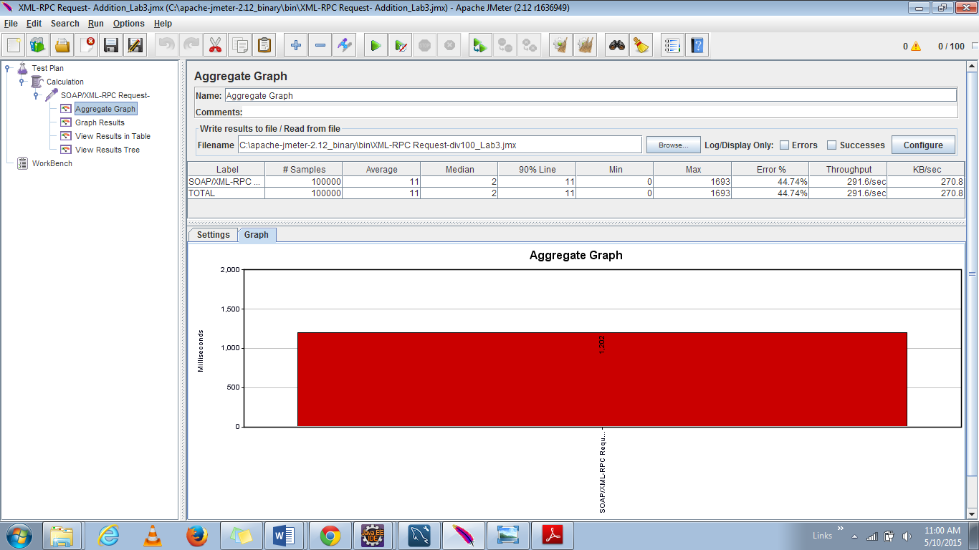

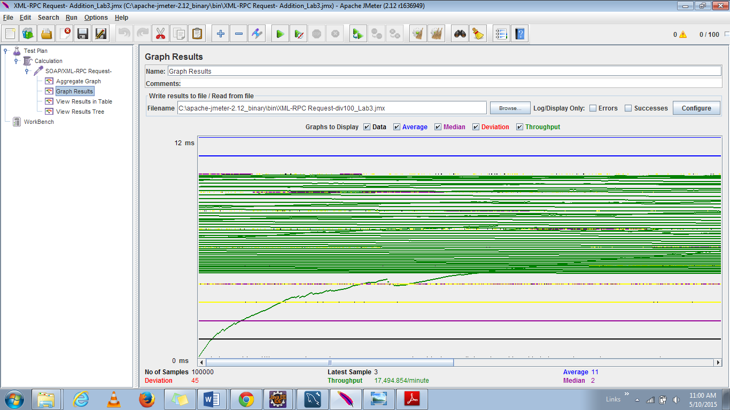

#### **Multiplication:**

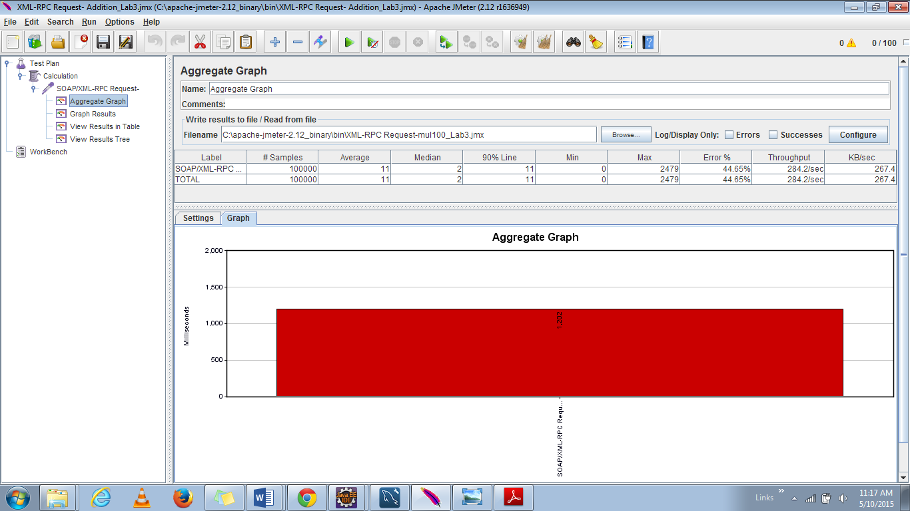

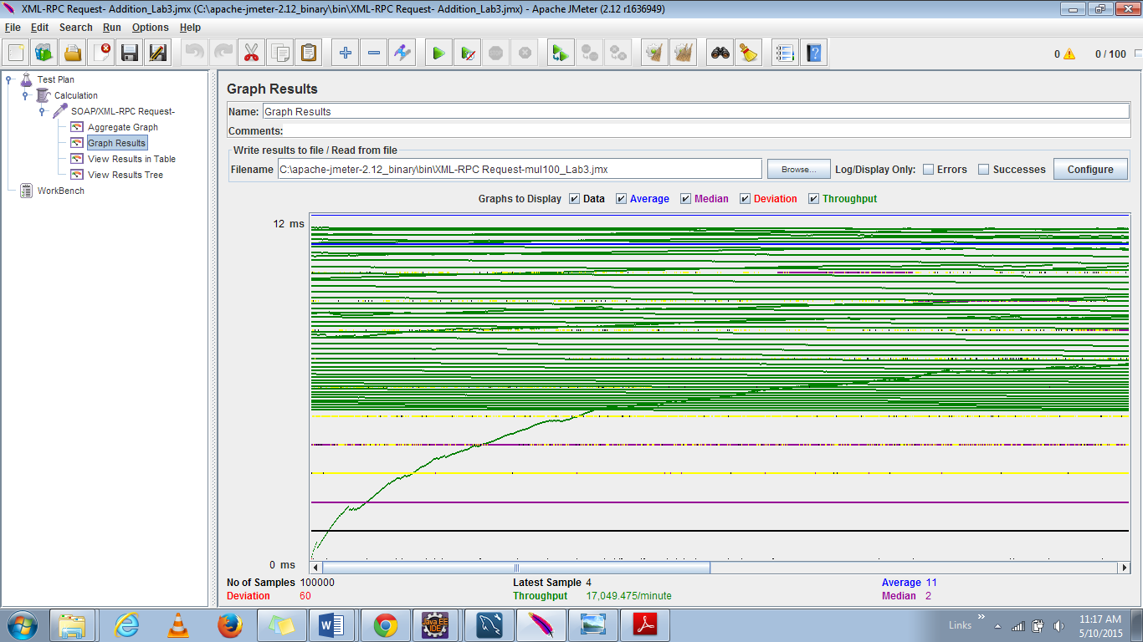

#### **Subtraction:**

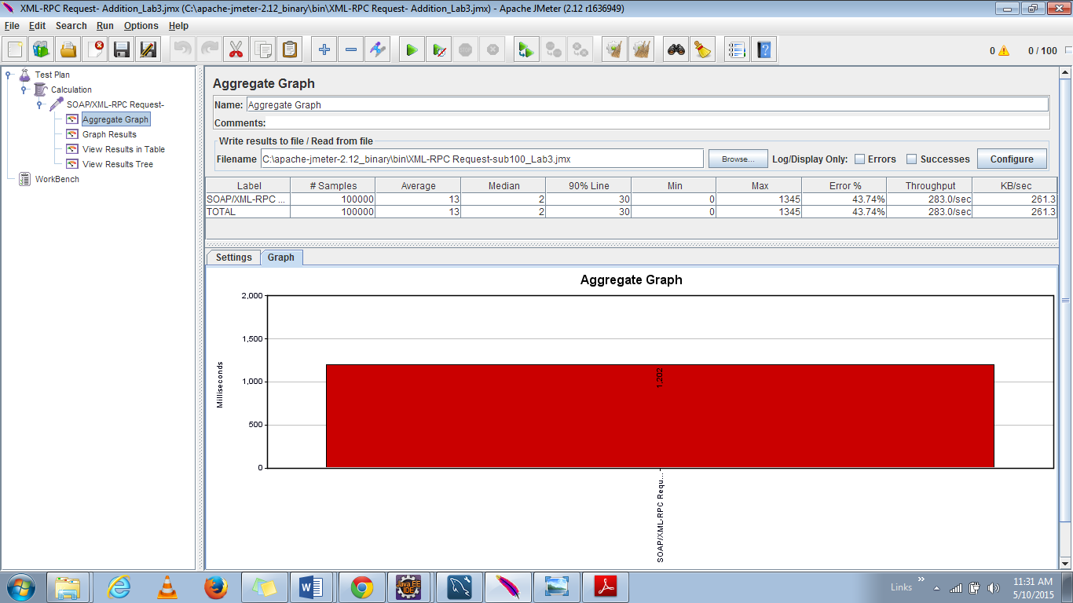

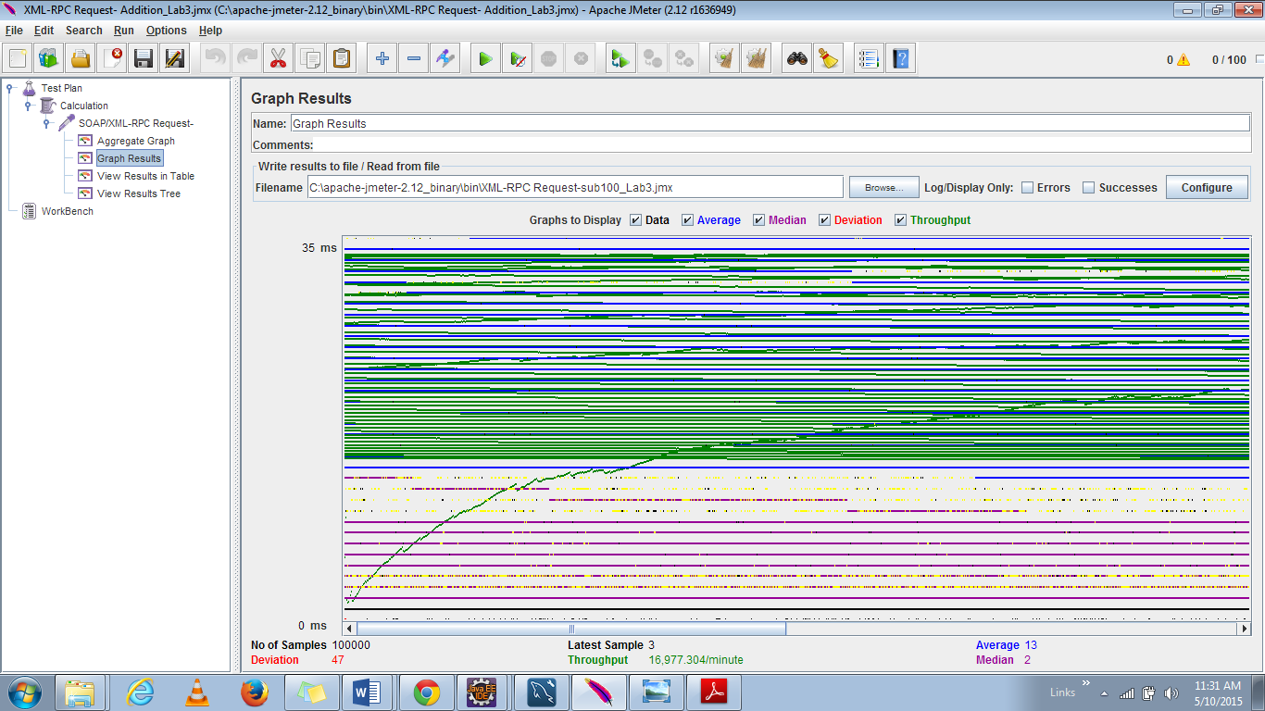

#### **Addition:**

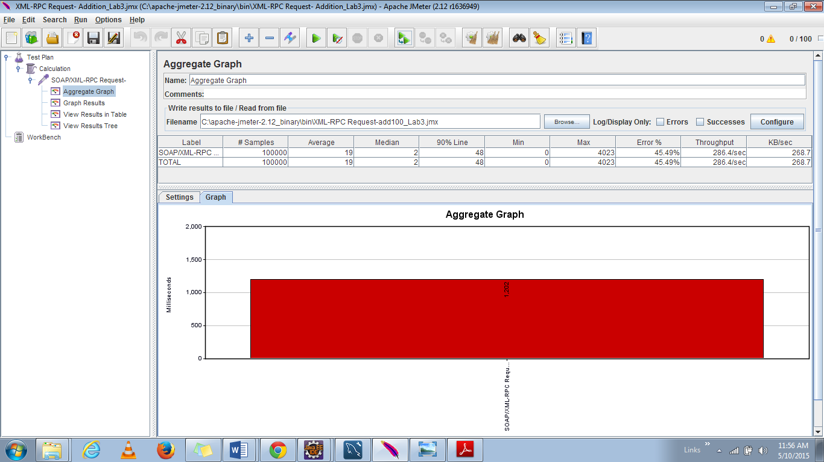

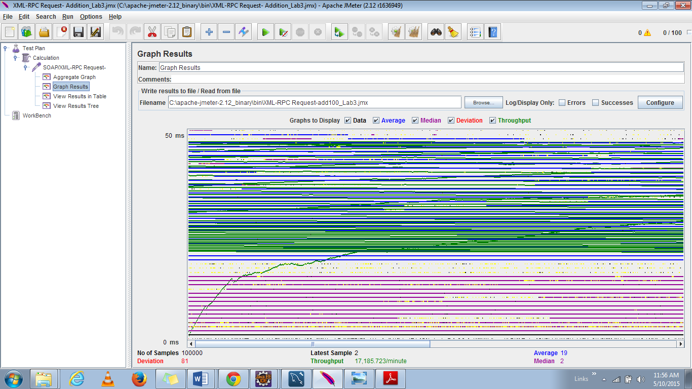

|  |  |  |  |  |
| --- | --- | --- | --- | --- |
| **Calculation** | **Average(ms)** | **Median** | **Throughput (per minute)** | **Deviation** |
| Addition | 4957 | 8306 | 18016 | 2000 |
| Subtraction | 4471 | 4560 | 30054.5 | 1795 |
| Multiplication | 3915 | 3374 | 33426.18 | 1491 |
| Division | 4495 | 4567 | 30459.91 | 1639 |

**Discussions:**

The performance of the calculator has a wide range of deviation initially and later it seems to be consistent. The blue color line shows the average time for performing the calculation.

## **Comparison with Restful Services:**

The graph shown below depicts the aggregate graph of Restful Services server for 5000 users.

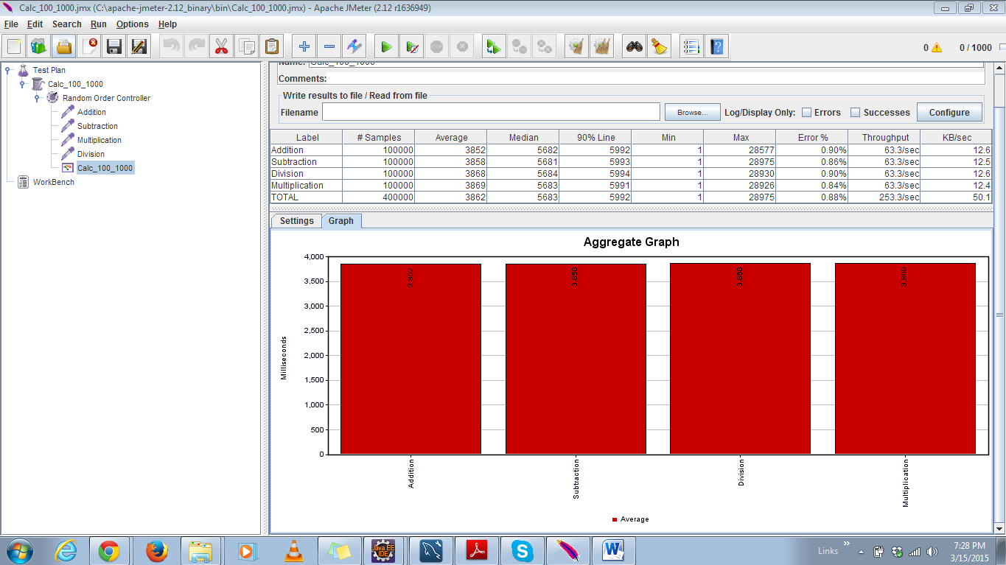

* It is clearly shown from the graph that the average time taken by Restful services is very low (half of) compared to the time taken by Web Services.
* As nodejs is a lightweight scalable server rapid prototyping is done and thus the through put is also high.
* But when we need machine to machine interoperable interaction over a network we need Web Services.
* As node js is asynchronous non-blocking execution whereas web services is blocking; there is a wait time and the average time for web services is high.
* Moreover Java web service has an overhead of SOAP; whereas Restful services do not have that overhead.

# **LinkedIn Client/Server**

The LinkedIn Server is the 2nd Server, which is created using web services and below are the functionalities performed by LinkedIn application similar to the real time LinkedIn application:

* A new user to Sign Up
* Existing User to Sign In
* Current user to Sign Out
* Edit the profile page using the attributes: summary, education, experience, skills.
* Display the profile page with the attributes: summary, education, experience, skills.
* Search for existing members using certain attributes like username or email Id.
* Send Invitation to other existing users using username or email Id of the users.
* Accept Or Reject Invitations from other users.
* Show the list of Connections in a user’s profile.

## **Purpose of Web Service based LinkedIn Server**

A web service based LinkedIn server is used as it can manage the code and can be remotely invoked using HTTP that is HTTP requests are activated using it. It is also used to expose the functionality of existing code over the network. Other applications can use this functionality of the program as it is exposed to a network.

## **System Design**

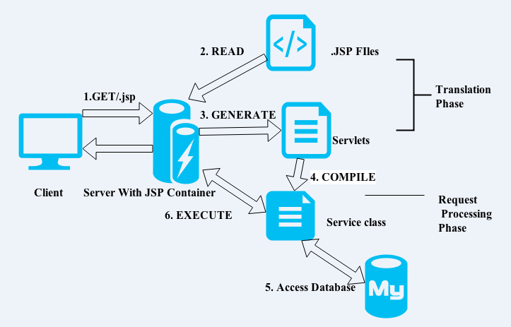

**Figure: System Design Architecture**

Below are the details on how web server creates the web pages using:

* Browser sends a HTTP request to the web server.
* Web server recognizes that the request is for a JSP page and forwards it to the JSP engine using the URL like
* Servlet content is created when JSP engine is loaded from the JSP page from disk.

The three major roles handled by web services are:

* Service Provider:

It implements the service and makes it available on the internet. It is the provider of web service.

* Service Requestor:

It is the consumer of web service. By opening a network connection, requestor utilizes an existing web service and sends an XML request.

* Service Registry:

It is the directory of services. It is a place where new services and existing ones are provided for developers.

* An executable class file is compiled using JSP engine and then it’s executed.
* HTTP response is forwarded to the browser using HTML content.
* Finally dynamically generated content is handled by the web browser by HTML page inside HTTP response.

Below diagram shows the structure of the Server:

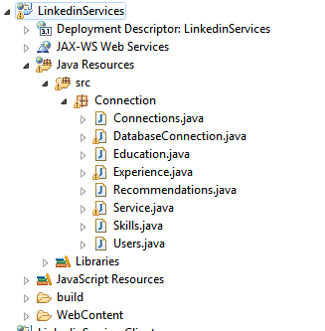

Below is the snapshot of the wsdl file:

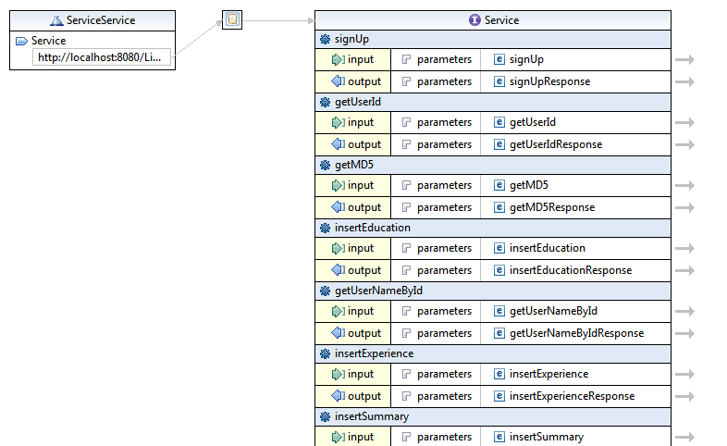

**UI Engine:**

The views for the application are provided here. Have used .jsp along with bootstrap, HTML and CSS to define the view page and corresponding navigation. The following are the view pages:

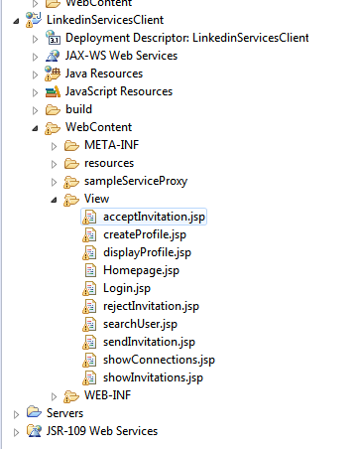

## **Exception Handling:**

Exceptions are handled based on the incoming parameters and their functions.

Below are few of the exceptions handled:

* Invalid Login.
* No null values for sign in and sign up.
* No null values while creating profile.

**Database Schema and Values:**

Model for the application is given by DB Schema and I have used MySQL to define the database tables. Below is the ER Diagram of the schema:

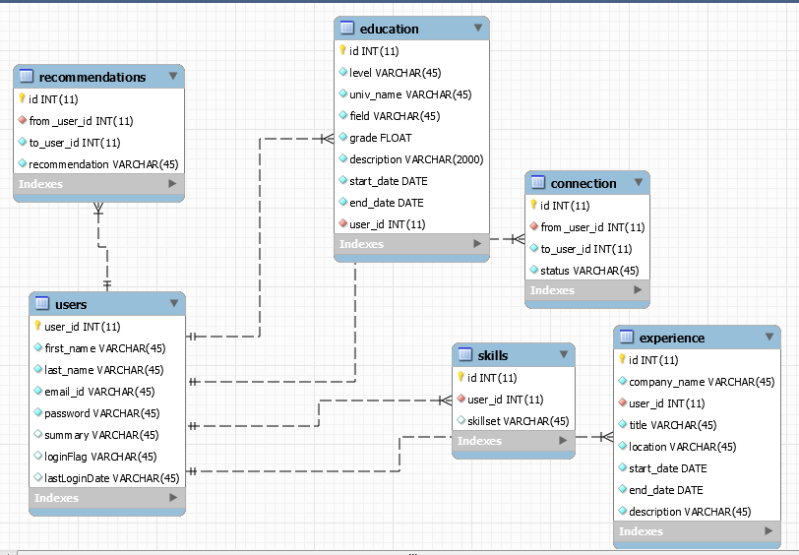

**Database Schema in MySQL**

## **Web Services Result for LinkedIn Server**

**Web service for SignUp**

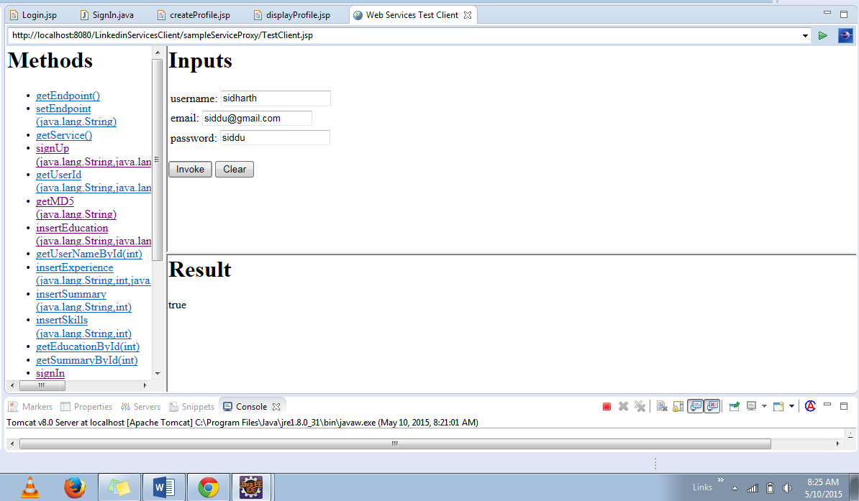

**Web Service for SignIn**

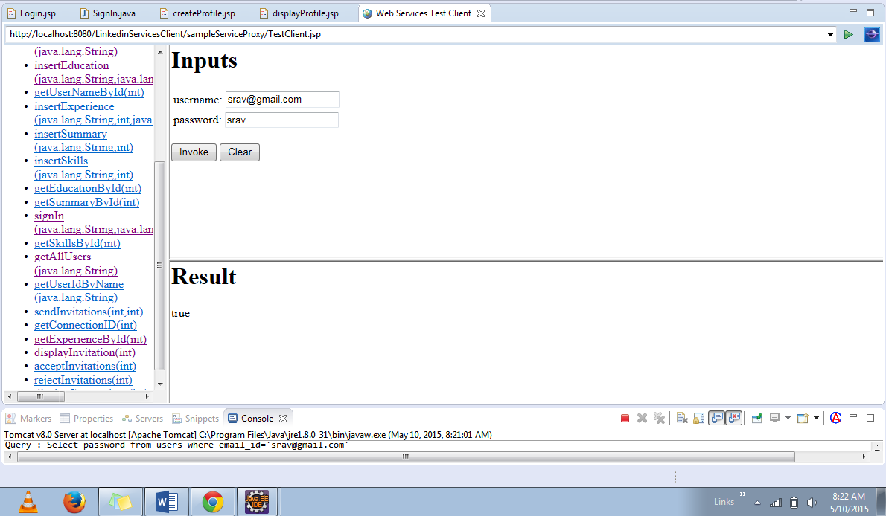

**Web Service for Invalid Login**

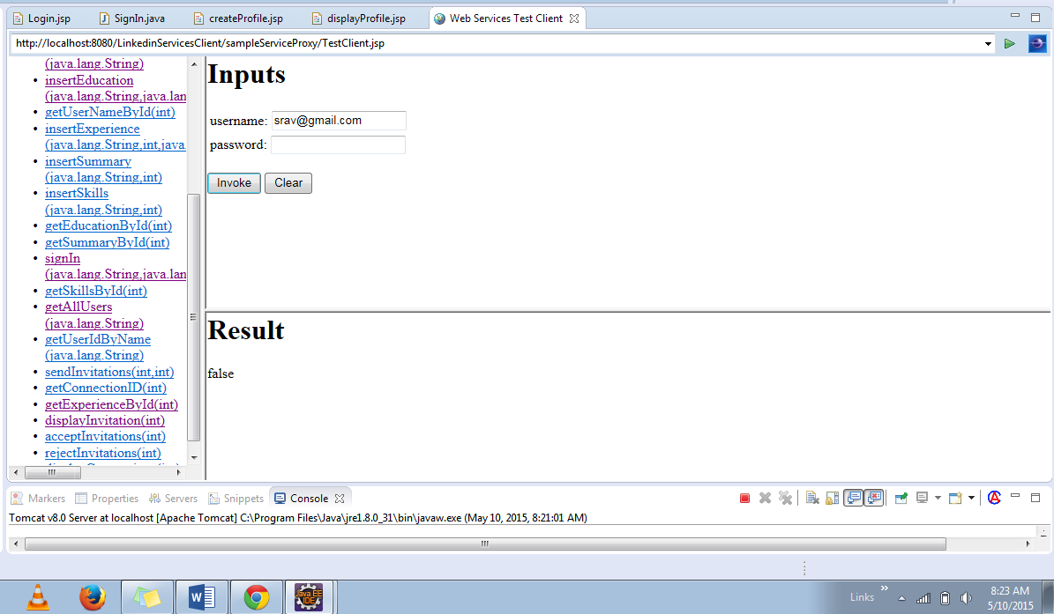

**Web Service to insert Experience:**

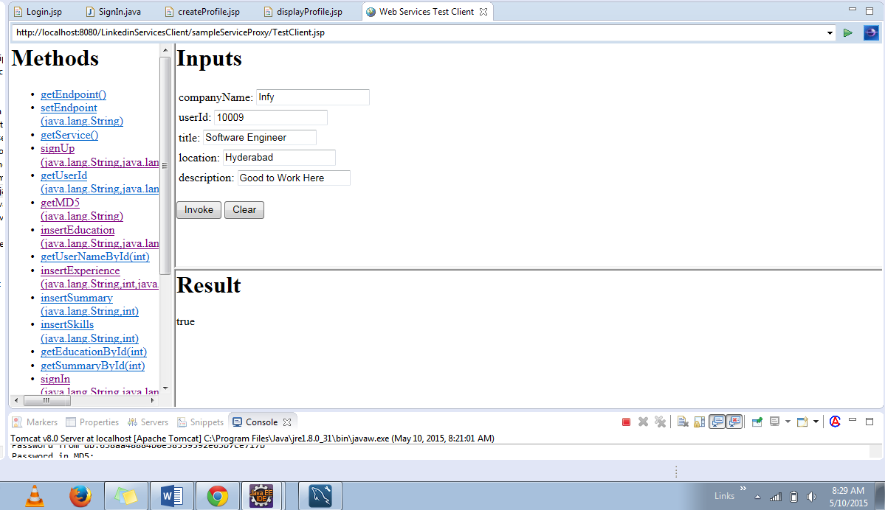

**Web Service to insert Education**

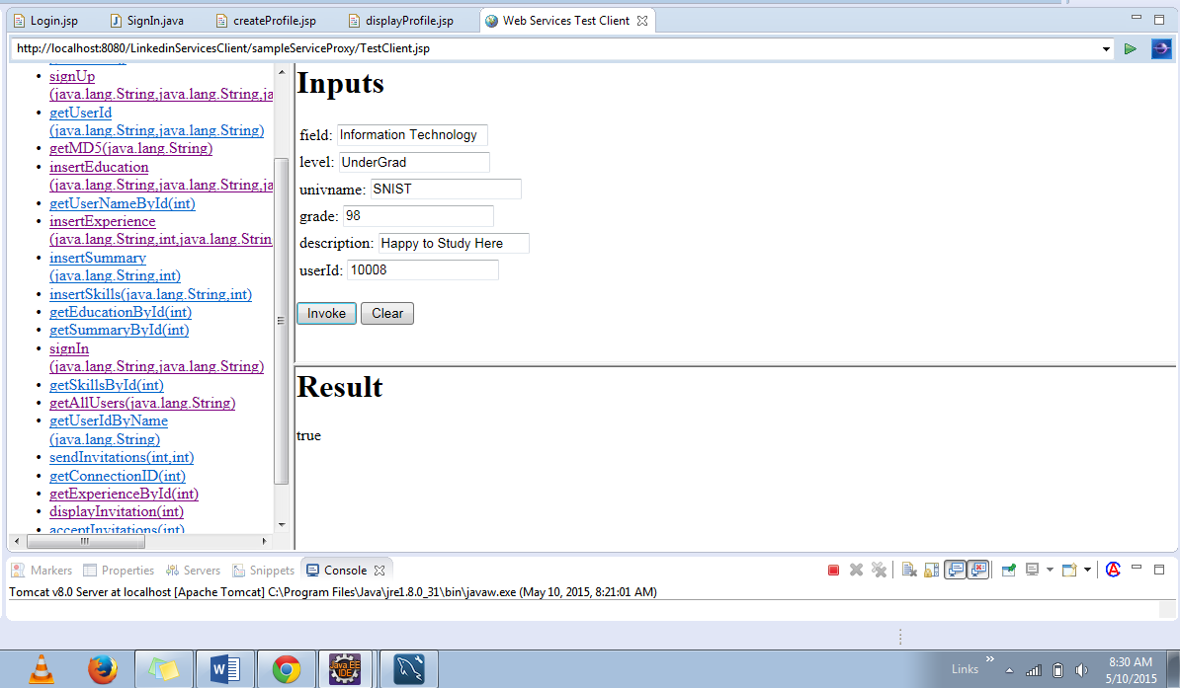

**Web Service to insert Summary:**

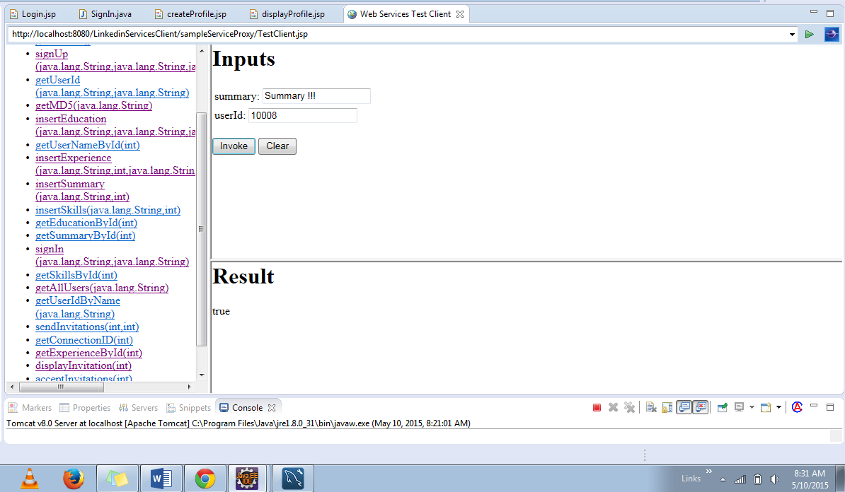

**Web Service to insert Skills:**

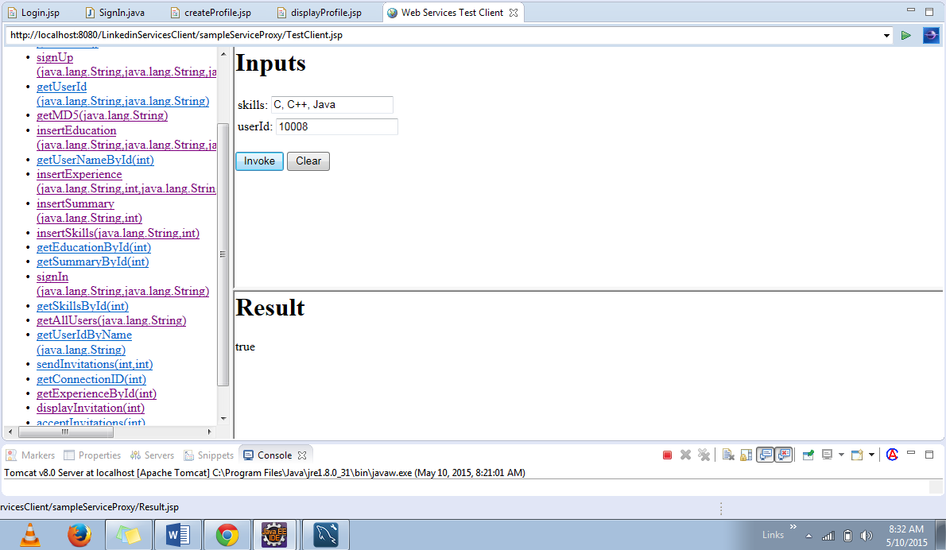

**Web Service to retrieve Education using UserId**

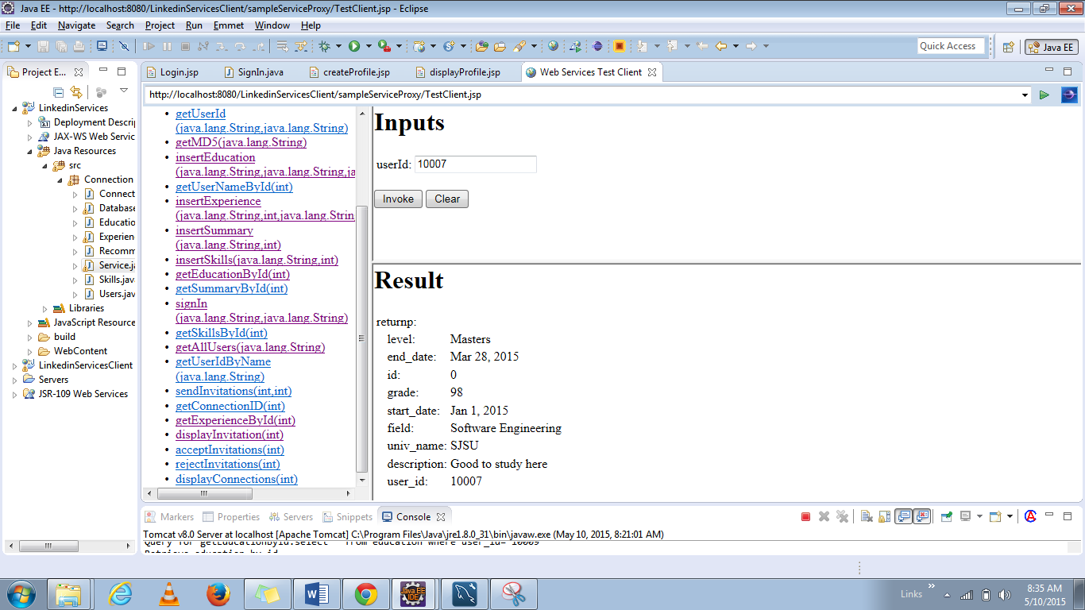

**Web Service to retrieve Experience using UserId**

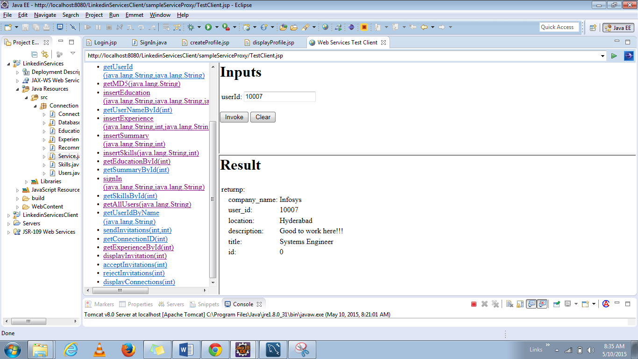

**Web Service to retrieve Summary using UserId:**

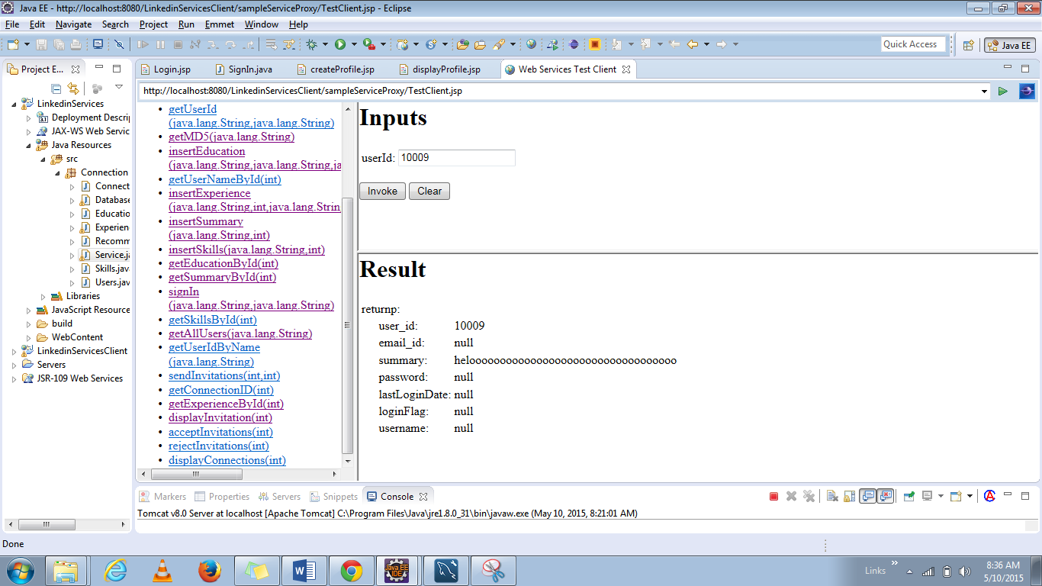

**Web Service to retrieve Skills using UserId**

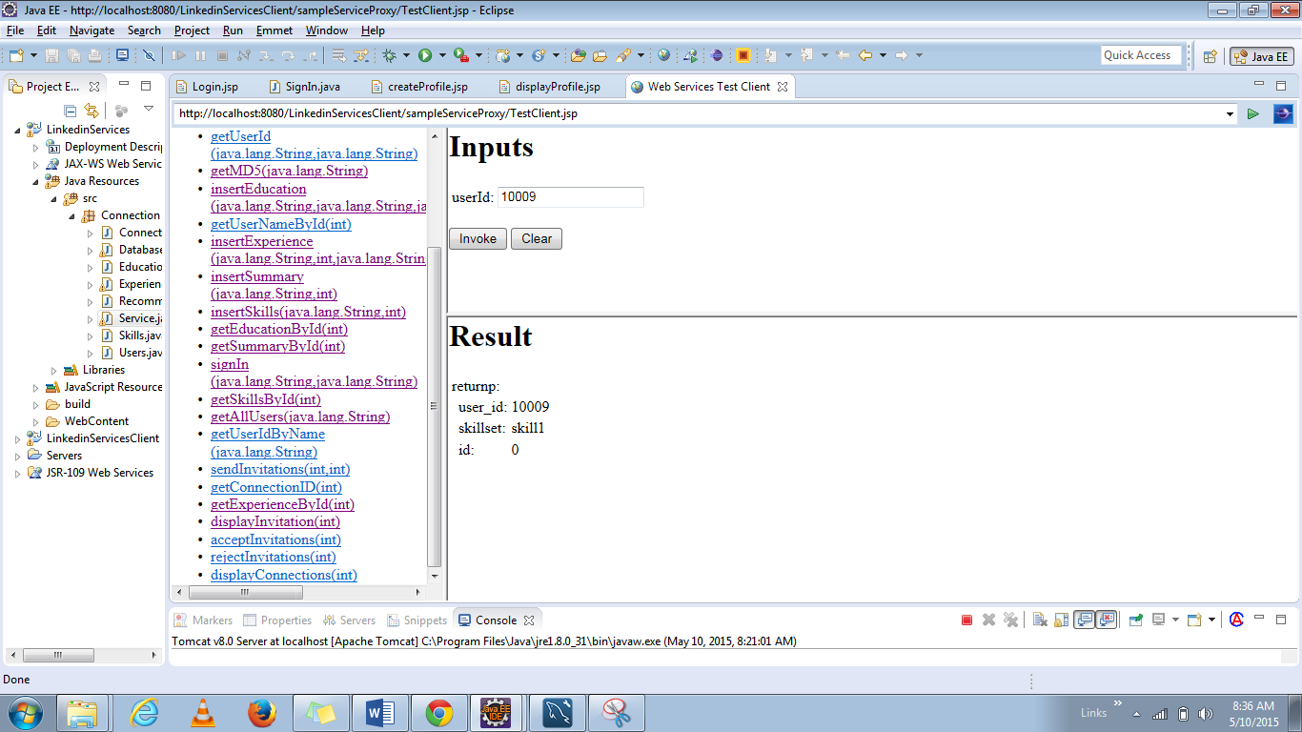

**Web Service to search members using the given text:**

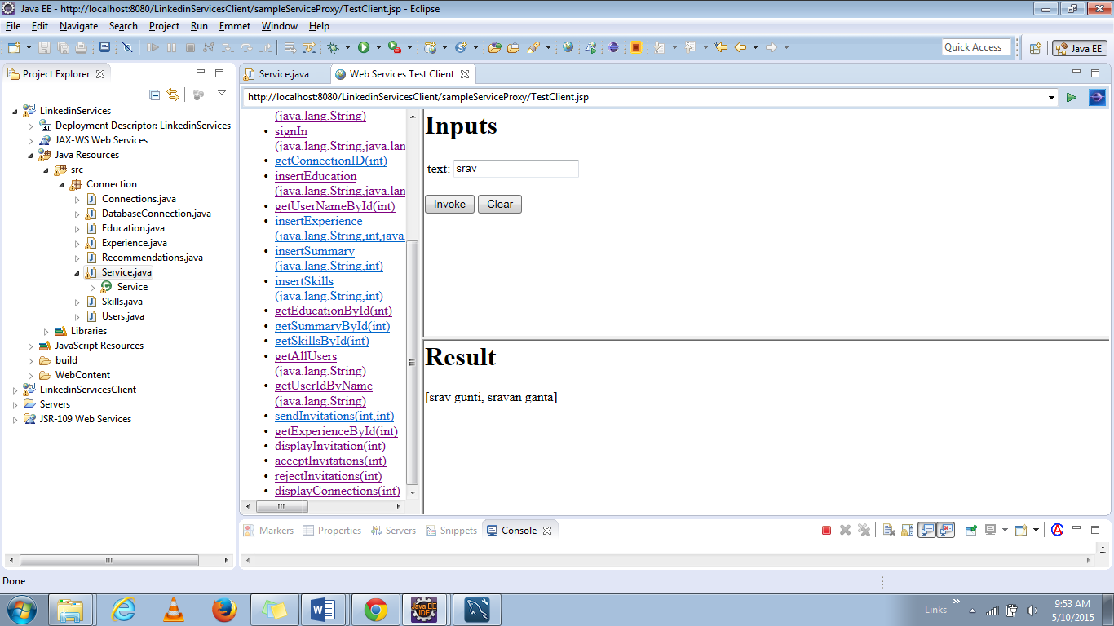

**Web Service to Send an Invitation:**

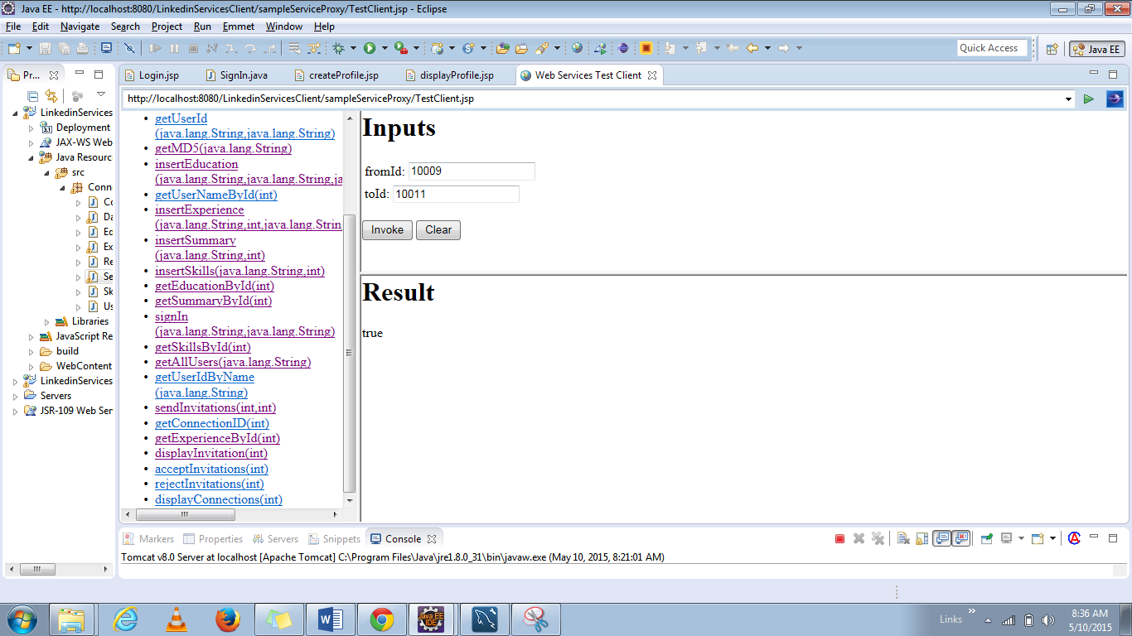

**Web Service to Accept Invitation**

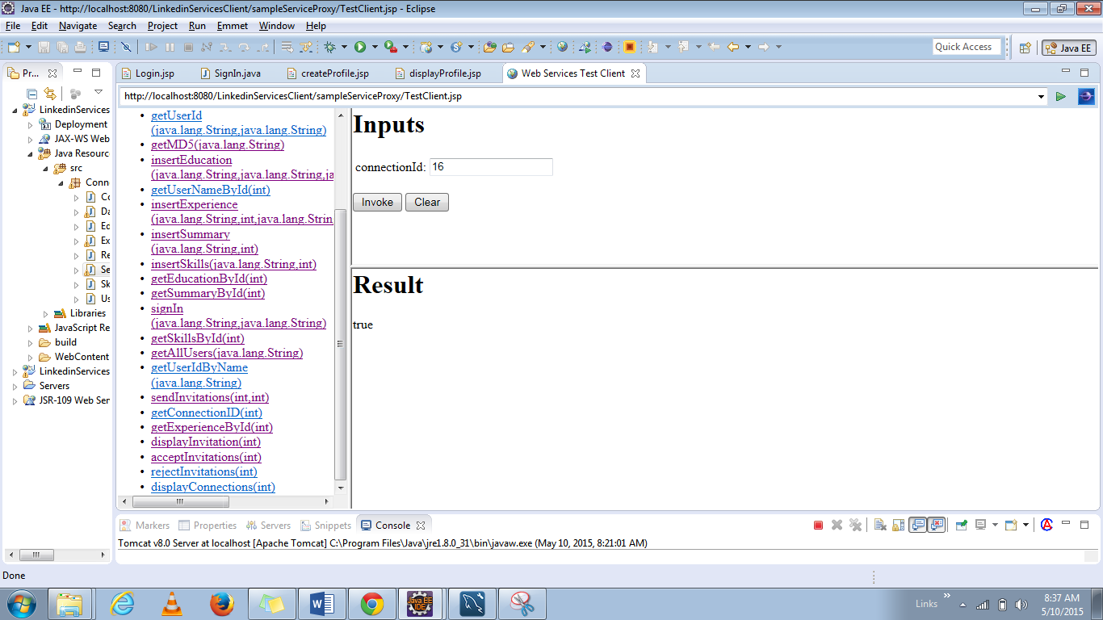

**Web Service to Send duplicate invitations**

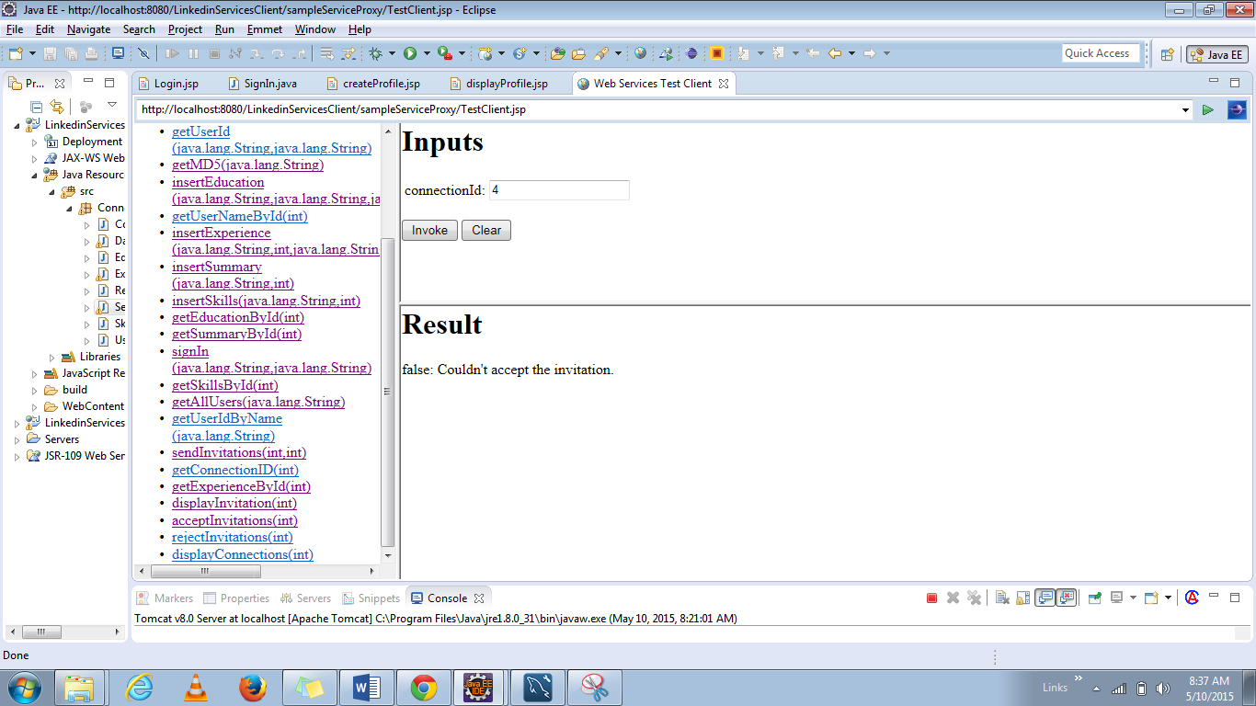

**Web Service to show Connections of a User**

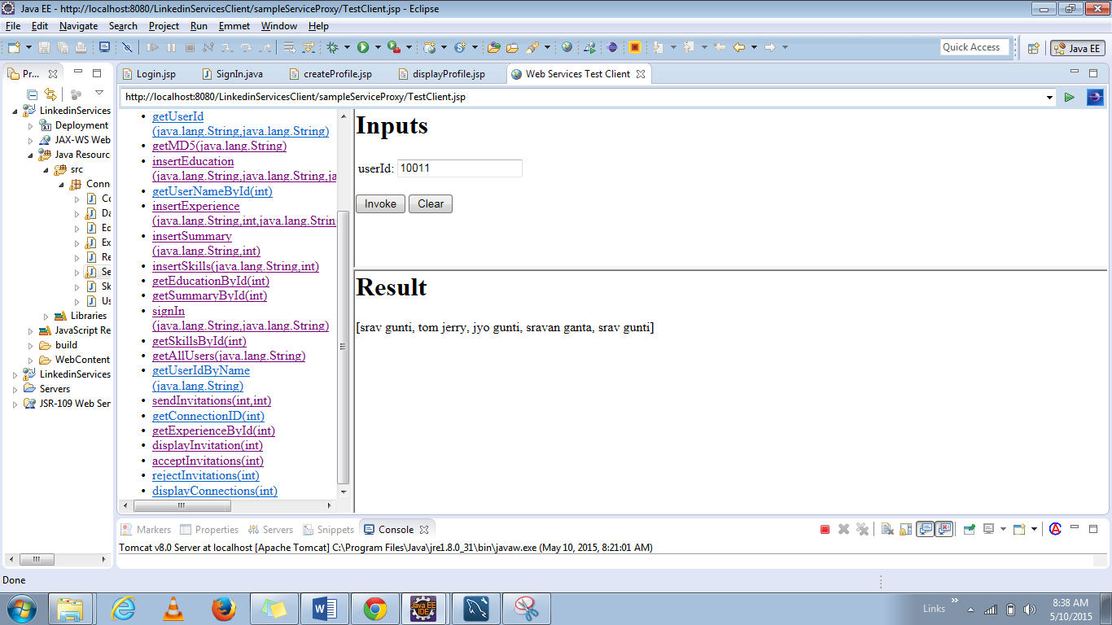

**Web Service to Reject Invitation** 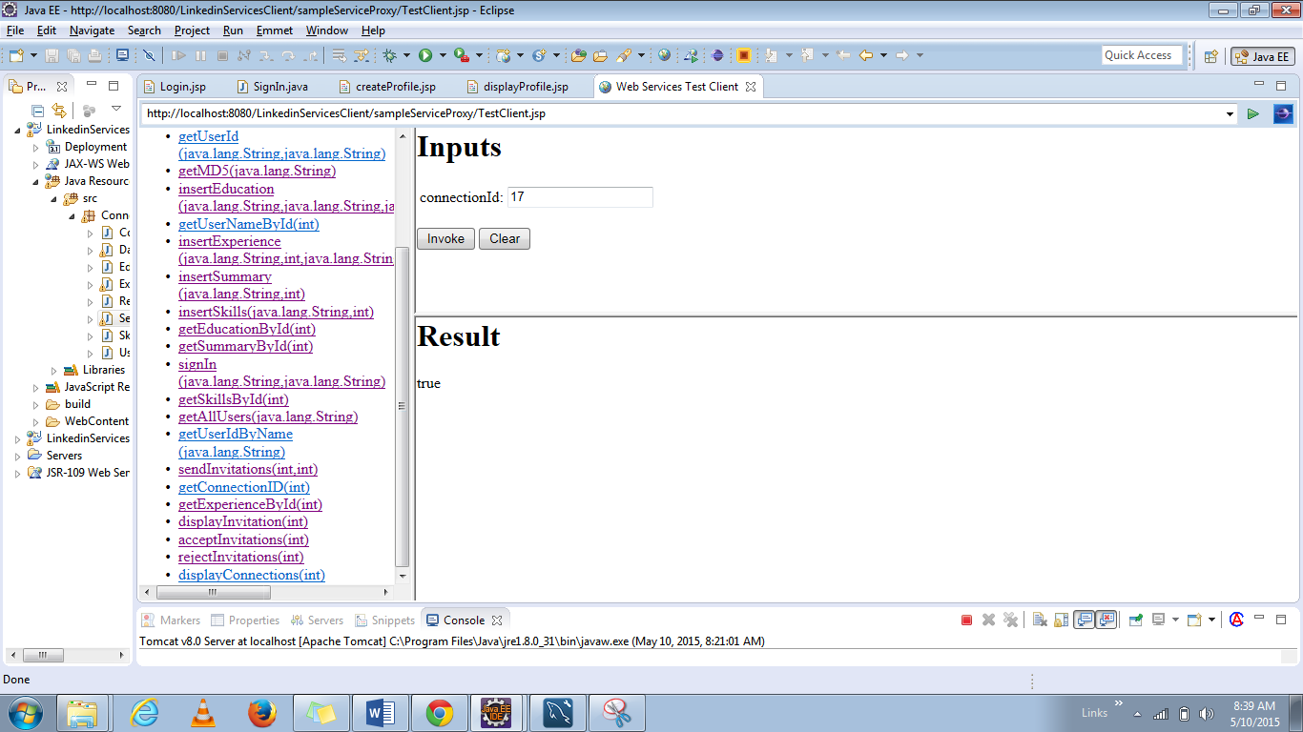

**Web Service to Display Connections**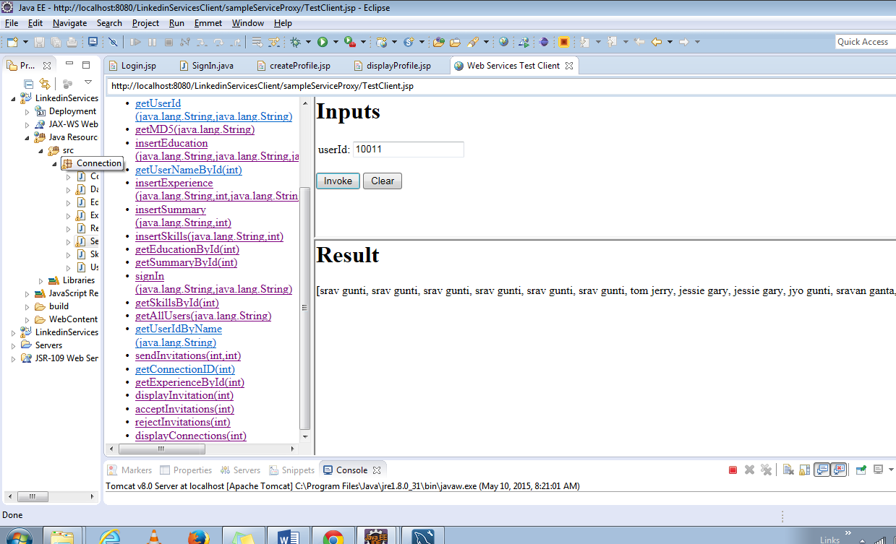

## **Screen Shots for LinkedIn Application:**

**Login/ Signup Page :**

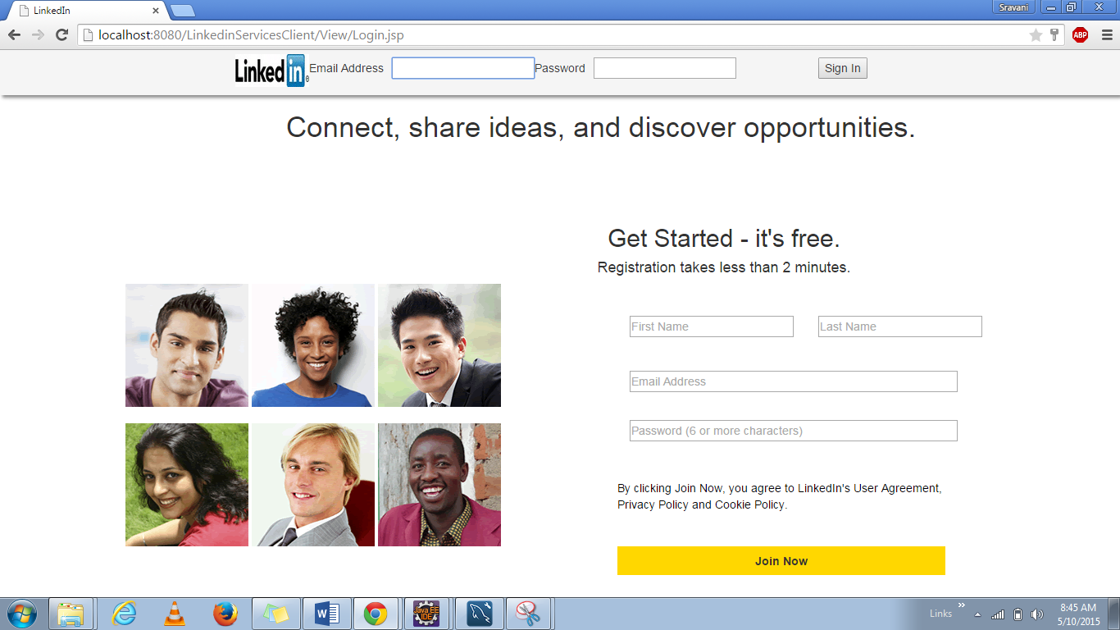

**Error validation when trying to login without giving details**

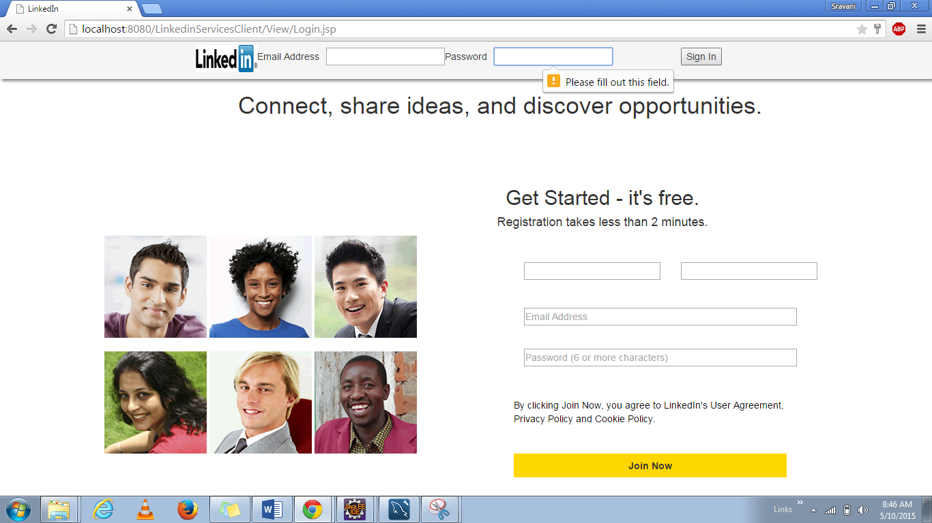

**Error Validation When trying to signup without giving details like first name, last name, email address or password.**

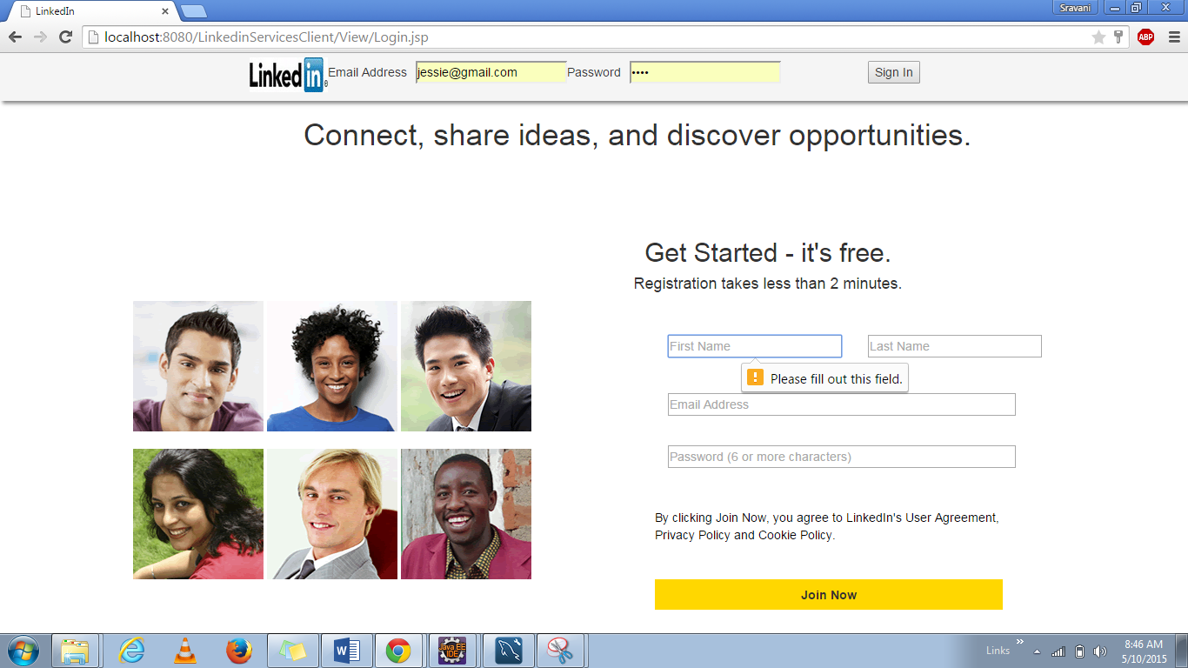

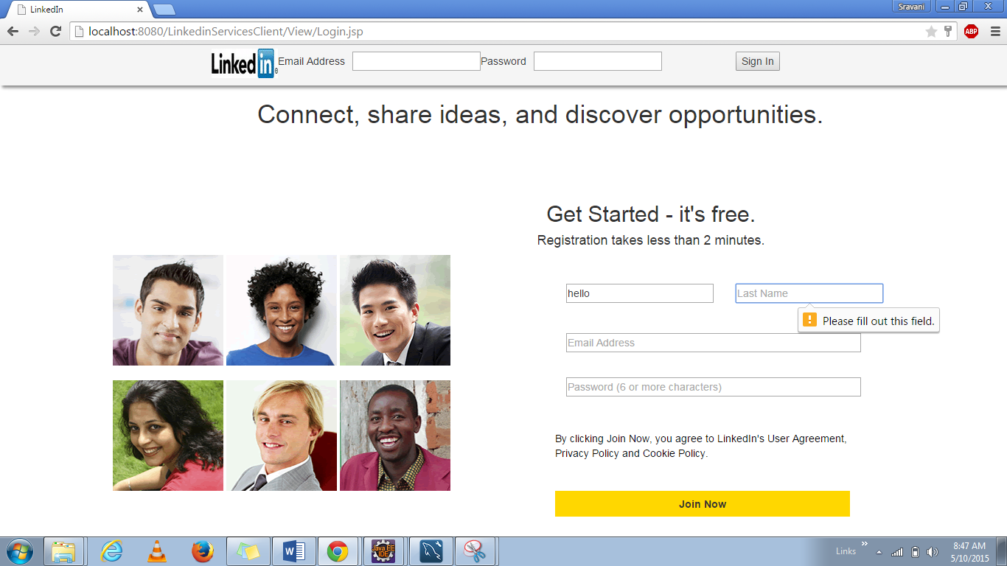

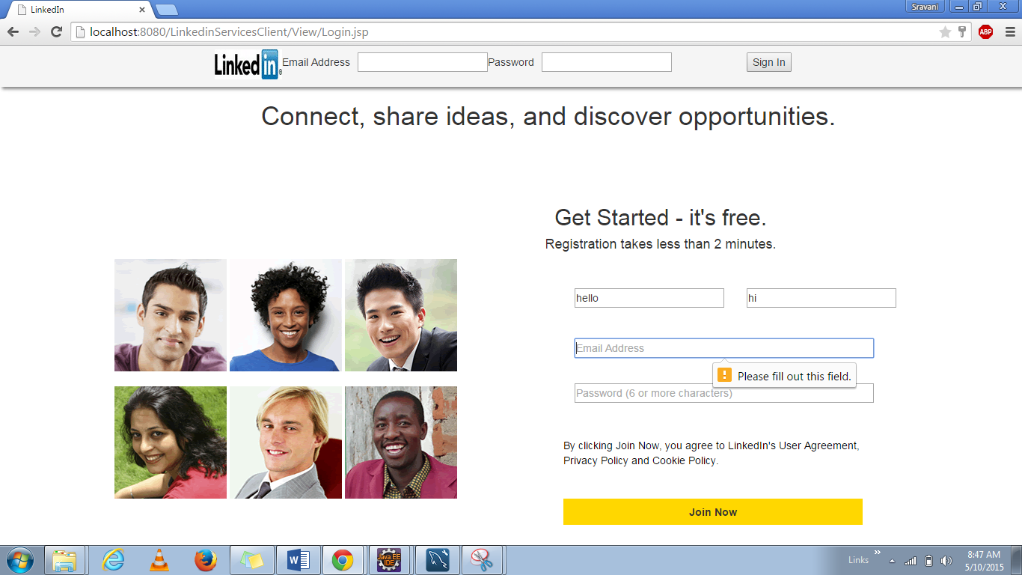

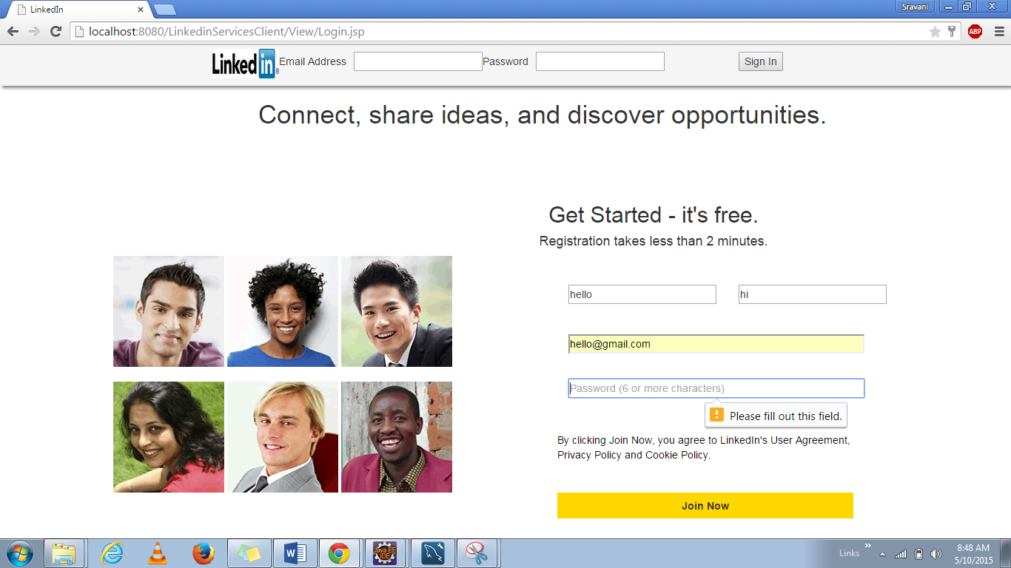

**When Signing in with correct input a session will be created and profile page will be loaded**

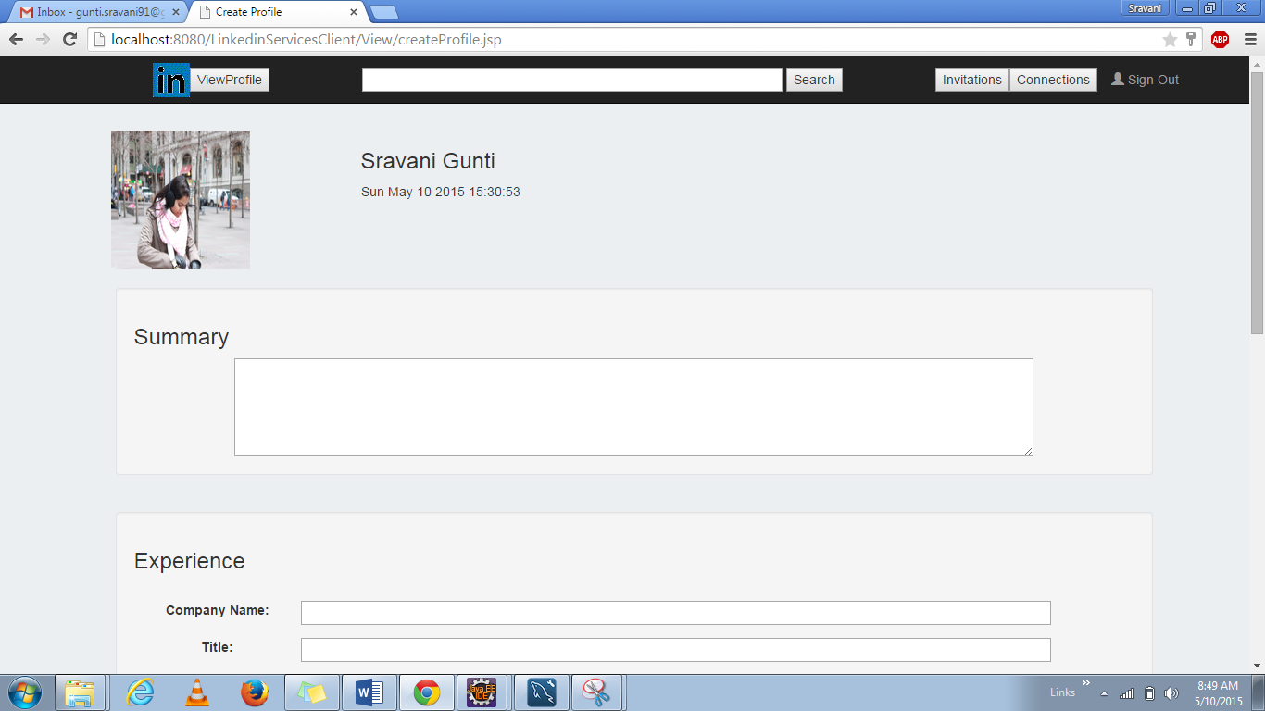

**As we scroll down, we can check all the sections like Summary, Experience, Education, Skills and last login information. The sections are empty as the using has signed up for the first time.**

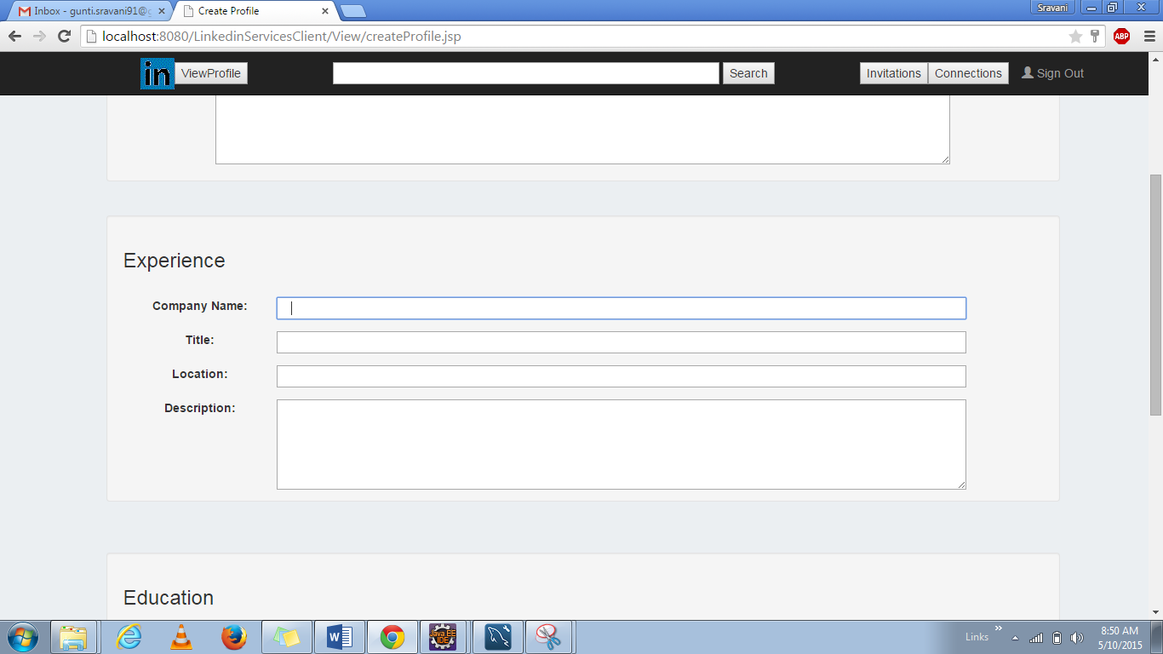

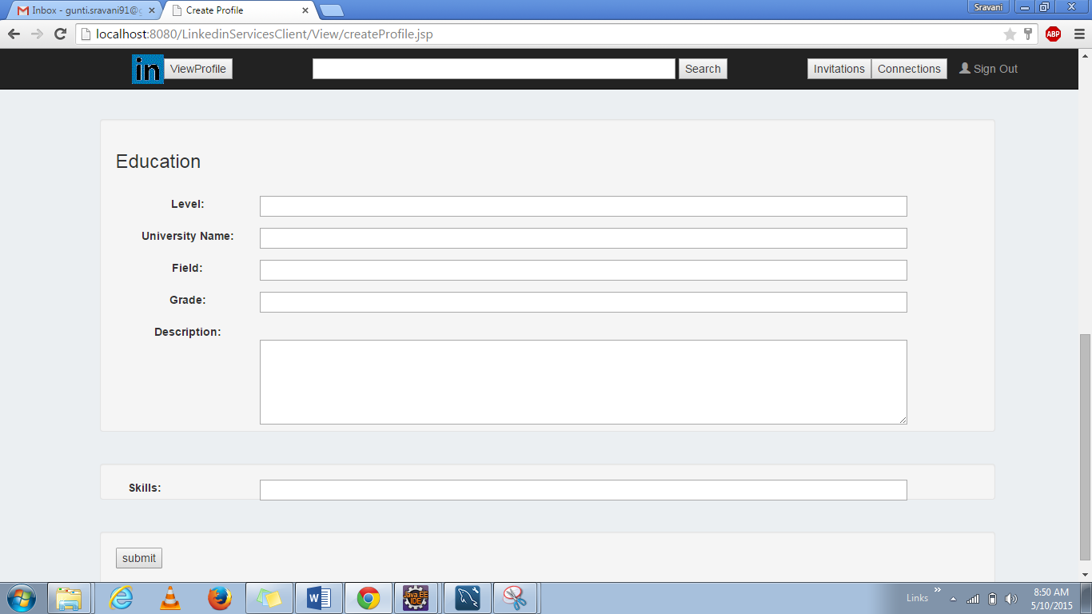

**Validations have been put, mentioning that all the fields are mandatory to be filled by the user when he logs in for the first time.**

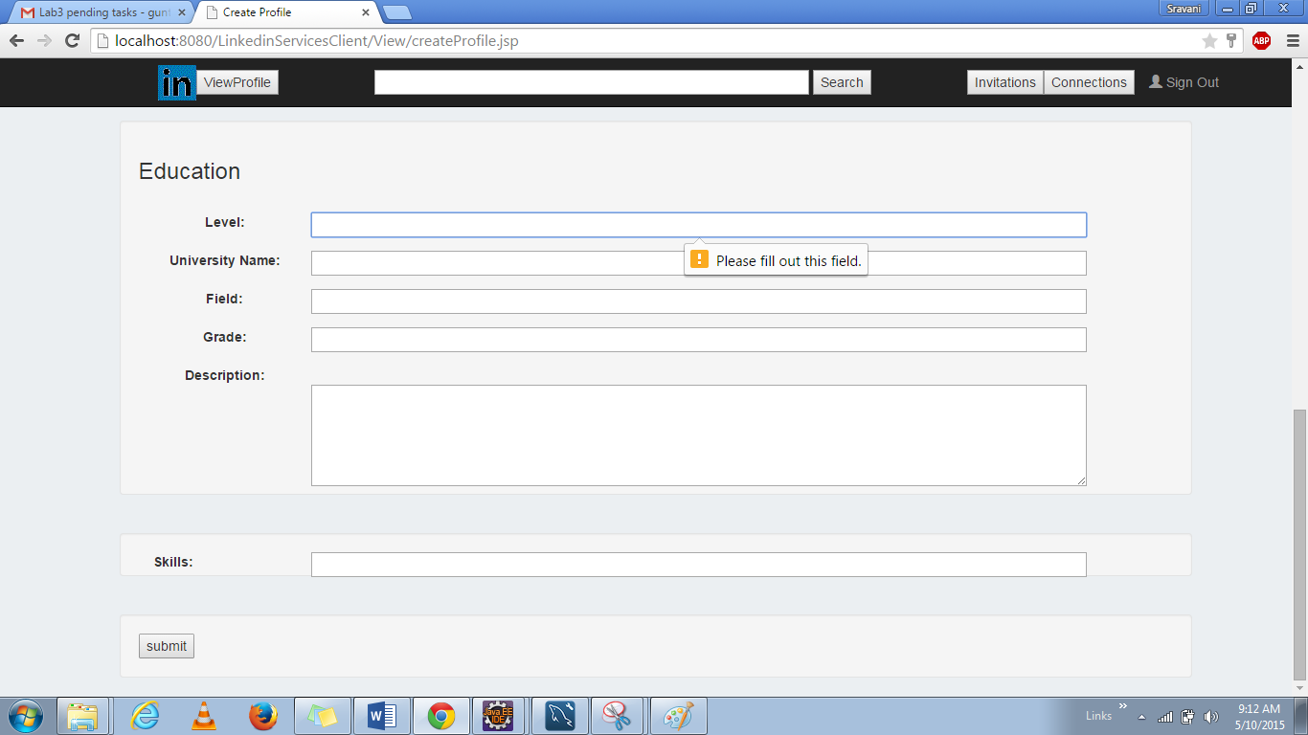

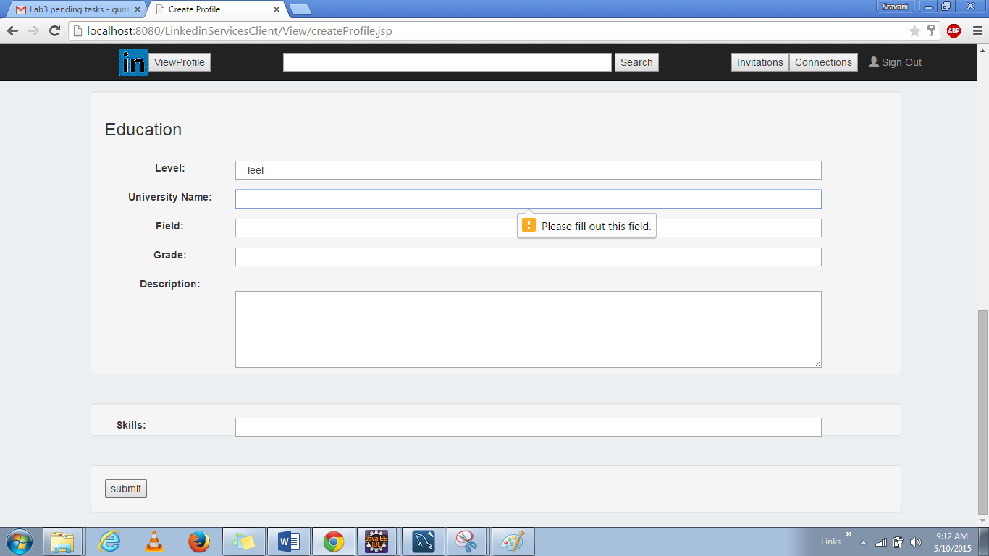

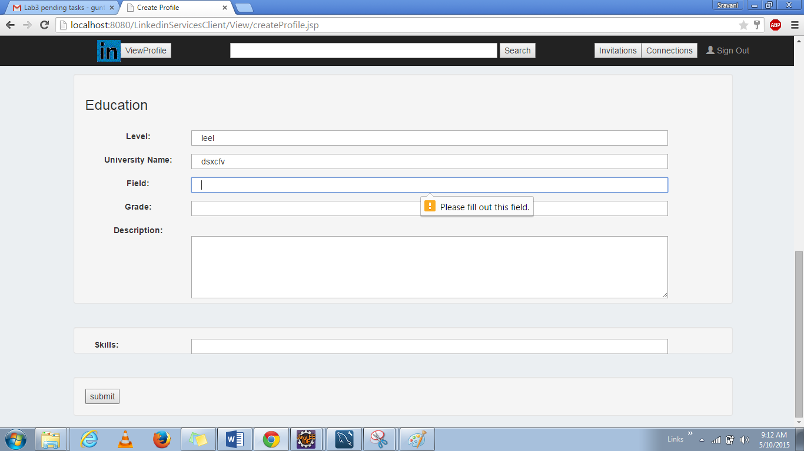

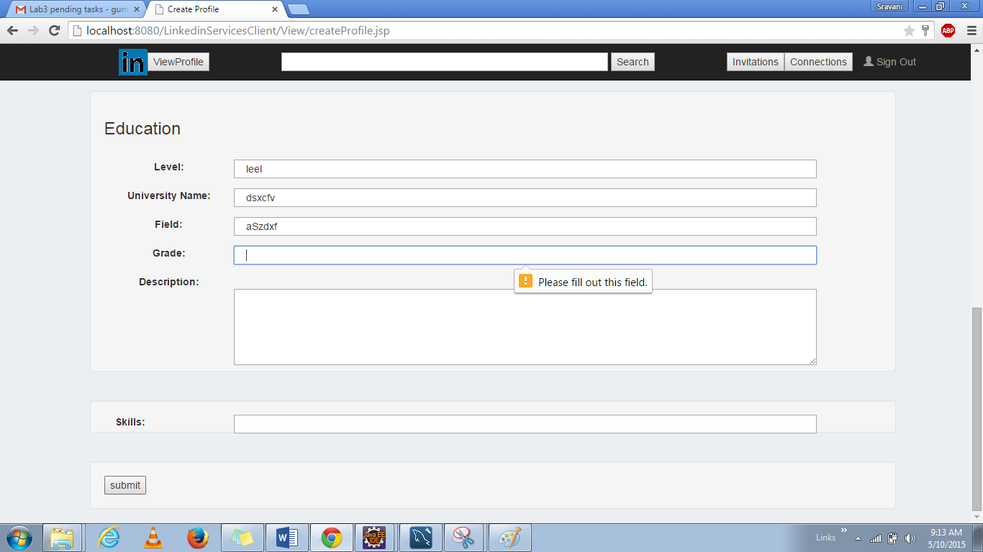

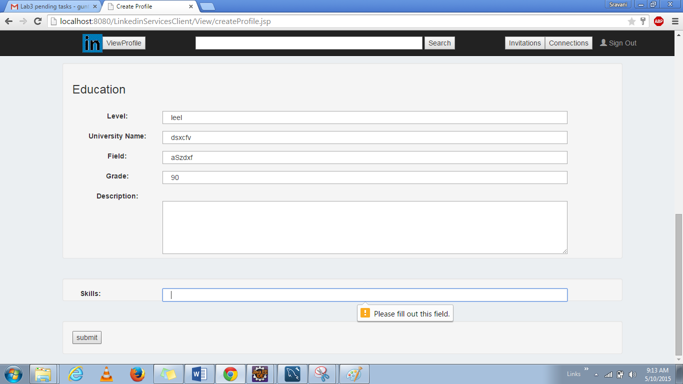

**All the field are entered by the user**

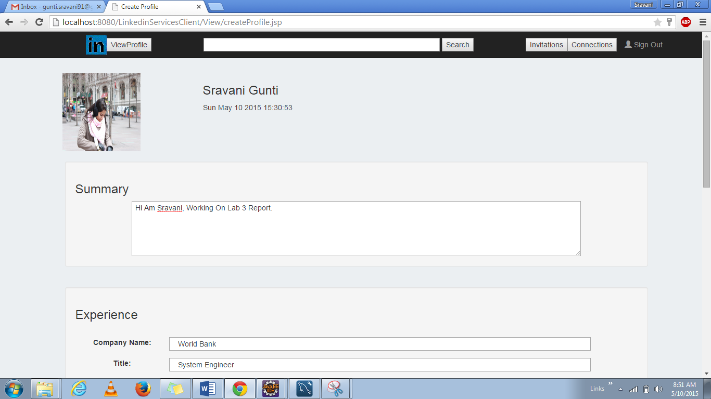

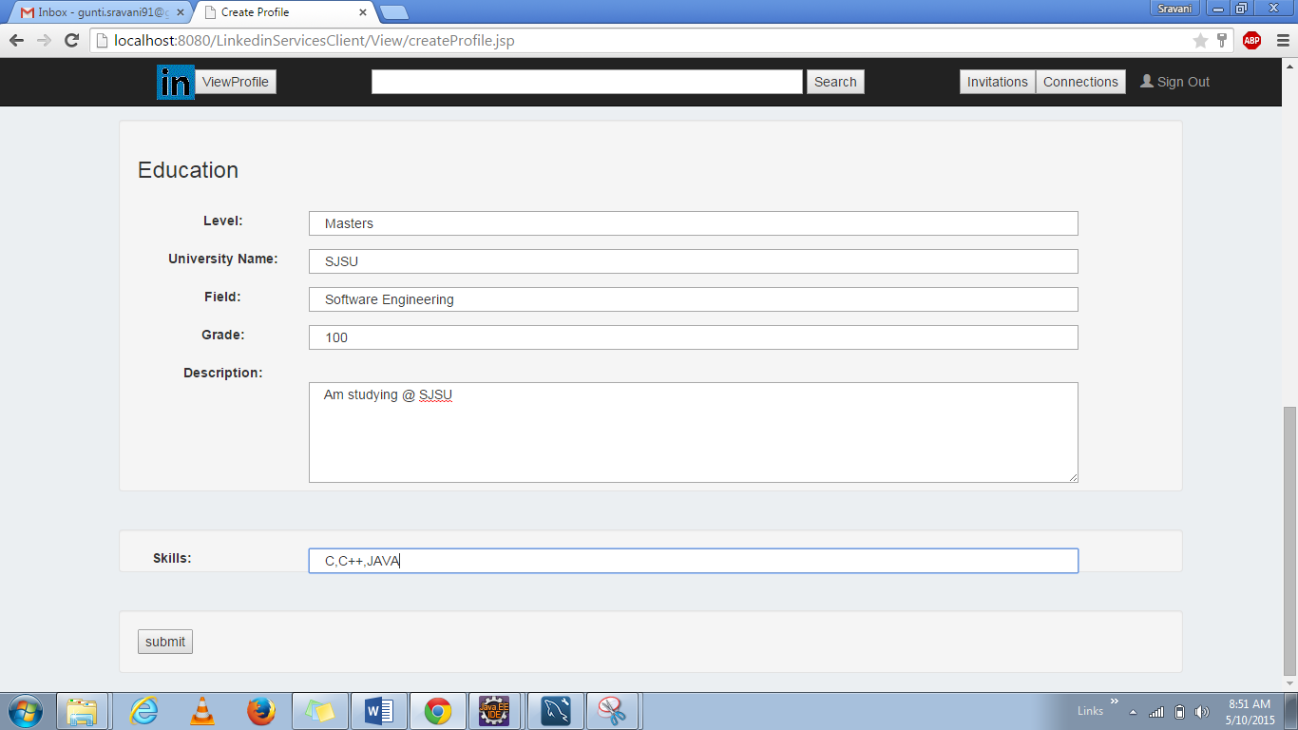

**When all the field are entered and submit button is clicked then the display profile page is shown as below**

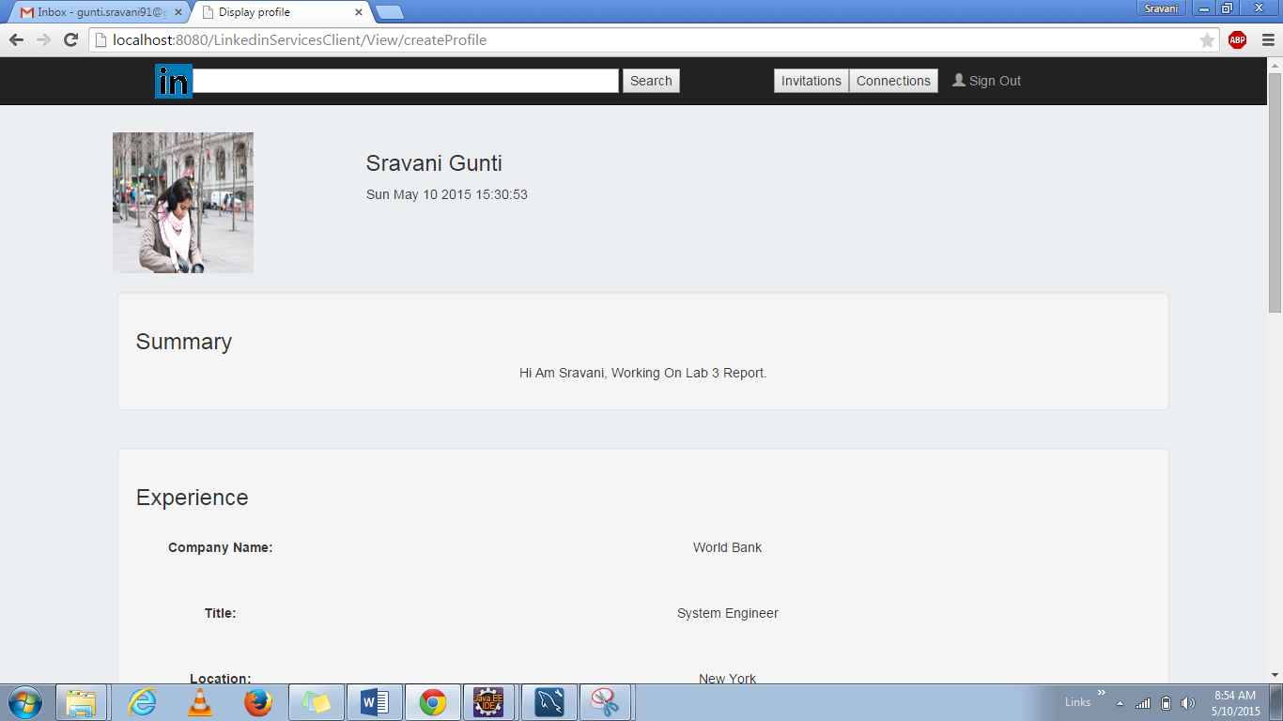

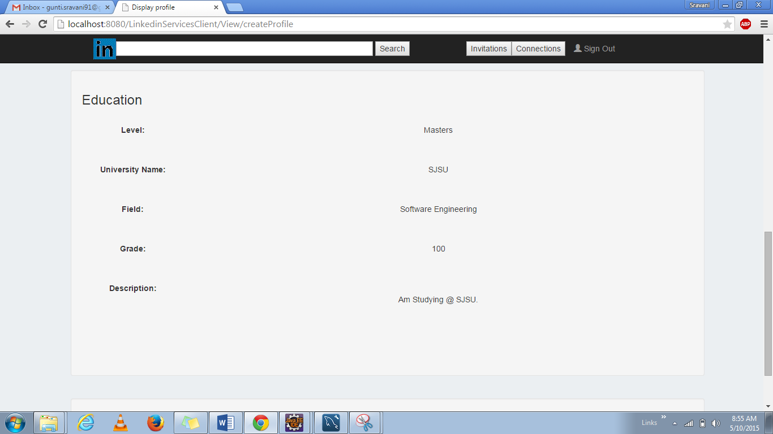

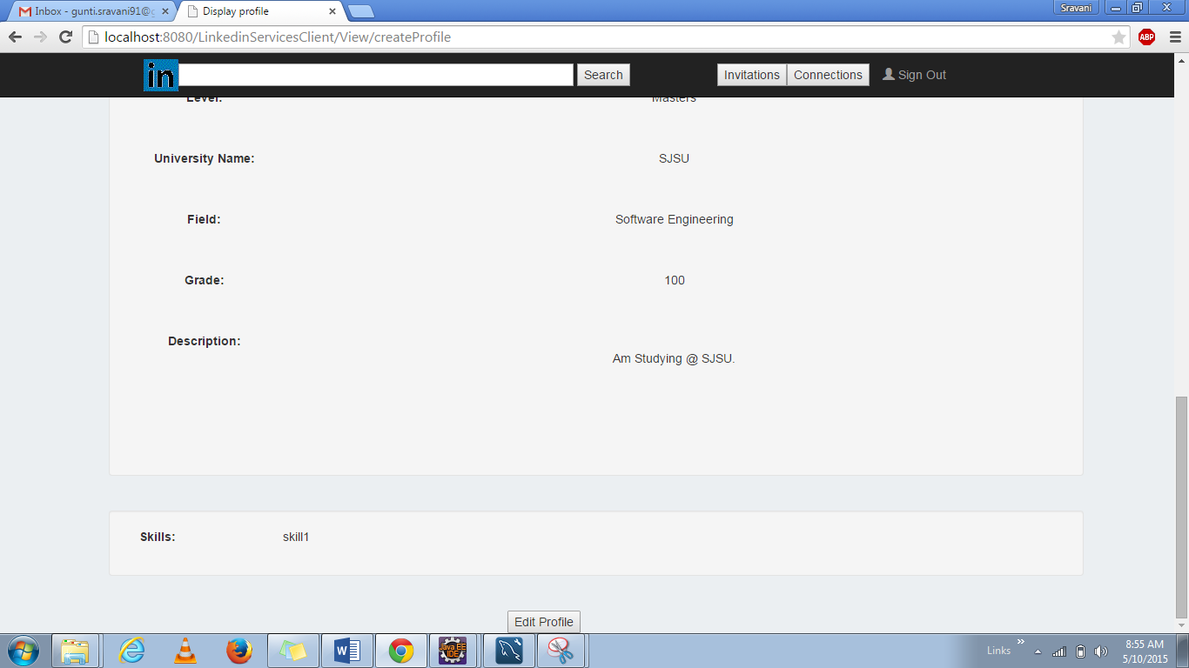

**After the page is displayed the user can again edit the profile using the ”Edit Profile” button.**

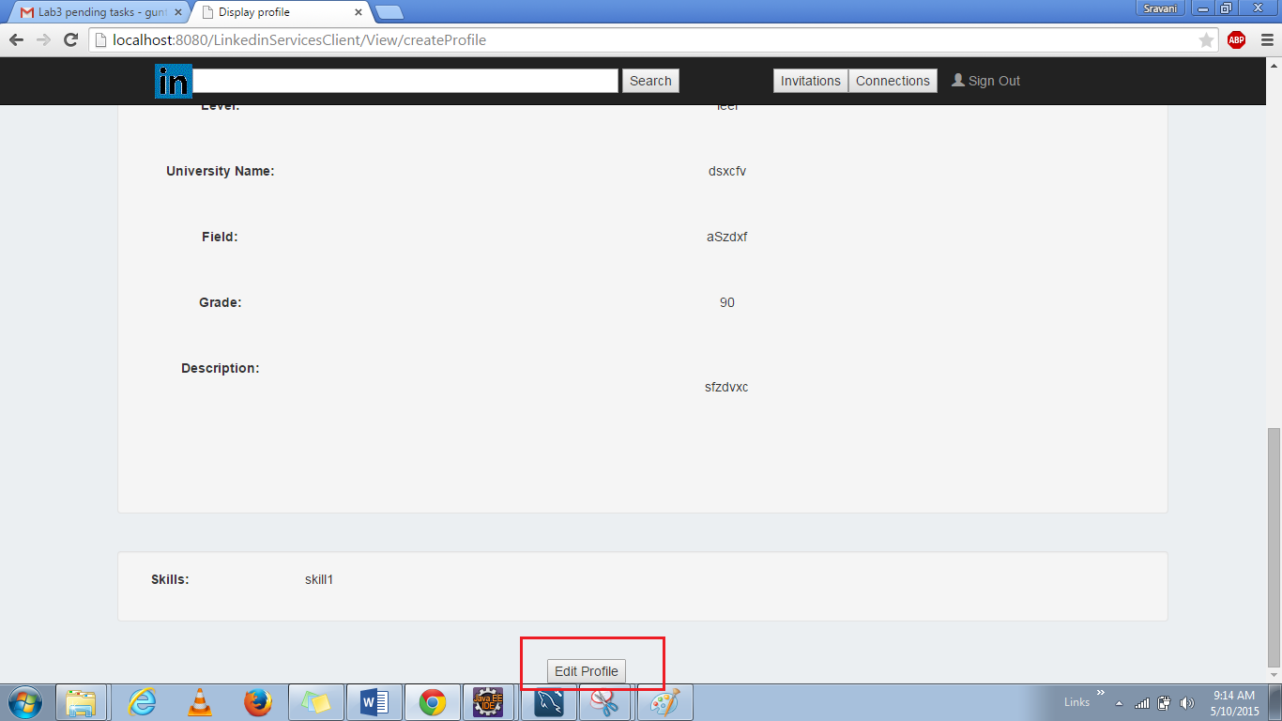

**When “Edit Profile” button is clicked, then the user is navigated back to update the profile page.**



**“Last Login Time” is displayed when the user signs in repeatedly.**

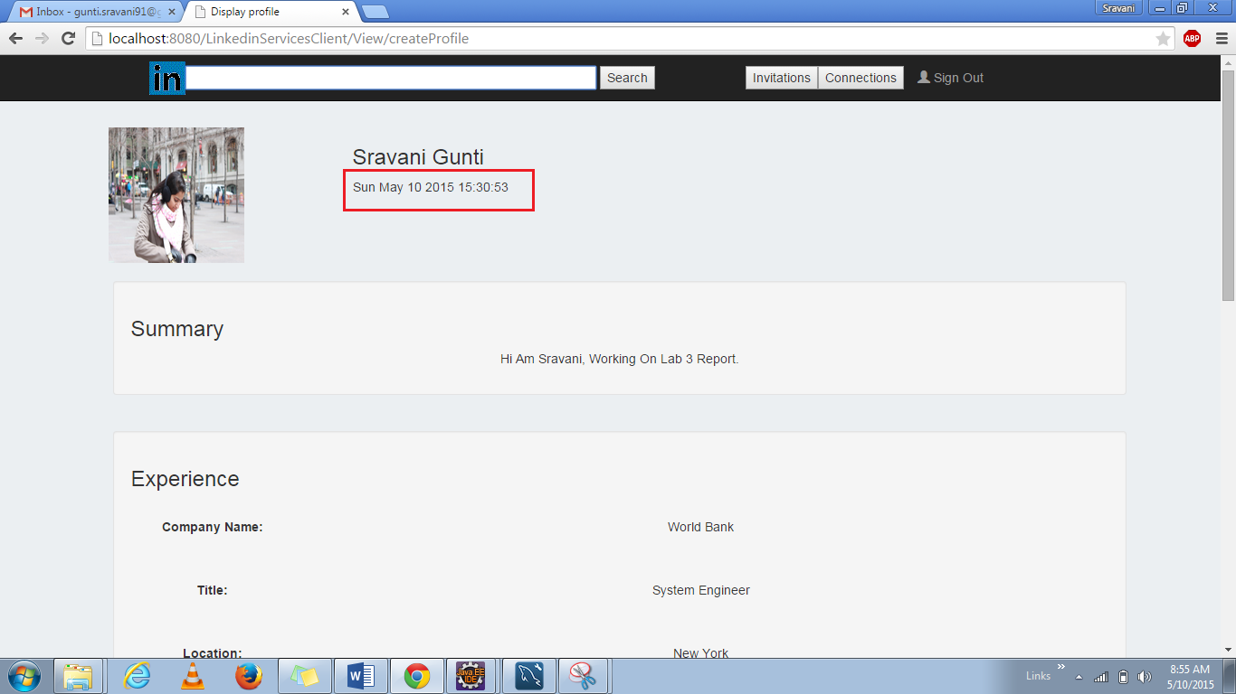

**On giving the text and Clicking on the “Search” button; validation is done for the text again the username and email. And then the list of users will be displayed. ”Send Invitation” button allows the user to invite the people. Here the invitation is sent to “Sravan Ganta”.**

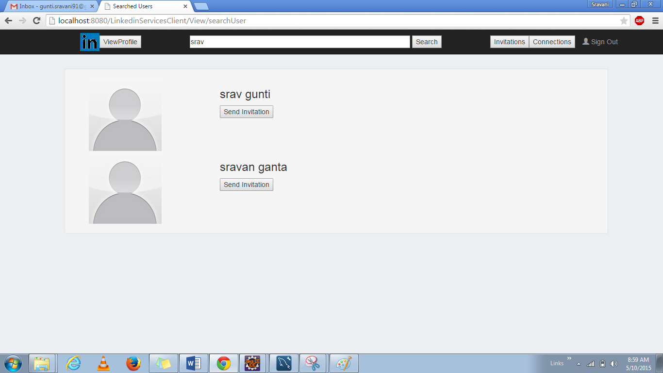

**When Invitation is sent then a success message will be displayed on the screen.**

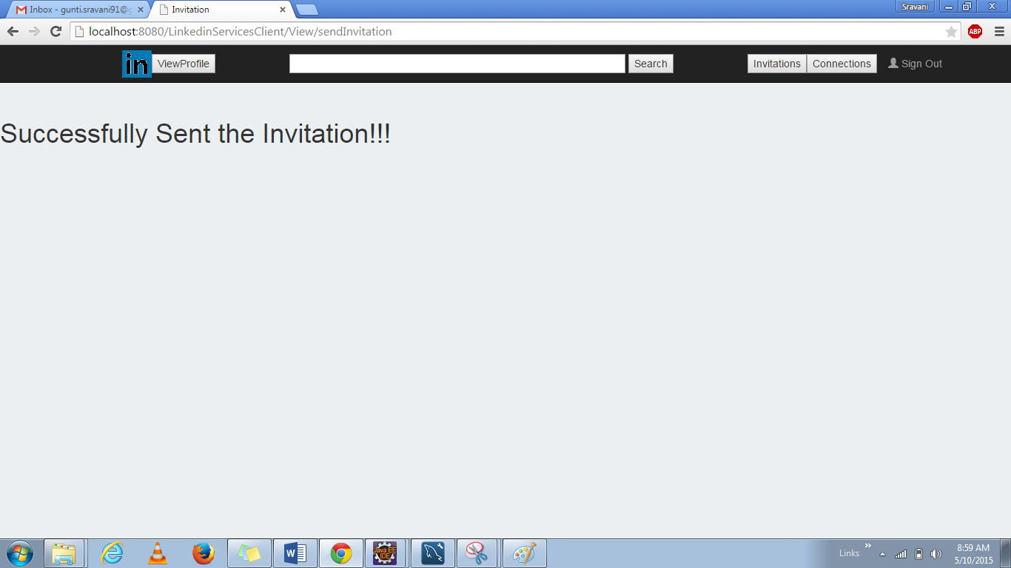

**Now logging into Sravan Ganta profile**

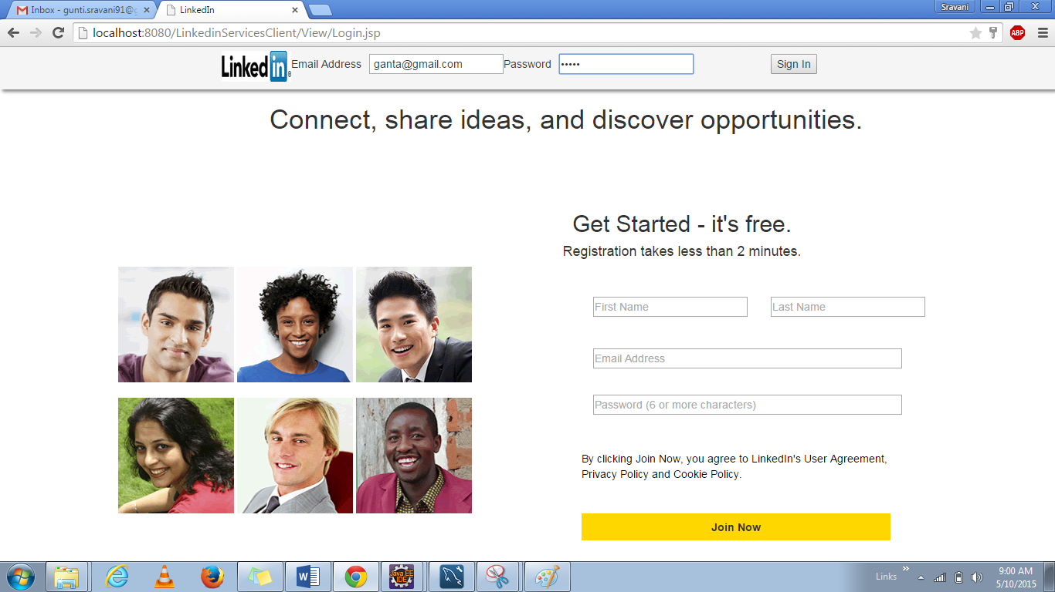

**On clicking the invitations button: we can see that Srav Gunti has sent an invitation. Now the user has a choice to either Accept Invitation or Reject Invitation.**

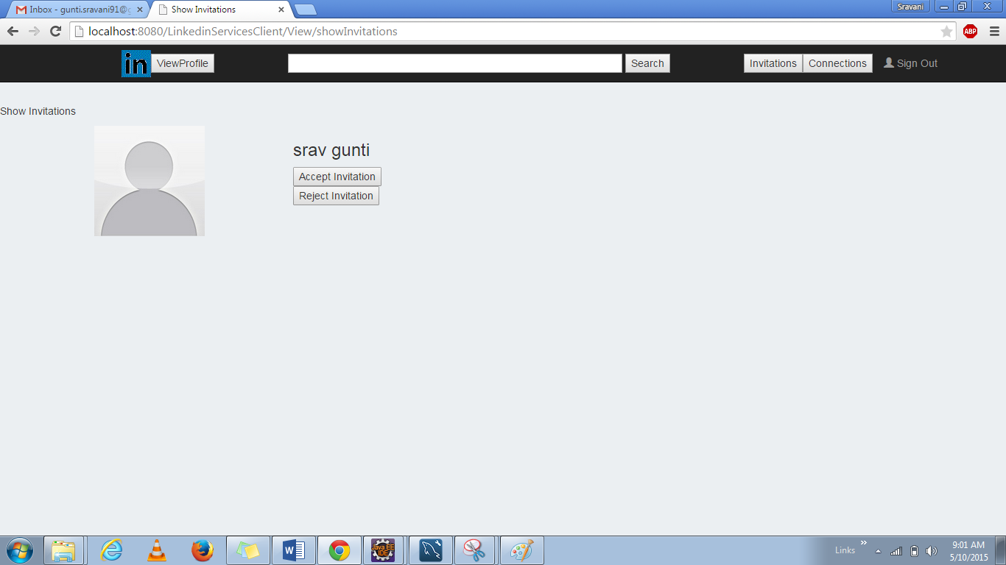

**A Success message is displayed when user accepts the invitation.**

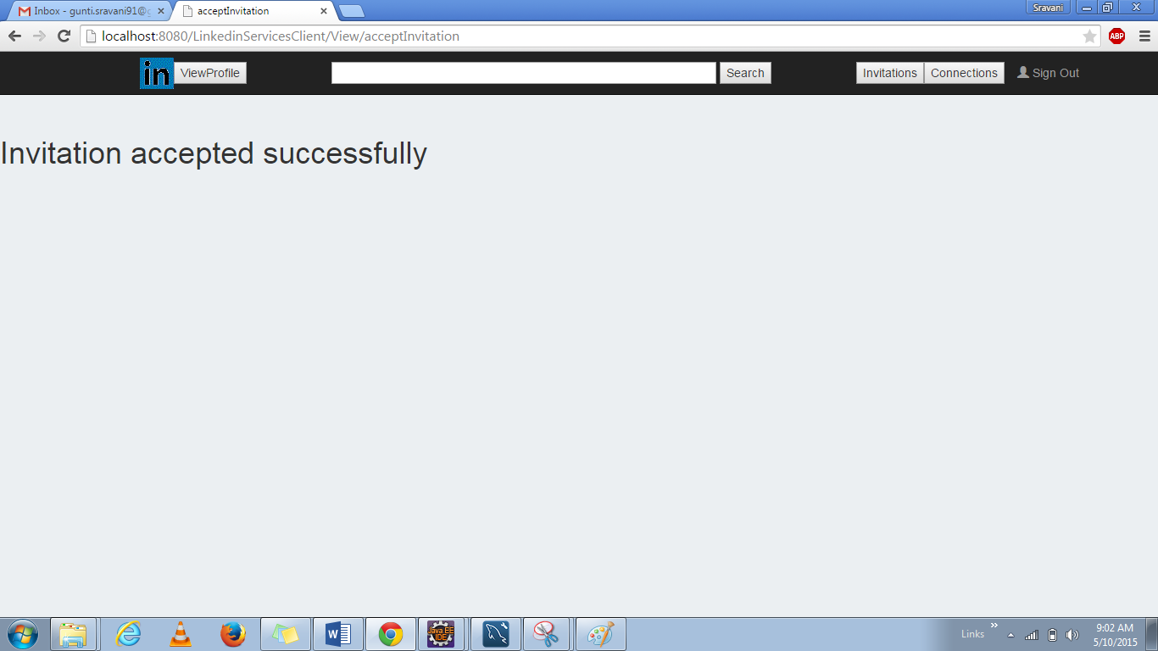

**Now Let’s see the invitations In Srav Gunti Profile.**

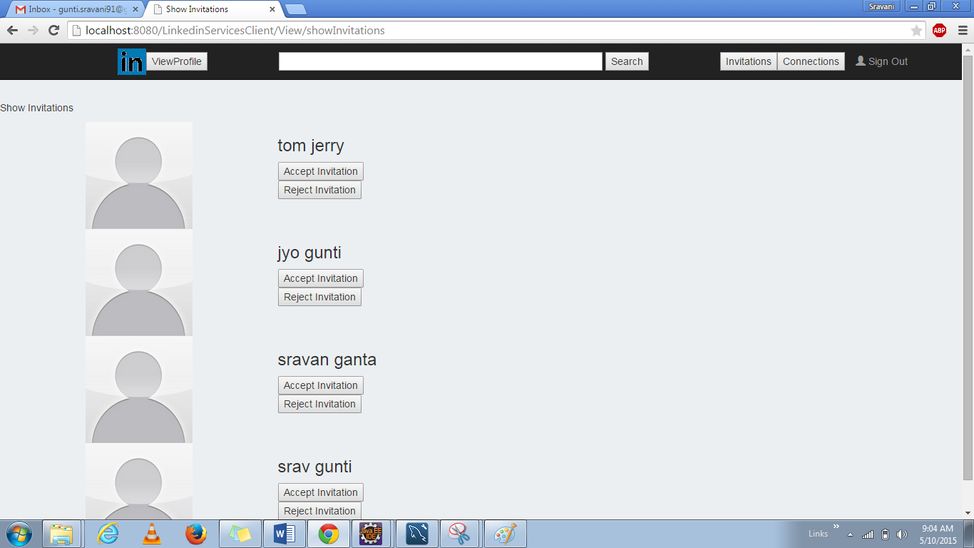

**If the user rejects the invitation; A message is displayed on the screen that the invitation is rejected.**

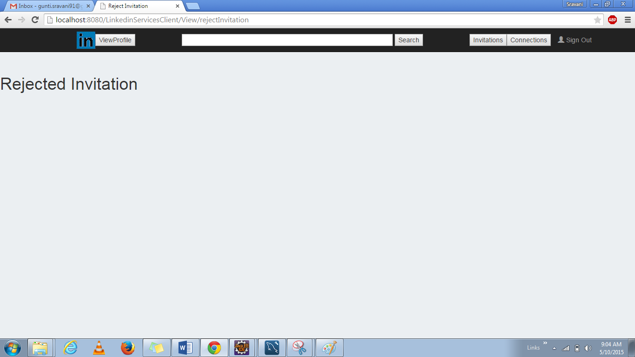

**On Clicking Connections Button; the list of users connected to the logged in user is displayed.**

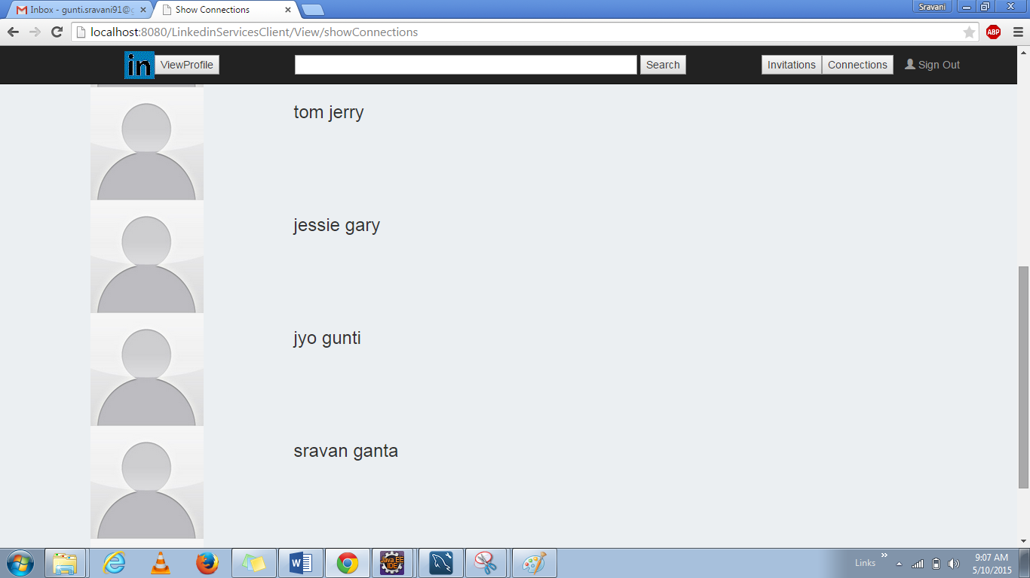

**On Clicking Sign out Button; the user is navigated back to the login page.**

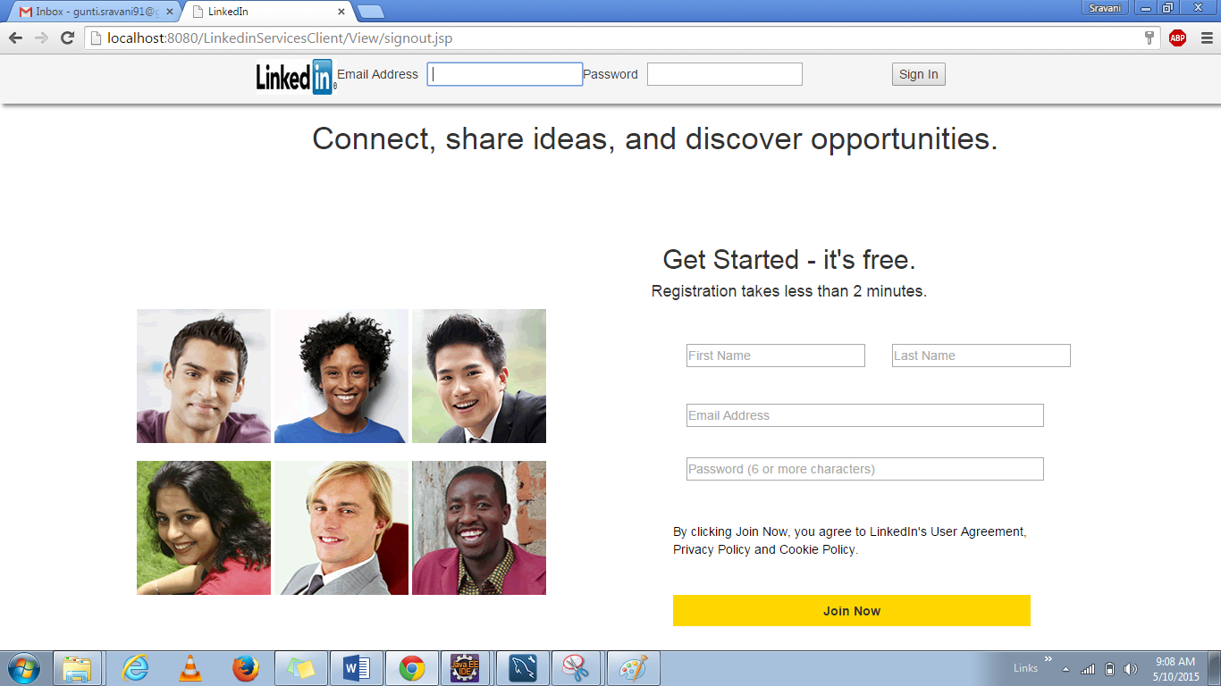

## **Performance Results for LinkedIn:**

### **For 100 calls:**

#### **getEducationById:**

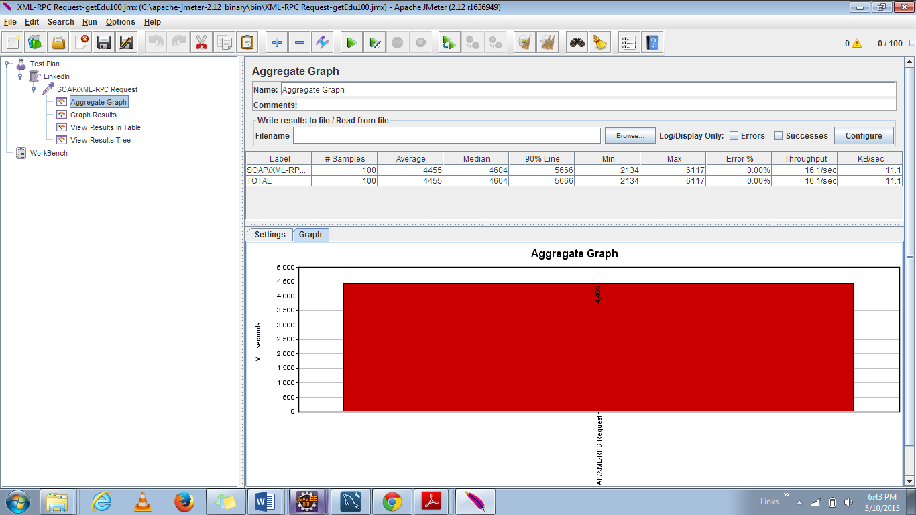

#### 

#### **getAllUsers:**

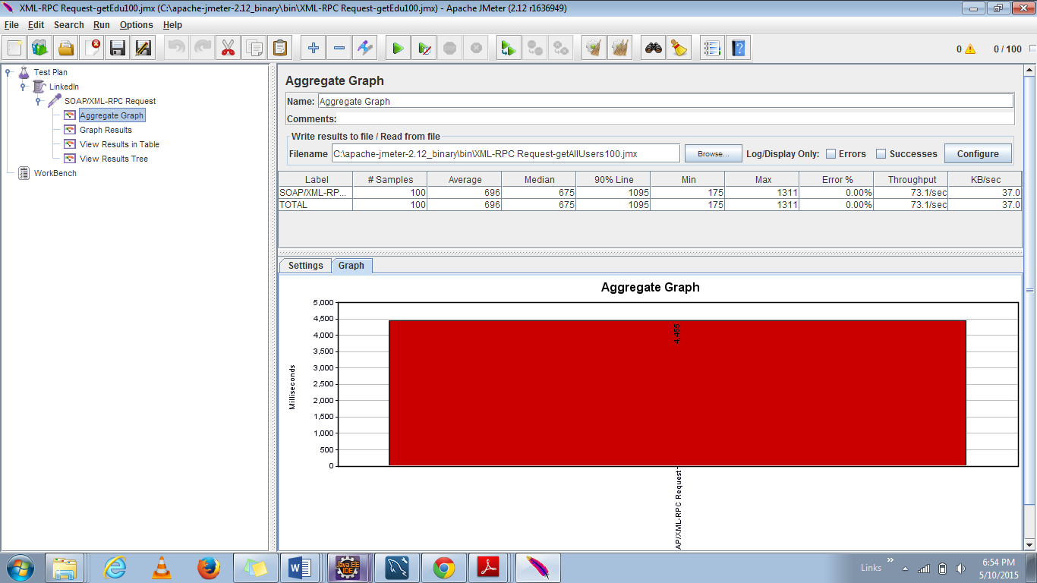

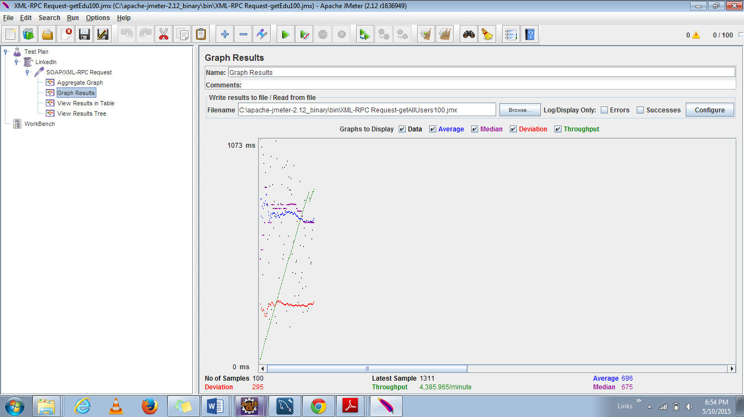

|  |  |  |  |  |
| --- | --- | --- | --- | --- |
| Functionality | Average(ms) | Median | Throughput(per minute) | Deviation |
| getEducationById | 4455 | 4504 | 957.274 | 987 |
| getAllUsers(Search Funtionality) | 696 | 675 | 4385.9 | 295 |

**Discussions:**

* The performance of the LinkedIn server application is not very consistent across all the two API considered.
* The aggregate graph gives the details of the average time across the four APIs.
* The blue line indicates the average time taken for all the 100 calls.
* However we can see that **when large amount of data is retrieved for a single API, the performance is better than compared** to less amount of data.

### **For 200 calls:**

#### **getEducationById:**

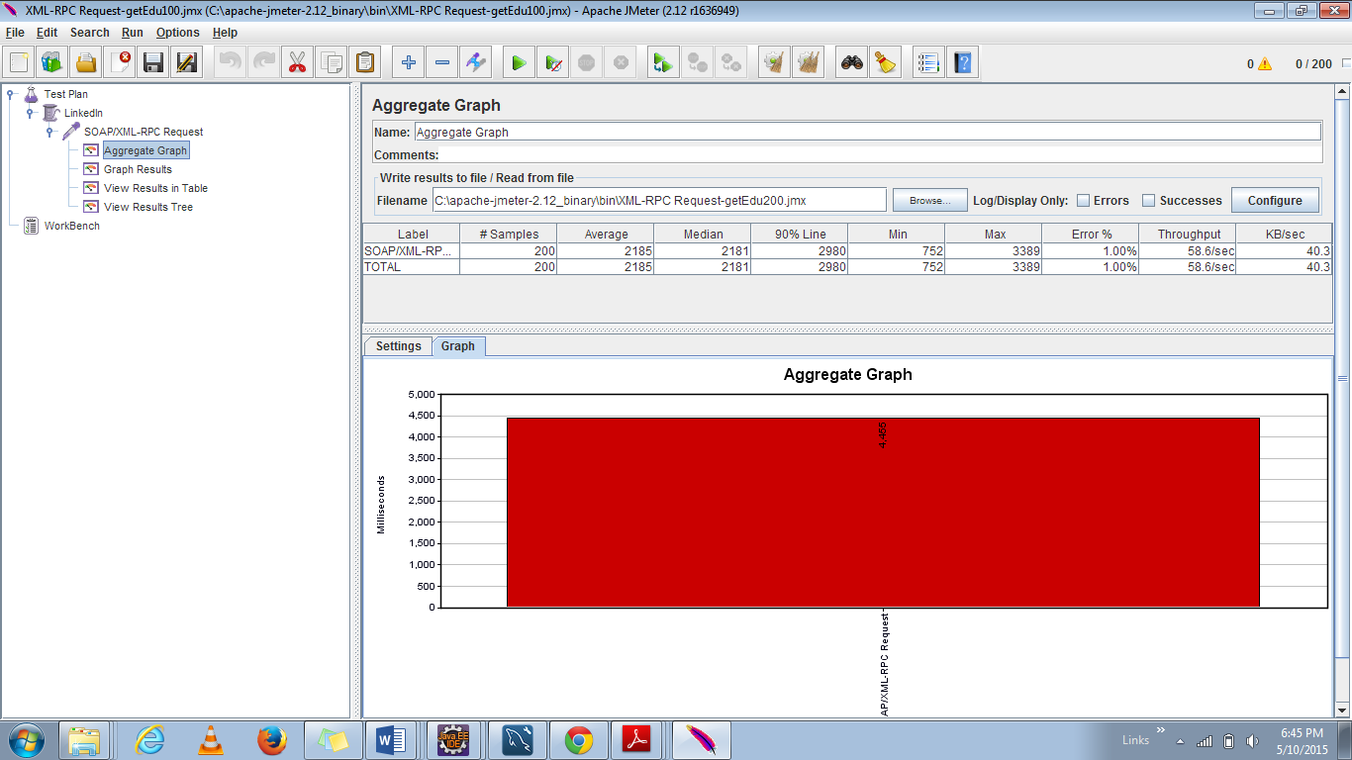

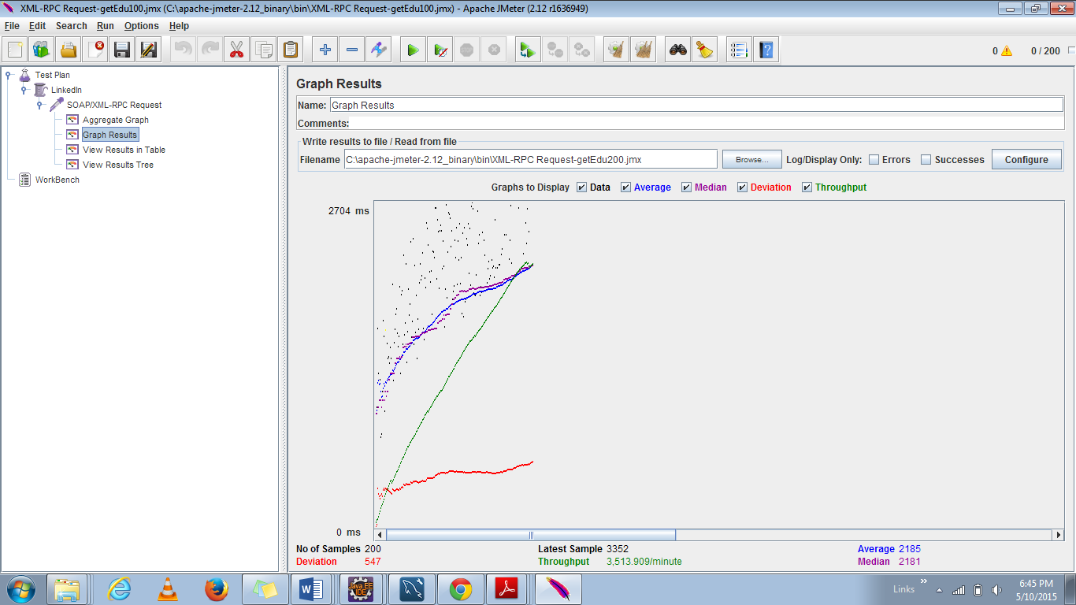

Data source rejected establishment of connection, message from server: "Too many connections".

#### **getAllUsers**

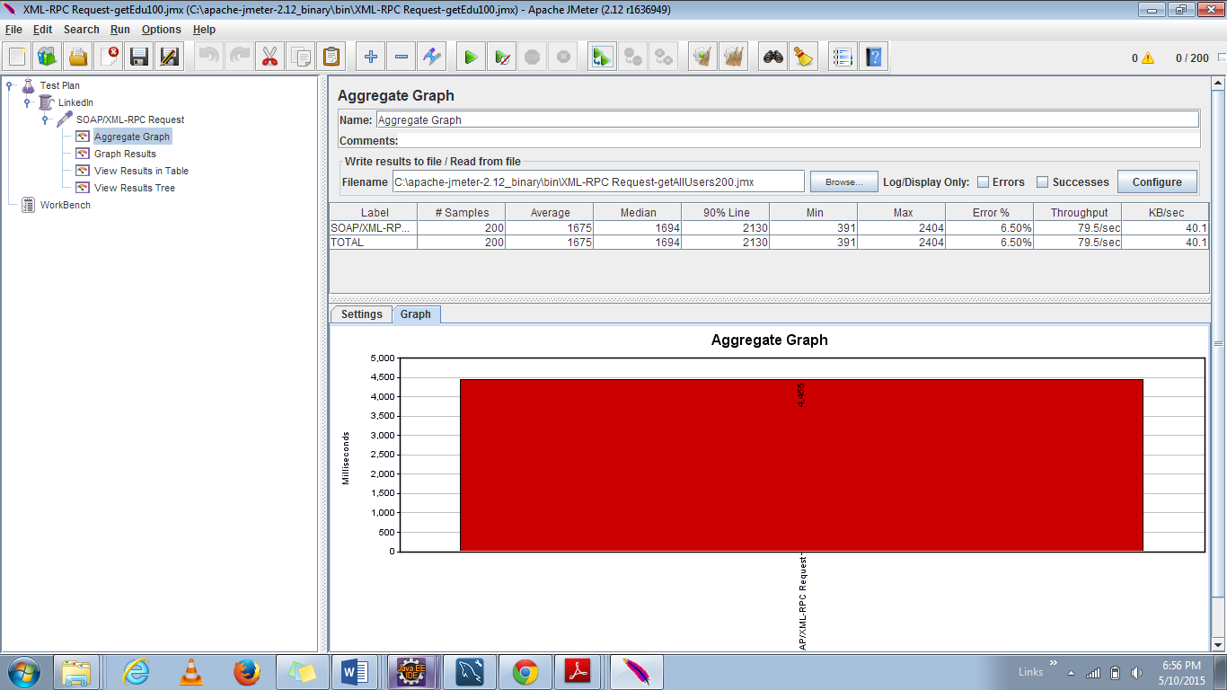

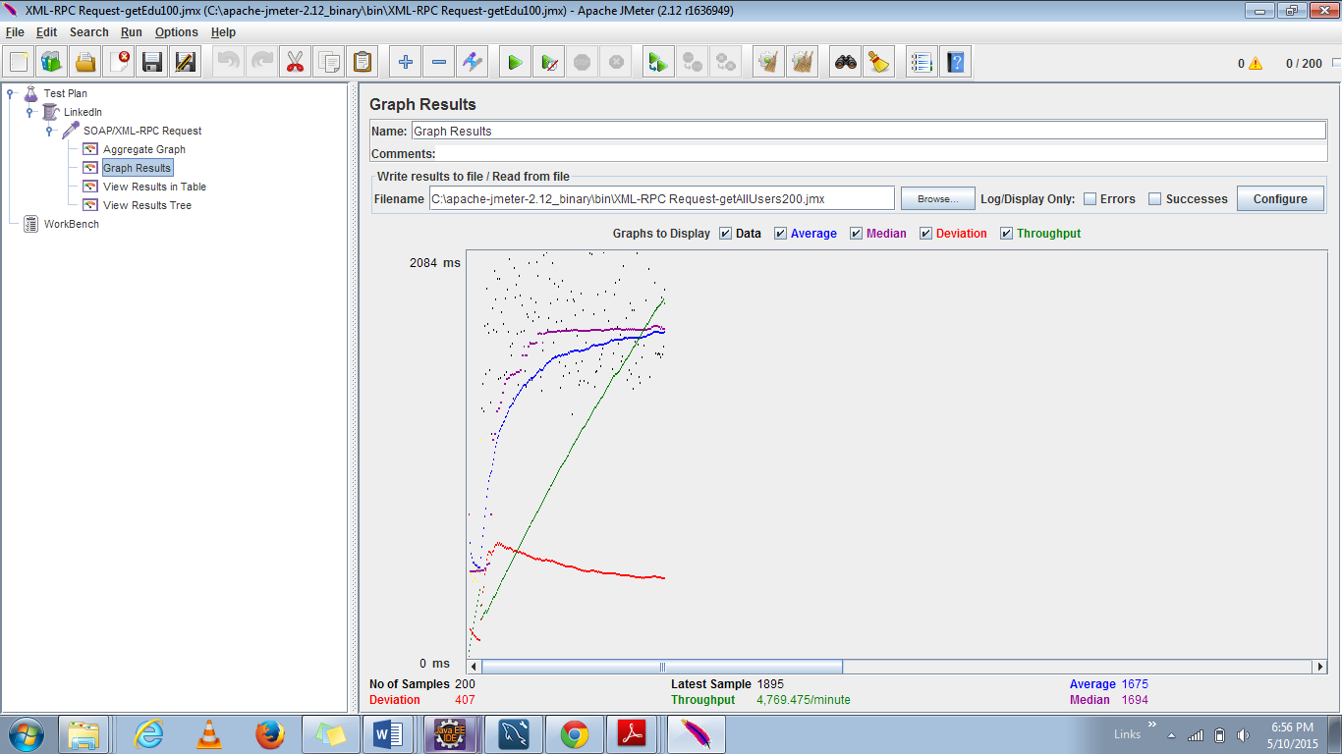

|  |  |  |  |  |
| --- | --- | --- | --- | --- |
| Functionality | Average | Median | Throughput (per minute) | Deviation |
| getEducationById | 2185 | 2181 | 3513.9 | 547 |
| getAllUsers(Search Funtionality) | 1676 | 1594 | 4769.475 | 407 |

**Discussions:**

* The performance of the LinkedIn server application is not very consistent across all the two API considered.
* The aggregate graph gives the details of the average time across the four APIs.
* The blue line indicates the average time taken for all the 200 calls.
* However we can see that **when large amount of data is retrieved for a single API, the throughput is high than compared** to less amount of data.

### **For 300 calls:**

#### **getEducationById:**

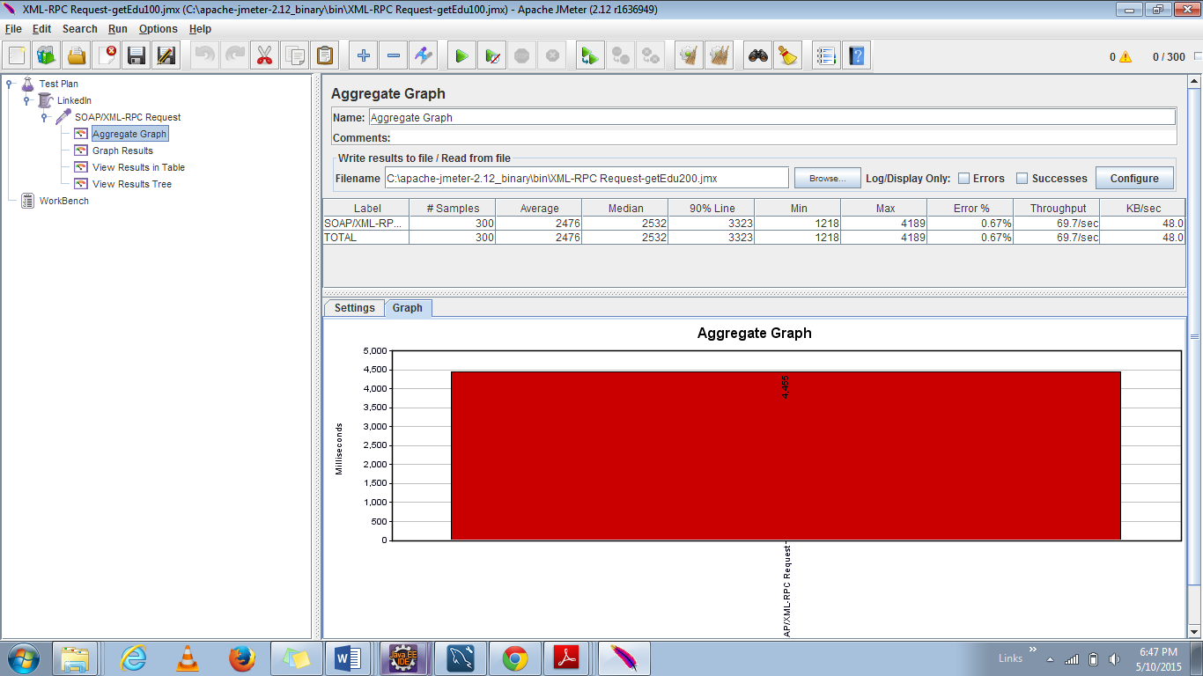

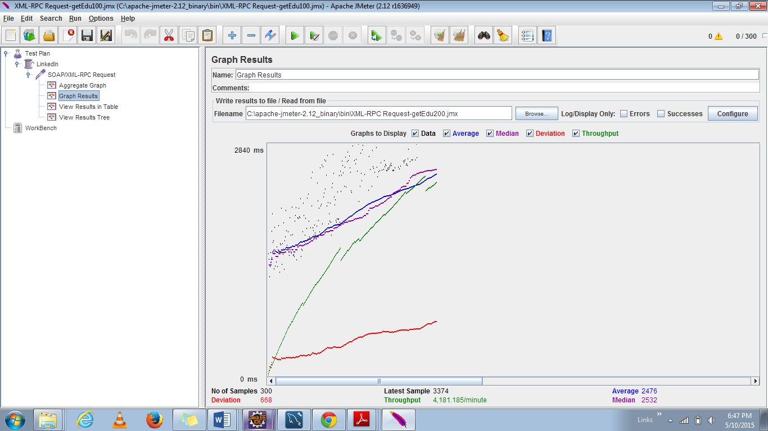

#### **getAllUsers**

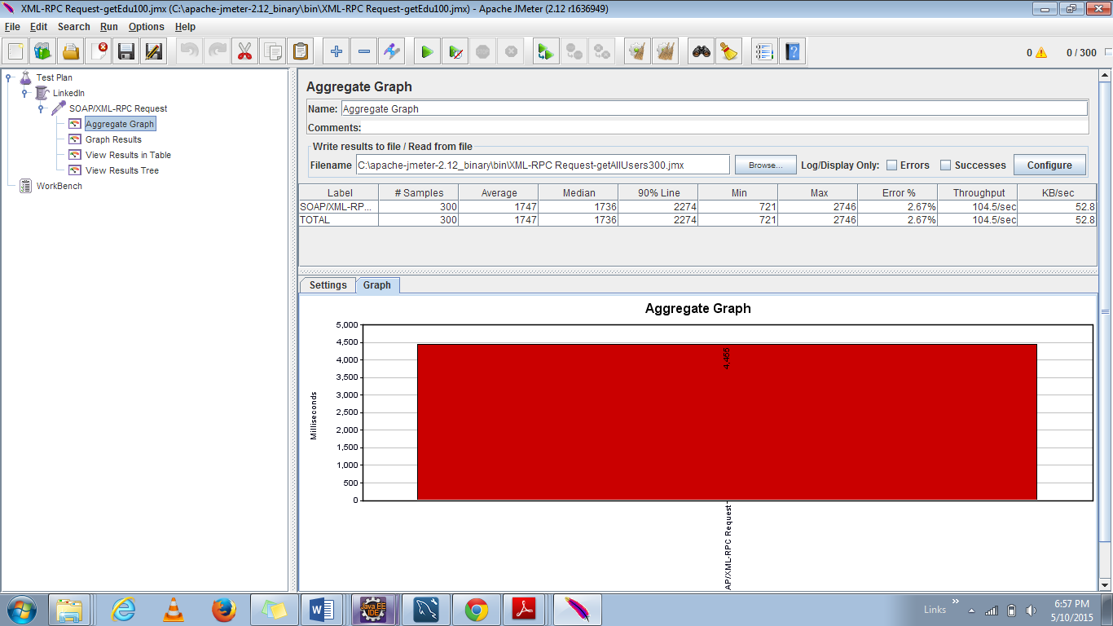

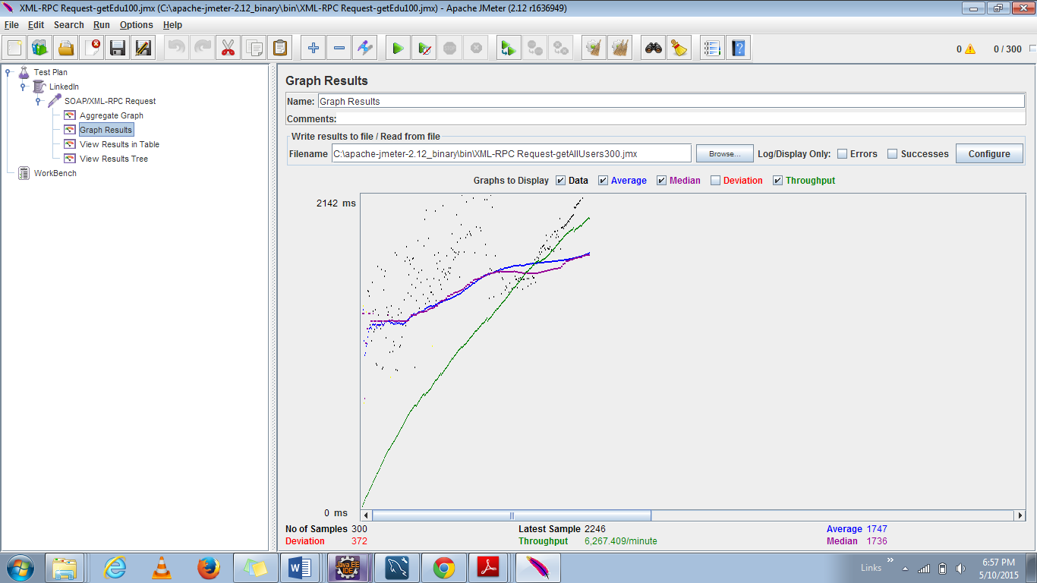

|  |  |  |  |  |
| --- | --- | --- | --- | --- |
| Functionality | Average | Median | Throughput | Deviation |
| getEducationById | 2476 | 2532 | 4181.185 | 568 |
| getAllUsers(Search Funtionality) | 1747 | 1736 | 6257.4 | 372 |

**Discussions:**

* The performance of the LinkedIn server application is not very consistent across all the two API considered.
* The aggregate graph gives the details of the average time across the four APIs.
* The blue line indicates the average time taken for all the 300 calls.
* However we can see that **when large amount of data is retrieved for a single API, the performance is better than compared** to less amount of data retrieval.

### **For 400 calls:**

#### **getEducationById**

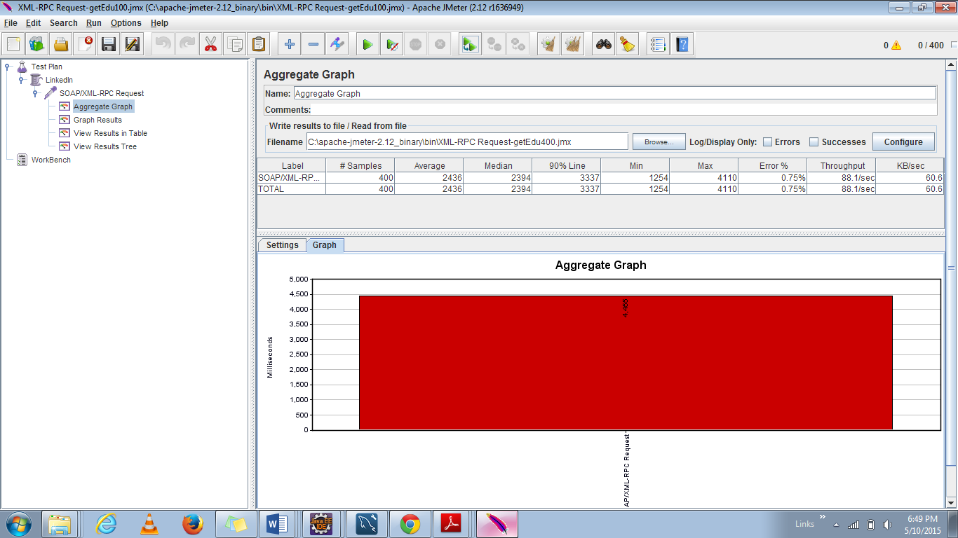

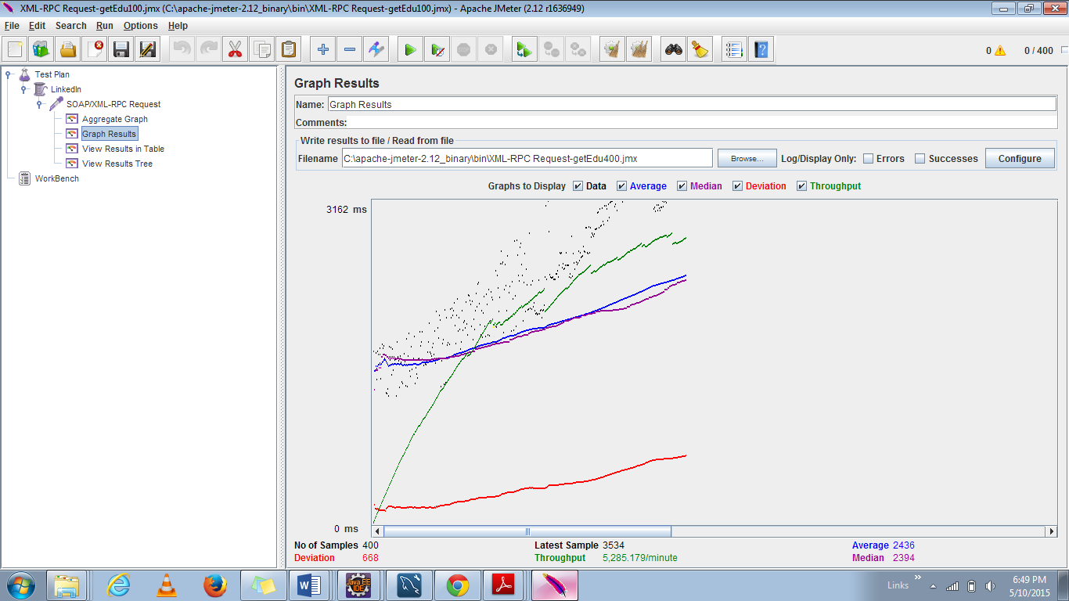

#### **getAllUsers**

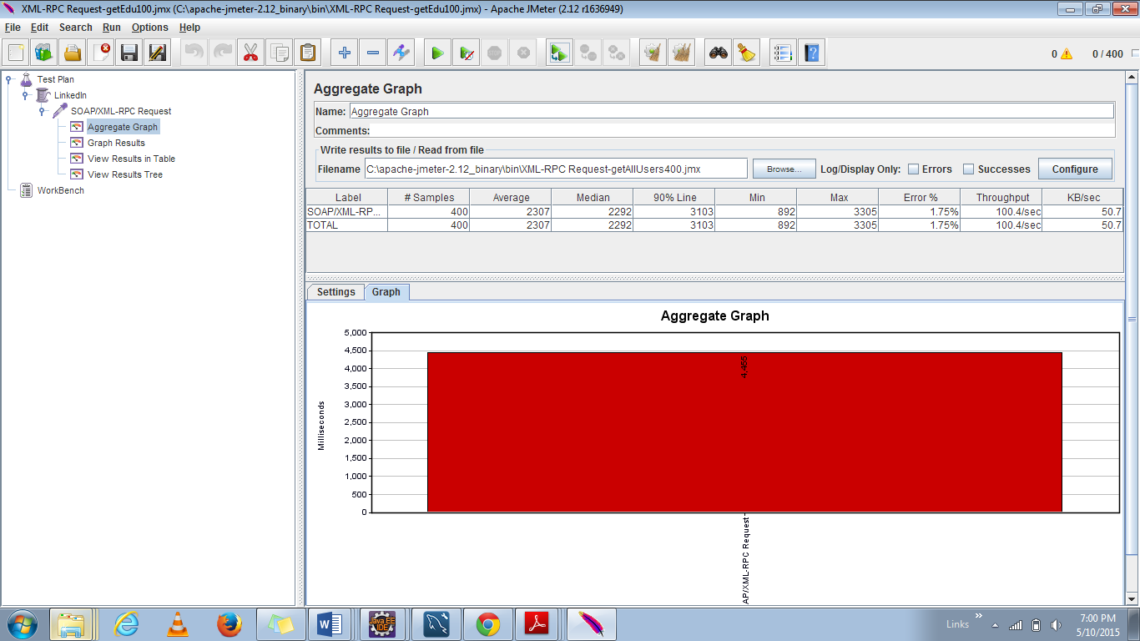

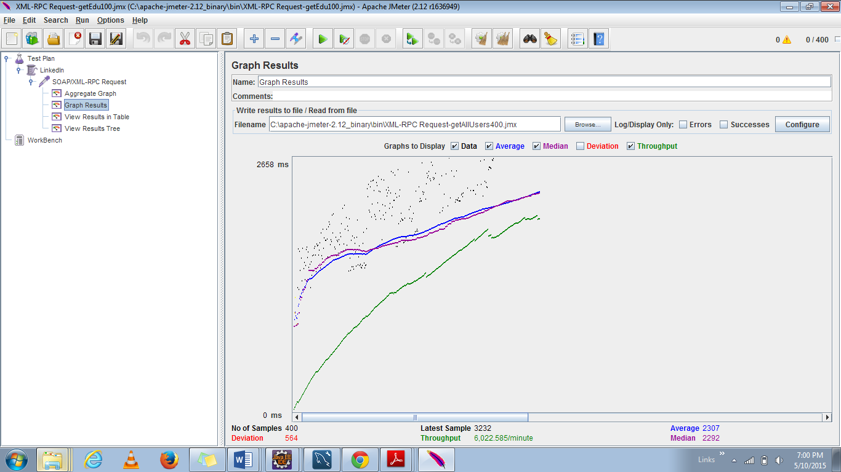

|  |  |  |  |  |
| --- | --- | --- | --- | --- |
| Functionality | Average | Median | Throughput | Deviation |
| getEducationById | 2436 | 2394 | 5285 | 568 |
| getAllUsers(Search Funtionality) | 2307 | 2292 | 6022.585 | 564 |

**Discussions:**

* The performance of the LinkedIn server application is not very consistent across all the two API considered.
* The aggregate graph gives the details of the average time across the four APIs.
* The blue line indicates the average time taken for all the 500 calls.
* However we can see that **when large amount of data is retrieved for a single API, the throughput is high compared** to less amount of data.

### **For 500 calls:**

#### **getEducationById**

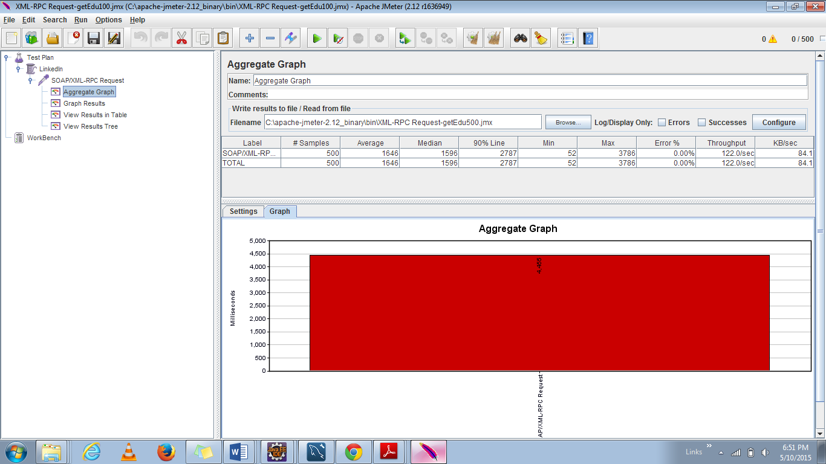

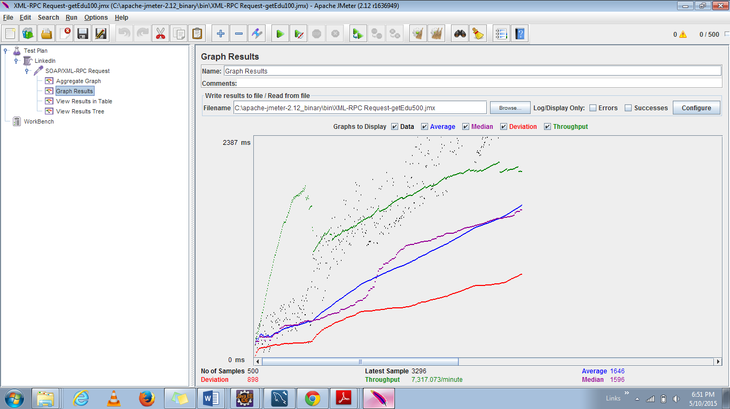

#### **getAllUsers**

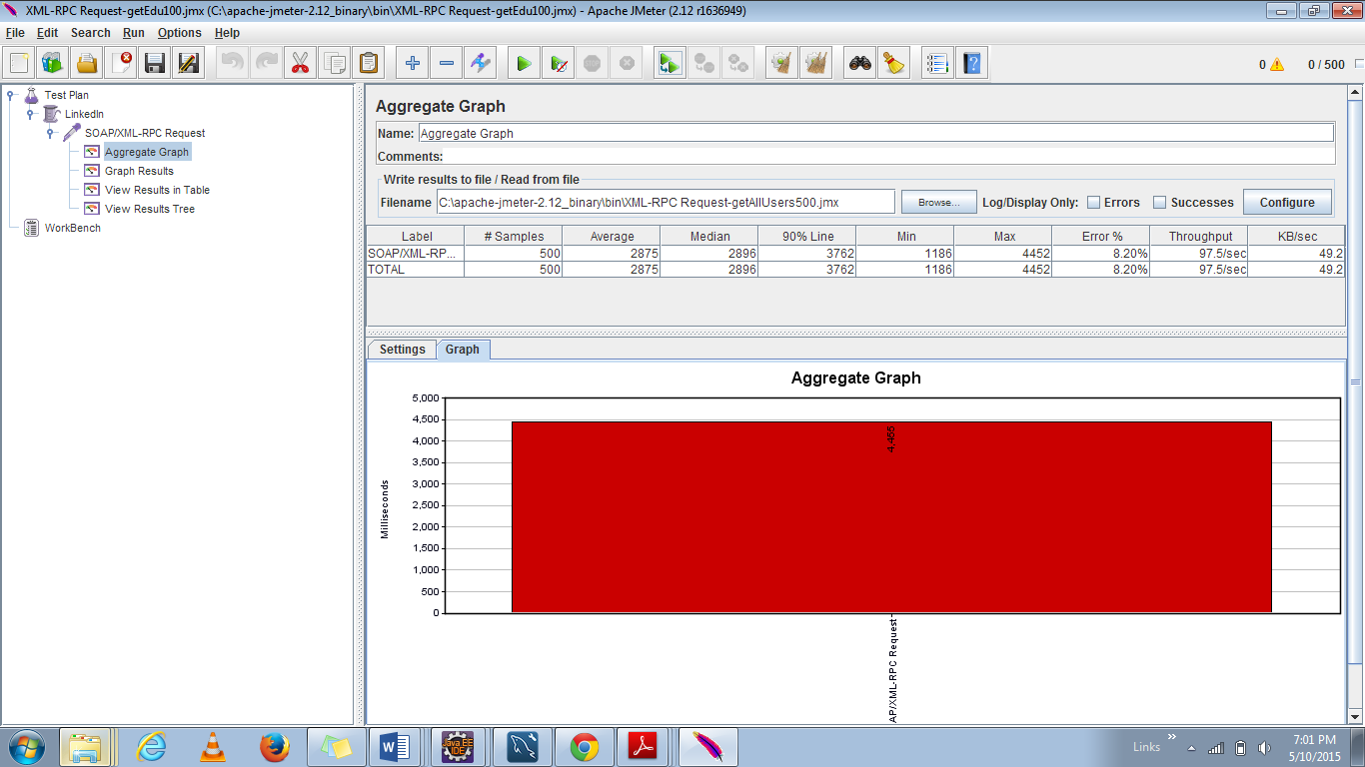

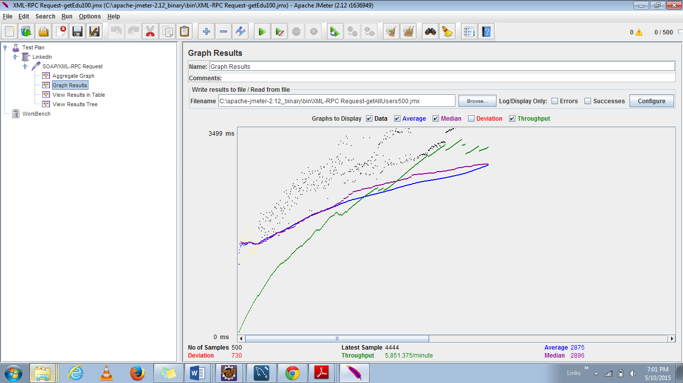

|  |  |  |  |  |
| --- | --- | --- | --- | --- |
| Functionality | Average | Median | Throughput | Deviation |
| getEducationById | 1546 | 1596 | 7317.073 | 598 |
| getAllUsers(Search Funtionality) | 2876 | 2896 | 5851.375 | 730 |

**Discussions:**

* The performance of the LinkedIn server application is not very consistent across all the two API considered.
* The aggregate graph gives the details of the average time across the four APIs.
* The blue line indicates the average time taken for all the 500 calls.
* However we can see that **as the number of users are increased, large amount of data retrieval is has greater average time in comparison and at the same time throughput is also high.**

### **For 1000 calls:**

#### **getEducationById**

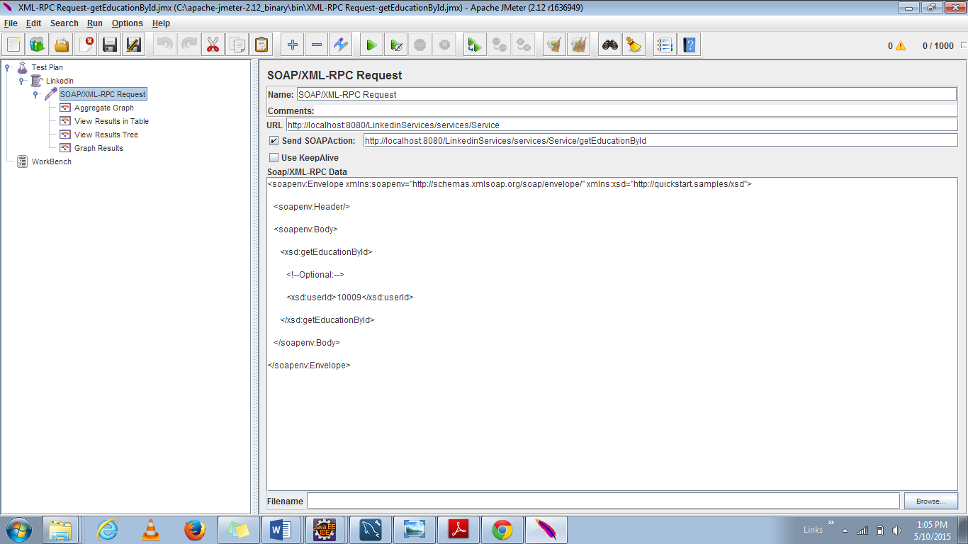

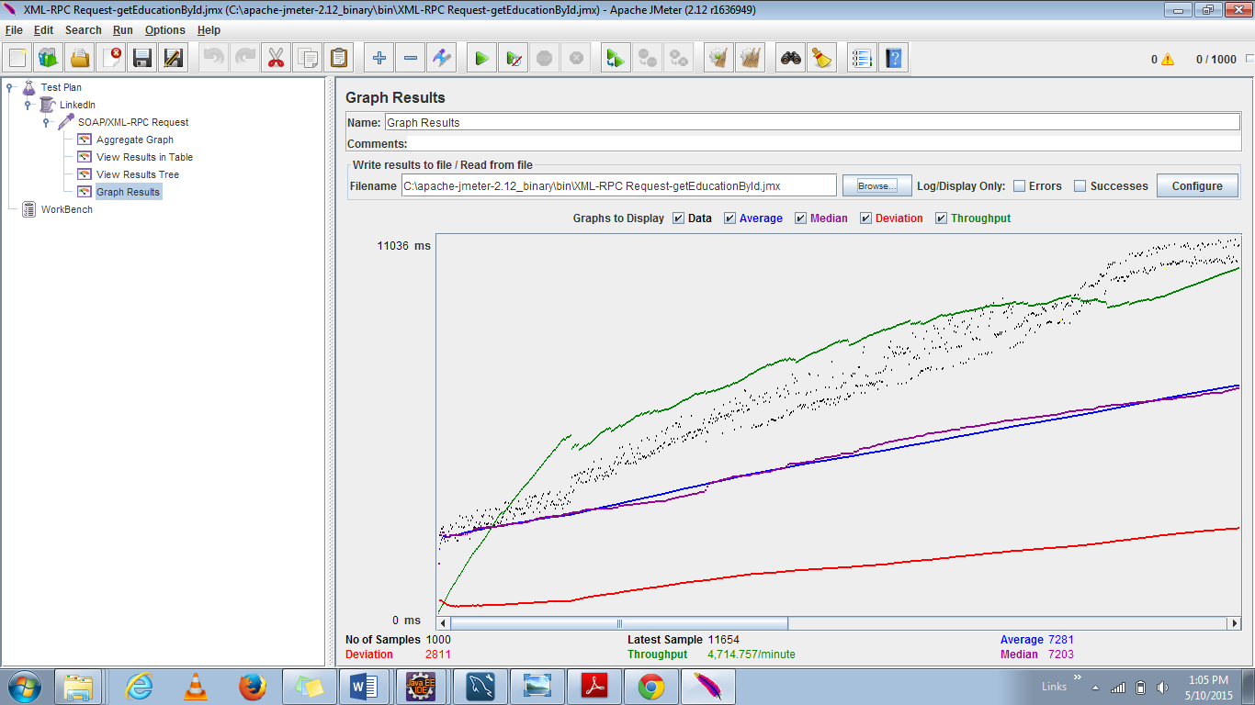

#### **getAllUsers:**

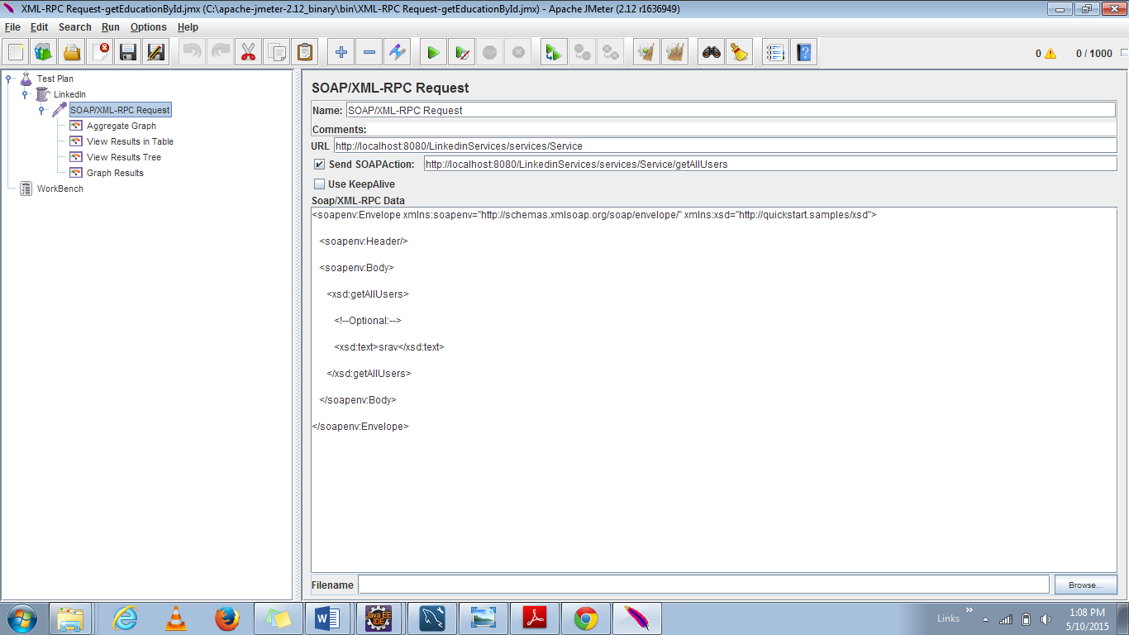

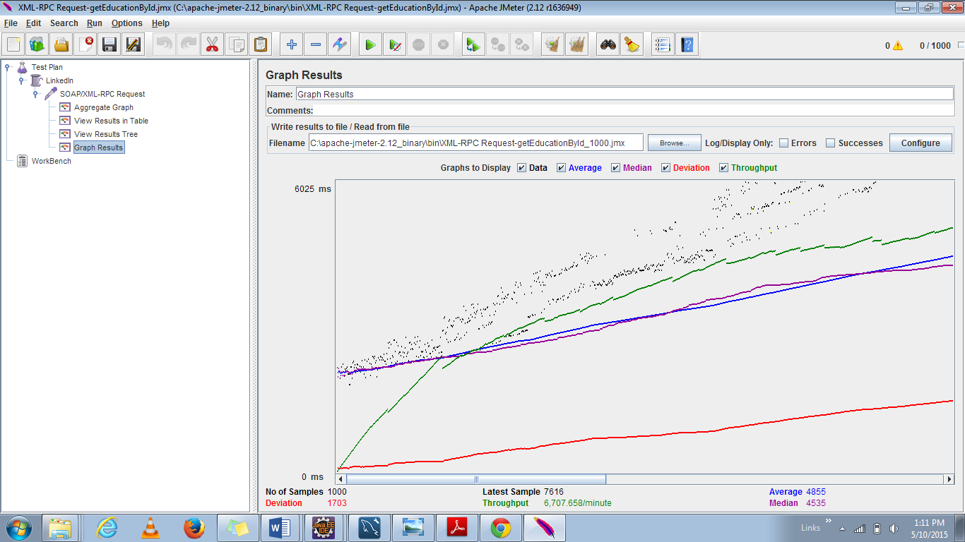

|  |  |  |  |  |
| --- | --- | --- | --- | --- |
| Functionality | Average | Median | Throughput | Deviation |
| getEducationById | 7281 | 7203 | 4714.7 | 2811 |
| getAllUsers(Search Funtionality) | 4855 | 4535 | 6707.558 | 1703 |

**Discussions:**

* The performance of the LinkedIn server application is not very consistent across all the two API considered.
* The aggregate graph gives the details of the average time across the four APIs.
* The blue line indicates the average time taken for all the 100 calls.
* However we can see that **when large amount of data is retrieved for a single API, the performance is better than compared** to less amount of data. And moreover, **the average time taking to search the users from database take less time in comparison to retrieve only one single row**

### **For 5000 calls:**

#### **getEducationById:**

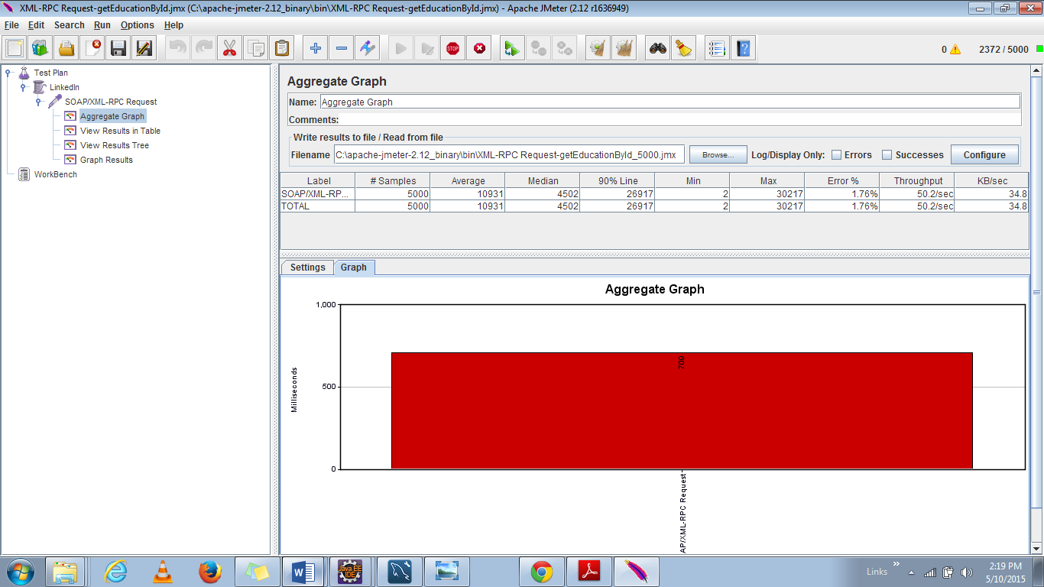

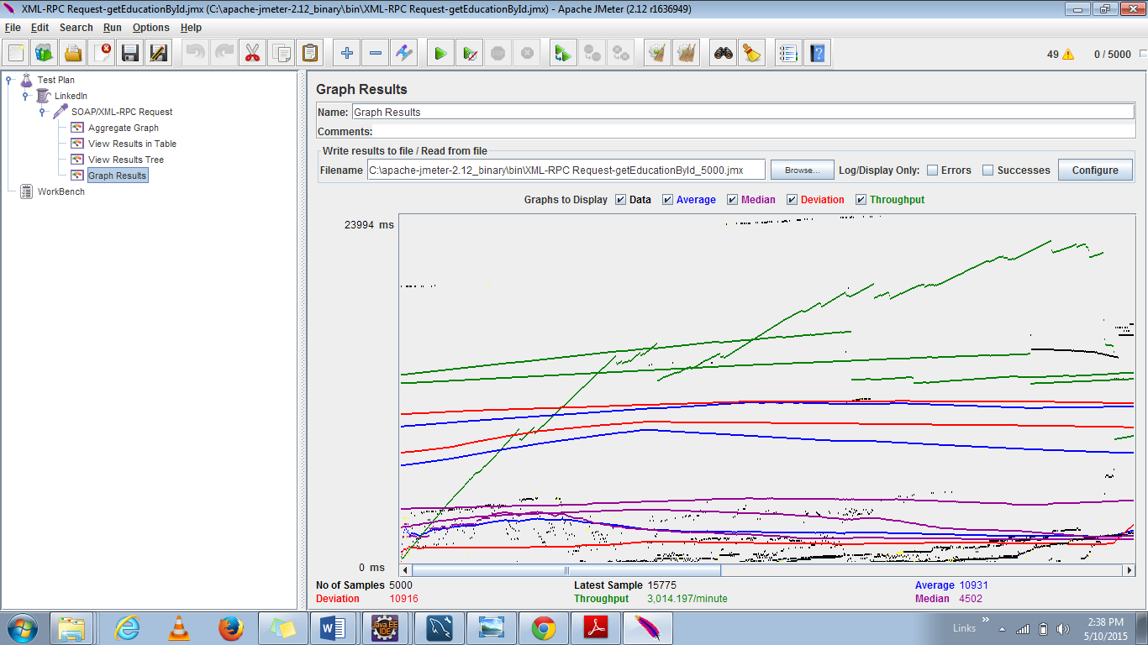

#### **getAllUsers:**

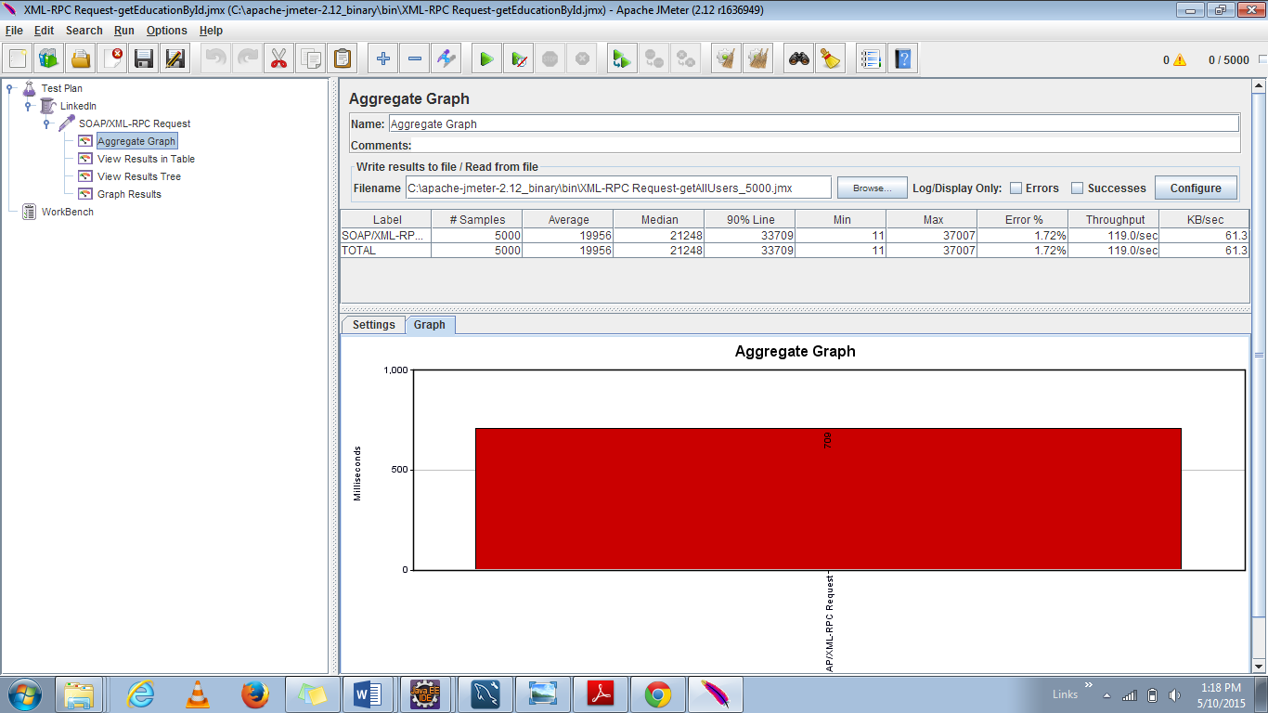

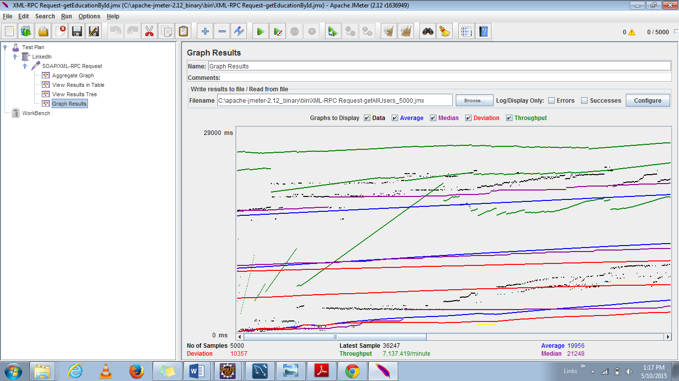

|  |  |  |  |  |
| --- | --- | --- | --- | --- |
| Functionality | Average | Median | Throughput | Deviation |
| getEducationById | 10931 | 4502 | 3014.107 | 10913 |
| getAllUsers(Search Funtionality) | 19956 | 21248 | 7137.418 | 10357 |

**Discussions:**

* The performance of the LinkedIn server application is not very consistent across all the two API considered.
* The aggregate graph gives the details of the average time across the four APIs.
* The blue line indicates the average time taken for all the 100 calls.
* As the number of users increased, average time taken to retrieve large amount of data is higher and throughput is high; but the throughput can be maximum for that amount of time using RESTful Services.

### **For 100 concurrent users each operation 1000 calls:**

#### **getEducationById:**

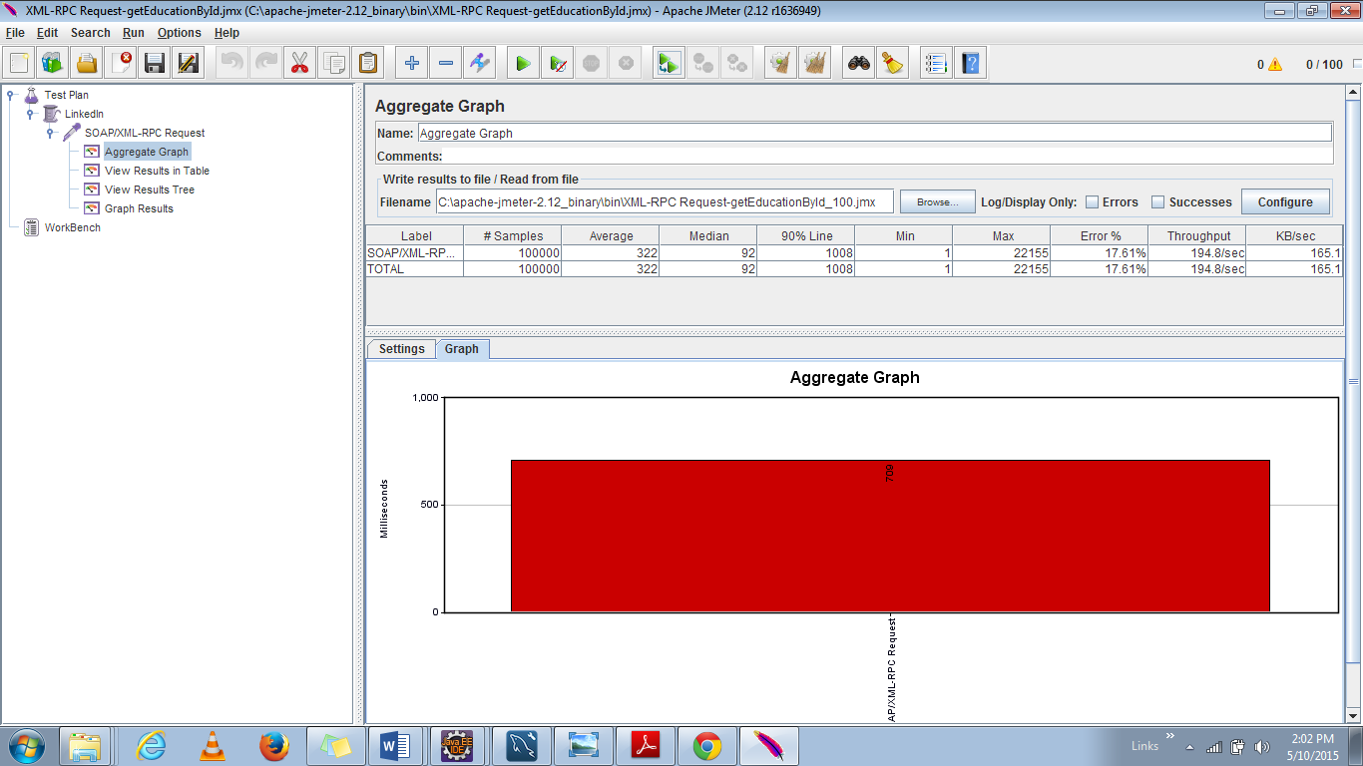

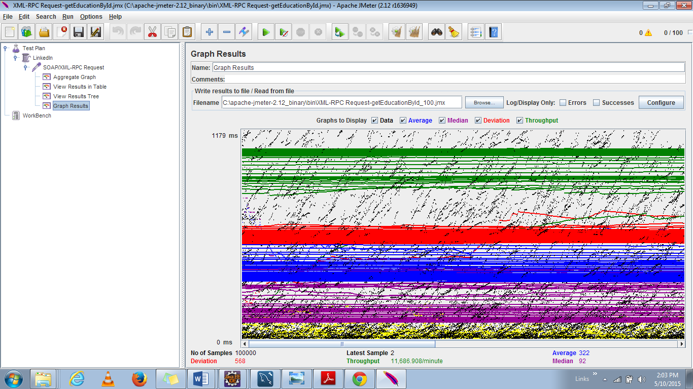

An error message is displayed on the console as below

“ **Data source rejected establishment of connection, message from server: "Too many connections"**”

#### **getAllUsers:**

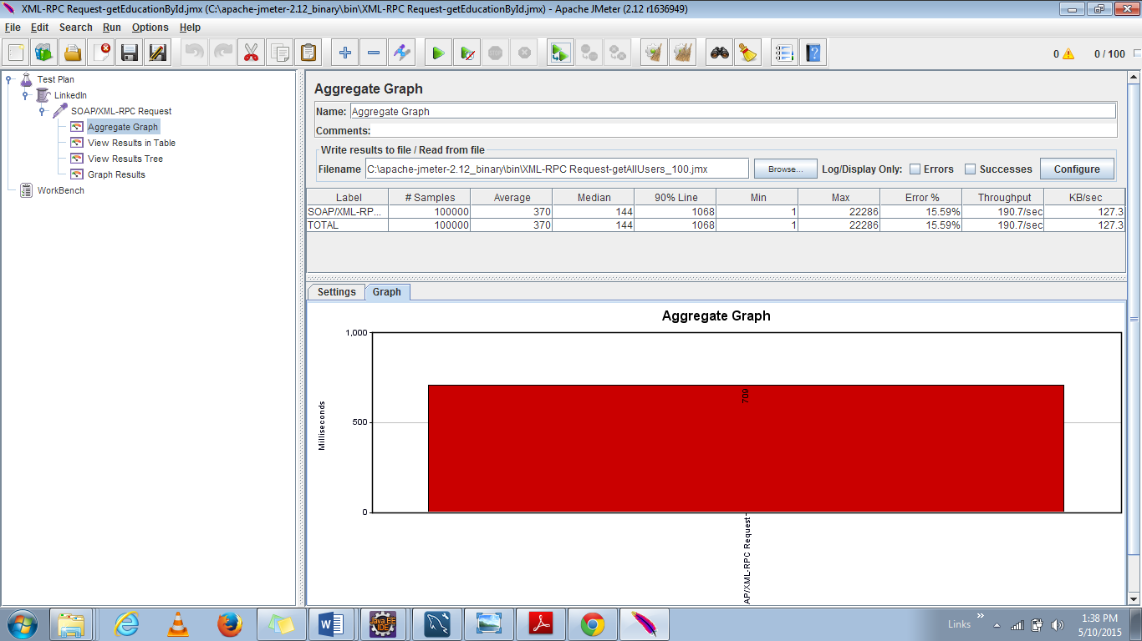

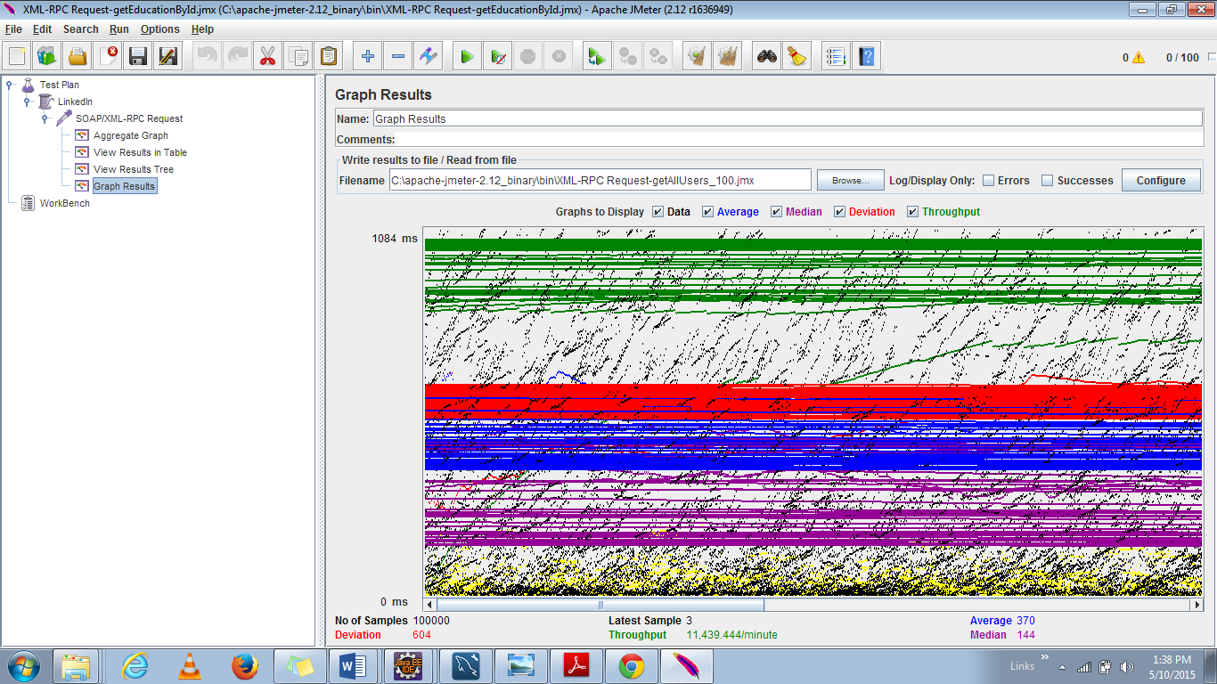

|  |  |  |  |  |
| --- | --- | --- | --- | --- |
| Functionality | Average | Median | Throughput | Deviation |
| getEducationById | 322 | 92 | 11586.908 | 568 |
| getAllUsers(Search Funtionality) | 370 | 144 | 11439.44 | 504 |

**Discussions:**

* The performance of the LinkedIn server application is not very consistent across all the two API considered.
* During the generation of these graphs have seen the below error on the console “

Data source rejected establishment of connection, message from server: "Too many connections"”

* The aggregate graph gives the details of the average time across the four APIs.
* The blue line indicates the average time taken for all the 100 calls.
* However we can see that **when large amount of data is retrieved for a single API, the performance is better than compared** to less amount of data.

### **Comparison with Restful Services:**

Below are the graphs generated during Lab 1 performance testing for LinkedIn Application.

### **For 100 users:**

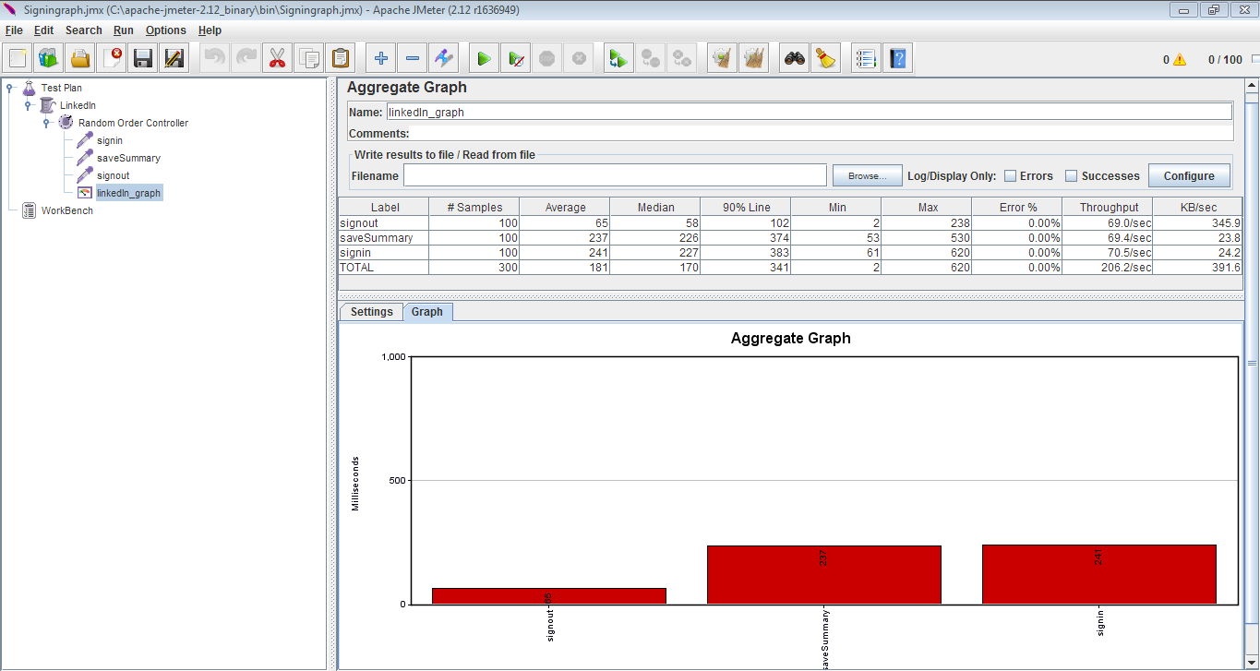

100 users without connection pooling

### **For 200 users**

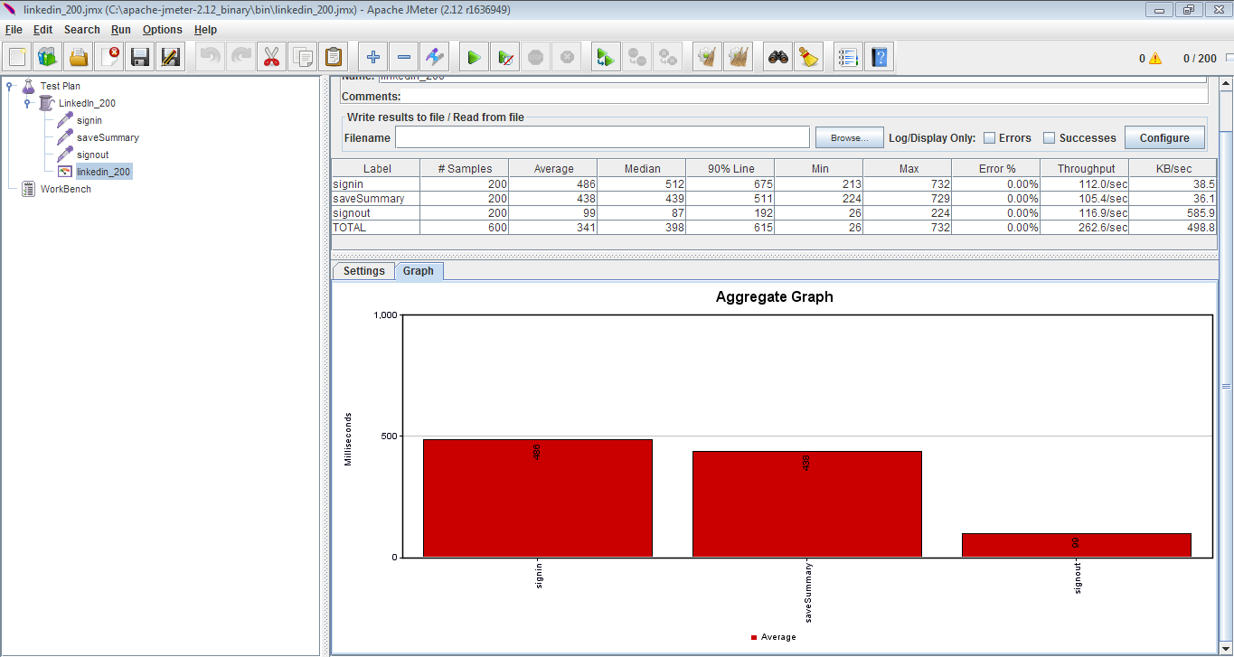

200 users without connection pooling

### **For 300 users**

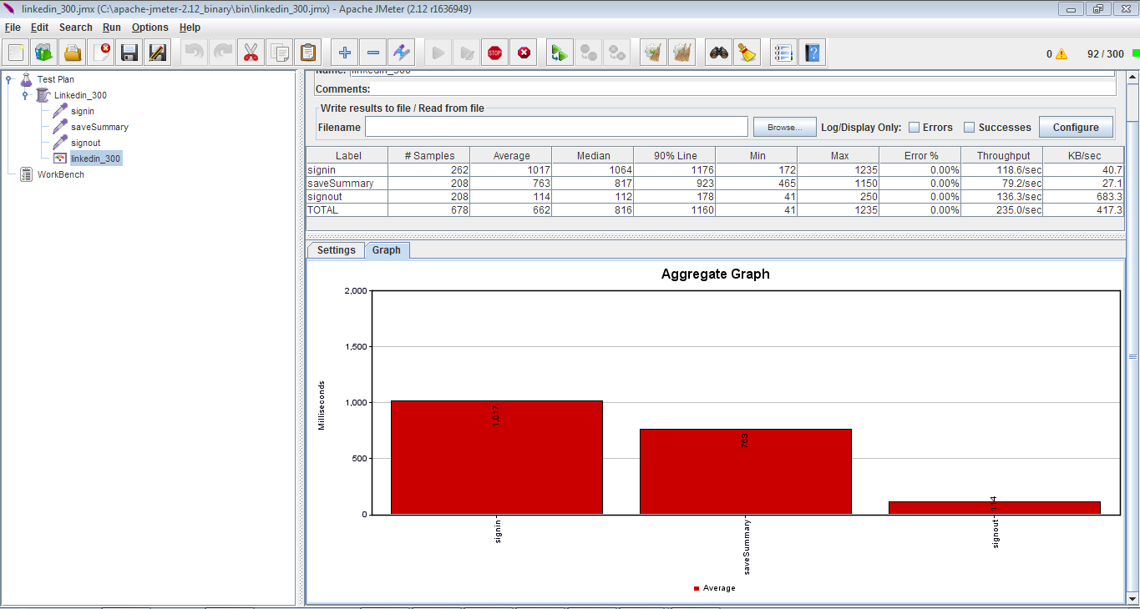

300 users without connection pooling

### **For 400 users**

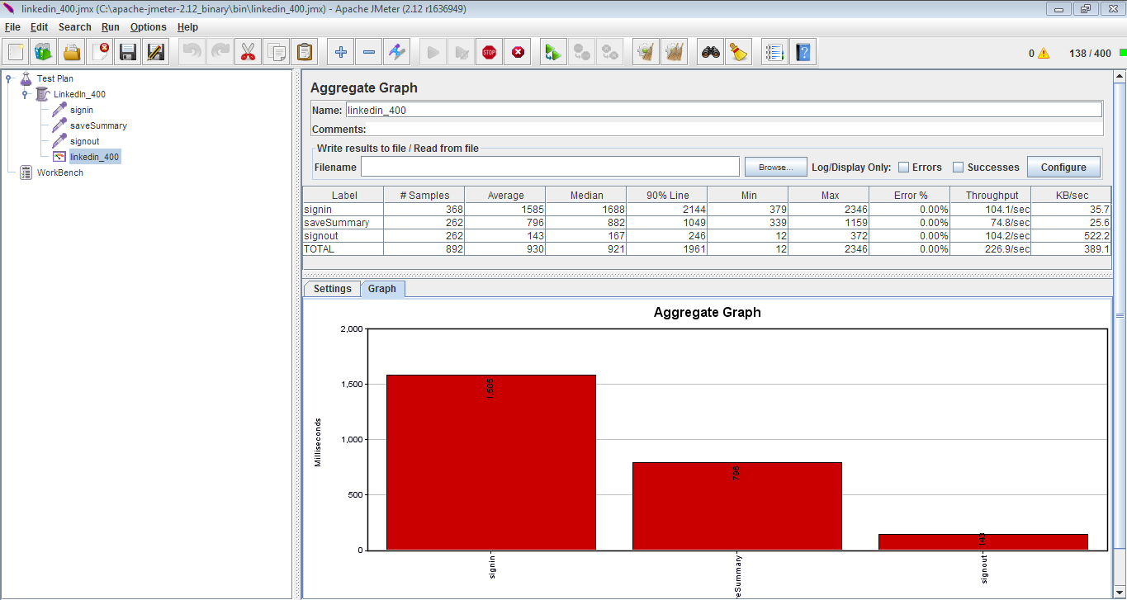

400 users without connection pooling

### **For 500 users**

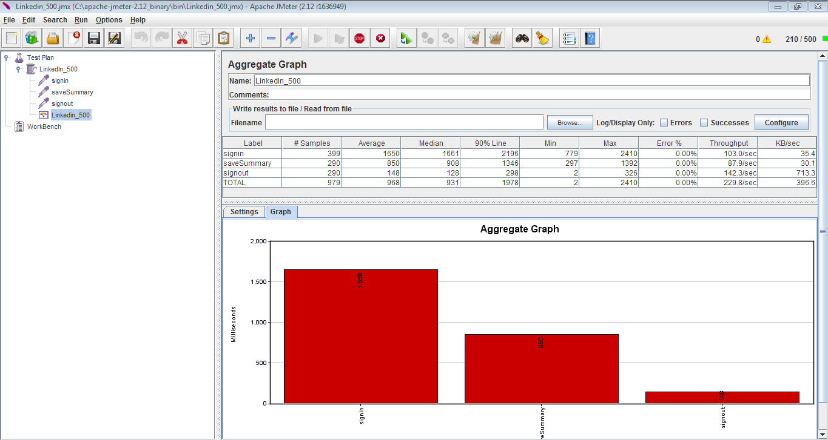

500 users without connection pooling

* It is clearly shown from the graph that the average time taken by Restful services is very low (half of) compared to the time taken by Web Services.
* As nodejs is a lightweight scalable server rapid prototyping is done and thus the through put is also high.
* But when we need machine to machine interoperable interaction over a network we need Web Services.
* As node js is asynchronous non-blocking execution whereas web services is blocking; there is a wait time and the average time for web services is high.
* Moreover Java web service has an overhead of SOAP; whereas Restful services do not have that overhead.